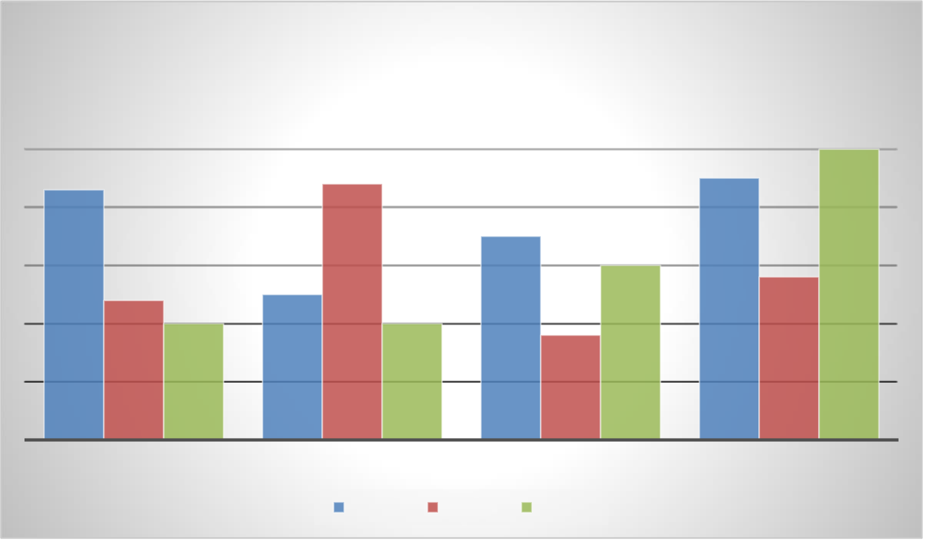

**Lorem ipsum dolor sit amet, consectetur adipiscing elit**.

Donec tempor, urna ut pretium imperdiet, leo orci sodales ligula, iaculis pellentesque lorem tellus non felis. Ut ut nisl eget est tristique cursus. Proin nec vehicula neque. Integer eu quam sed orci tristique euismod in ac urna. Sed sed aliquam purus. Etiam venenatis dolor nisi. Morbi et felis quis sapien blandit maximus viverra vel ex. Curabitur egestas lobortis ex, et rutrum ligula rutrum ac. Donec in nibh sem. Nam aliquam massa a consequat sollicitudin. Etiam tincidunt nunc sit amet consectetur consectetur.

|  |  |  |  |  |  |  |  |  |  |  |  |  |  |  |  |  |  |  |  |  |  |  |  |  |  |  |  |  |  |  |  |  |  |  |  |  |  |  |  |  |  |  |  |  |  |  |  |  |  |  |  |  |  |  |  |  |  |  |  |  |  |  |  |  |  |  |  |  |  |  |  |  |  |  |  |  |  |  |  |  |  |  |  |  |  |  |  |  |  |  |  |  |  |  |  |  |  |  |  |  |  |  |  |  |  |  |  |  |  |  |  |  |  |  |  |  |  |  |  |  |  |  |  |  |  |  |  |  |  |  |  |  |  |  |  |  |  |  |  |  |  |  |  |  |  |  |  |  |  |  |  |  |  |  |  |  |  |  |  |  |  |  |  |  |  |  |  |  |  |  |  |  |  |  |  |  |  |  |  |  |  |  |  |  |  |  |  |  |  |
| --- | --- | --- | --- | --- | --- | --- | --- | --- | --- | --- | --- | --- | --- | --- | --- | --- | --- | --- | --- | --- | --- | --- | --- | --- | --- | --- | --- | --- | --- | --- | --- | --- | --- | --- | --- | --- | --- | --- | --- | --- | --- | --- | --- | --- | --- | --- | --- | --- | --- | --- | --- | --- | --- | --- | --- | --- | --- | --- | --- | --- | --- | --- | --- | --- | --- | --- | --- | --- | --- | --- | --- | --- | --- | --- | --- | --- | --- | --- | --- | --- | --- | --- | --- | --- | --- | --- | --- | --- | --- | --- | --- | --- | --- | --- | --- | --- | --- | --- | --- | --- | --- | --- | --- | --- | --- | --- | --- | --- | --- | --- | --- | --- | --- | --- | --- | --- | --- | --- | --- | --- | --- | --- | --- | --- | --- | --- | --- | --- | --- | --- | --- | --- | --- | --- | --- | --- | --- | --- | --- | --- | --- | --- | --- | --- | --- | --- | --- | --- | --- | --- | --- | --- | --- | --- | --- | --- | --- | --- | --- | --- | --- | --- | --- | --- | --- | --- | --- | --- | --- | --- | --- | --- | --- | --- | --- | --- | --- | --- | --- | --- | --- | --- | --- | --- | --- | --- | --- | --- | --- |
| **Chart Title**   |  |  |  |  |  |  |  |  |  |  |  |  |  |  |  |  |  | | --- | --- | --- | --- | --- | --- | --- | --- | --- | --- | --- | --- | --- | --- | --- | --- | --- | |  |  |  |  |  |  |  |  |  |  |  |  |  |  |  | **5** |  | |  |  |  |  |  |  |  |  |  |  |  |  |  |  |  | |  |  |  |  |  |  |  |  |  |  |  |  |  |  |  | |  | **4.3** |  |  |  |  | **4.4** |  |  |  |  |  |  | **4.5** |  | |  |  |  |  |  |  |  |  |  | **3.5** |  |  |  |  |  | |  |  |  |  |  |  |  |  |  |  |  |  |  |  |  | |  |  |  |  |  |  |  |  |  |  |  | **3** |  |  |  | |  |  |  |  |  |  |  |  |  |  |  |  |  |  |  | |  |  |  |  |  | **2.5** |  |  |  |  |  |  |  |  | **2.8** | |  |  | **2.4** |  |  |  |  |  |  |  |  |  |  |  |  | |  |  |  | **2** |  |  |  | **2** |  |  | **1.8** |  |  |  |  |  |  |  |  |  |  |  |  |  | | --- | --- | --- | --- | --- | --- | --- | --- | | CATEGORY 1 | CATEGORY 2 | |  |  | CATEGORY 3 | | CATEGORY 4 | |  | |  |  | | --- | --- | |  |  | | Series 1 | |  |  | | --- | --- | |  |  | | Series 2 | |  |  | | --- | --- | |  |  | | Series 3 |  | |

Donec semper fermentum libero eu tempor. Maecenas vel semper dui. Praesent id purus sed dolor vehicula tincidunt quis nec mauris. Sed sed aliquet dui, ac fringilla mi. Interdum et malesuada fames ac ante ipsum primis in faucibus. Sed faucibus augue erat, a placerat massa aliquam non. Mauris pretium tortor a nisi vestibulum laoreet. Donec malesuada tempus lorem. Pellentesque at mollis neque. Nam eget sagittis est.

Suspendisse placerat elit dui, ac eleifend odio condimentum nec. Vivamus lacinia luctus elit, at porta justo viverra quis. Donec vel eros in arcu bibendum tempus. Morbi non felis et nulla aliquam sodales lacinia commodo massa. Proin pretium pellentesque quam nec dictum. Donec ex risus, consectetur at velit eget, pretium egestas magna. Donec at enim sit amet quam euismod bibendum quis nec nibh.

Fusce mi nisl, dignissim vitae feugiat id, posuere ut ante. Ut aliquam nec massa ac eleifend. Sed gravida non nisi a consectetur. Fusce pharetra tellus lacus. Etiam ultrices, nisl nec laoreet tincidunt, massa ipsum cursus nisi, sed tincidunt justo nulla quis tortor. Phasellus quis risus arcu. Nulla sem dui, bibendum id ex vel, sollicitudin pulvinar velit. Pellentesque et nulla quis metus mattis suscipit eu in massa. Nunc ultrices nisl quis ullamcorper lobortis. Mauris interdum pretium porta. Etiam sit amet lacus vitae quam vehicula fringilla. Vestibulum bibendum odio vel eros cursus rhoncus. Nunc eu eleifend justo. Integer ipsum neque, faucibus a cursus sed, faucibus eu mauris. Curabitur eu libero aliquam odio auctor cursus. Sed dui turpis, pharetra sed faucibus sed, vulputate non ipsum.

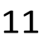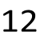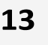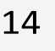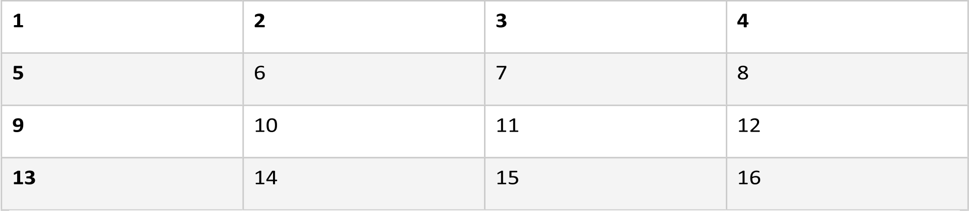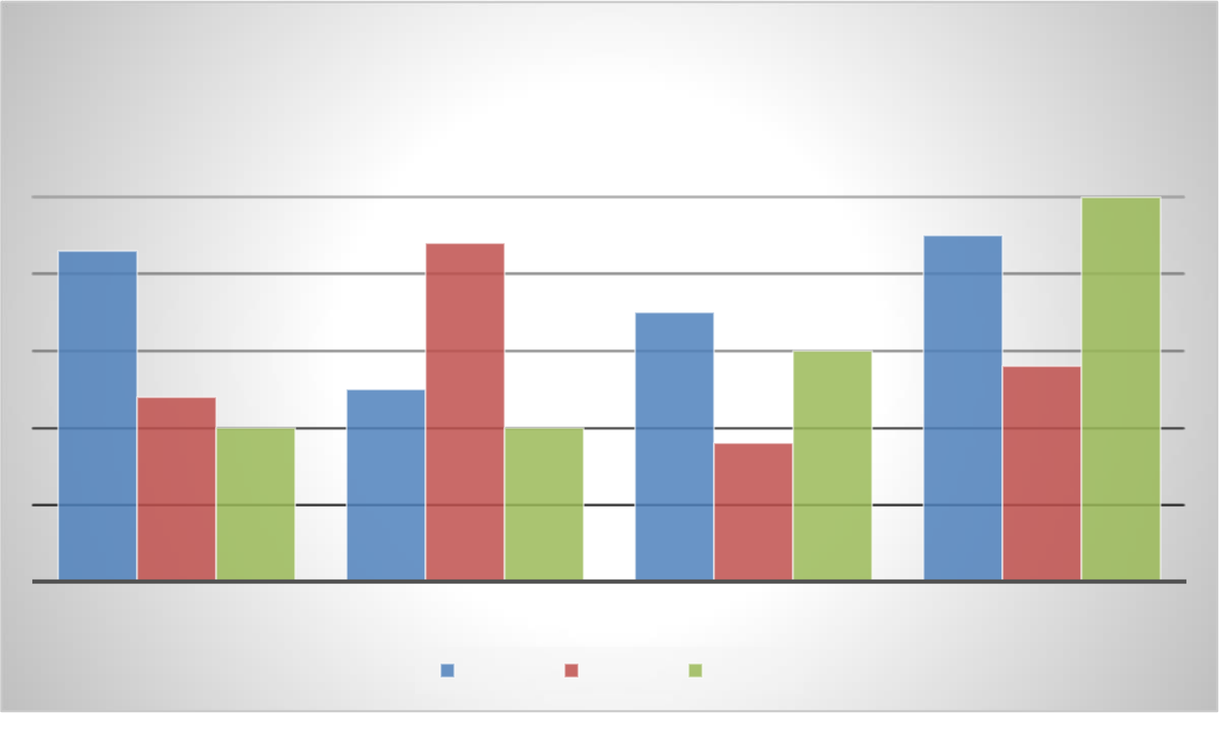

|  |  |  |  |  |  |  |  |
| --- | --- | --- | --- | --- | --- | --- | --- |
| 2 | 14 | 3 | 11 | 4 | 12 | 5 | 13 |
| 6 | 7 | 8 | 9 |
| 10 |
| 15 | 16 |



Morbi eu hendrerit arcu. Nullam ante quam, congue at libero id, lacinia dictum dolor. Sed tellus erat, semper vitae nulla vitae, euismod feugiat ante. Ut vehicula non mi blandit pulvinar. Fusce eu massa a ante tempus sodales a eget nunc. Pellentesque suscipit pharetra dolor quis commodo. Nunc eu mauris augue. Ut tincidunt arcu a congue porta. Curabitur feugiat libero vel dictum dictum. Donec mollis nunc sed purus finibus porttitor.

Cras rhoncus elit sit amet ante laoreet dapibus. Donec semper quis mi in ultricies. Phasellus fringilla vel sem nec ultricies. Sed vulputate risus id purus tincidunt, quis porta nunc rhoncus. In sit amet urna ut nulla aliquam aliquam. Duis lacinia risus at dolor venenatis lacinia. Aliquam et eros ac risus semper vulputate quis id urna. Vivamus cursus mollis nibh. Suspendisse ullamcorper dictum pharetra. Sed vitae elit erat. Nam iaculis metus quam, a semper mauris facilisis et. Ut a mollis metus, id imperdiet sem. Fusce et felis ac lorem facilisis feugiat. Nullam lorem dui, sodales eu ornare ac, dignissim non turpis.

|  |  |  |  |  |  |  |  |  |  |  |  |  |  |  |  |  |  |  |  |  |  |  |  |  |  |  |  |  |  |  |  |  |  |  |  |  |  |  |  |  |  |  |  |  |  |  |  |  |  |  |  |  |  |  |  |  |  |  |  |  |  |  |  |  |  |  |  |  |  |  |  |  |  |  |  |  |  |  |  |  |  |  |  |  |  |  |  |  |  |  |  |  |  |  |  |  |  |  |  |  |  |  |  |  |  |  |  |  |  |  |  |  |  |  |  |  |  |  |  |  |  |  |  |  |  |  |  |  |  |  |  |  |  |  |  |  |  |  |  |  |  |  |  |  |  |  |  |  |  |  |  |  |  |  |  |  |  |  |  |  |  |  |  |  |  |  |  |  |  |  |  |  |  |  |  |  |  |  |  |  |  |  |  |  |  |  |  |  |  |
| --- | --- | --- | --- | --- | --- | --- | --- | --- | --- | --- | --- | --- | --- | --- | --- | --- | --- | --- | --- | --- | --- | --- | --- | --- | --- | --- | --- | --- | --- | --- | --- | --- | --- | --- | --- | --- | --- | --- | --- | --- | --- | --- | --- | --- | --- | --- | --- | --- | --- | --- | --- | --- | --- | --- | --- | --- | --- | --- | --- | --- | --- | --- | --- | --- | --- | --- | --- | --- | --- | --- | --- | --- | --- | --- | --- | --- | --- | --- | --- | --- | --- | --- | --- | --- | --- | --- | --- | --- | --- | --- | --- | --- | --- | --- | --- | --- | --- | --- | --- | --- | --- | --- | --- | --- | --- | --- | --- | --- | --- | --- | --- | --- | --- | --- | --- | --- | --- | --- | --- | --- | --- | --- | --- | --- | --- | --- | --- | --- | --- | --- | --- | --- | --- | --- | --- | --- | --- | --- | --- | --- | --- | --- | --- | --- | --- | --- | --- | --- | --- | --- | --- | --- | --- | --- | --- | --- | --- | --- | --- | --- | --- | --- | --- | --- | --- | --- | --- | --- | --- | --- | --- | --- | --- | --- | --- | --- | --- | --- | --- | --- | --- | --- | --- | --- | --- | --- | --- | --- | --- |
| **Chart Title**   |  |  |  |  |  |  |  |  |  |  |  |  |  |  |  |  |  | | --- | --- | --- | --- | --- | --- | --- | --- | --- | --- | --- | --- | --- | --- | --- | --- | --- | |  |  |  |  |  |  |  |  |  |  |  |  |  |  |  | **5** |  | |  |  |  |  |  |  |  |  |  |  |  |  |  |  |  | |  |  |  |  |  |  |  |  |  |  |  |  |  |  |  | |  | **4.3** |  |  |  |  | **4.4** |  |  |  |  |  |  | **4.5** |  | |  |  |  |  |  |  |  |  |  | **3.5** |  |  |  |  |  | |  |  |  |  |  |  |  |  |  |  |  |  |  |  |  | |  |  |  |  |  |  |  |  |  |  |  | **3** |  |  |  | |  |  |  |  |  |  |  |  |  |  |  |  |  |  |  | |  |  |  |  |  | **2.5** |  |  |  |  |  |  |  |  | **2.8** | |  |  | **2.4** |  |  |  |  |  |  |  |  |  |  |  |  | |  |  |  | **2** |  |  |  | **2** |  |  | **1.8** |  |  |  |  |  |  |  |  |  |  |  |  |  | | --- | --- | --- | --- | --- | --- | --- | --- | | CATEGORY 1 | CATEGORY 2 | |  |  | CATEGORY 3 | | CATEGORY 4 | |  | |  |  | | --- | --- | |  |  | | Series 1 | |  |  | | --- | --- | |  |  | | Series 2 | |  |  | | --- | --- | |  |  | | Series 3 |  | |

Vivamus vestibulum massa ut pharetra egestas. Morbi molestie orci leo, vel eleifend nisi efficitur ut. Curabitur aliquam commodo lectus et luctus. Vivamus nunc leo, mollis finibus sapien at, tincidunt dignissim justo. Aenean dictum non tortor id feugiat. Curabitur at risus in libero maximus euismod quis in justo. Pellentesque quis lorem quis ligula aliquam congue et eget ex. Fusce cursus, nibh eget vestibulum fringilla, mauris eros tincidunt ante, 1

et interdum arcu ipsum eu velit. Praesent pharetra ac massa at tempor. Phasellus nulla lectus, interdum et faucibus quis, egestas quis tellus.

|  |  |  |  |
| --- | --- | --- | --- |
| **1** | **2** | **3** | **4** |
| **5** | 6 | 7 | 8 |
| **9** | 10 | 11 | 12 |
| **13** | 14 | 15 | 16 |

Aenean auctor mattis purus, vitae efficitur ex dictum ac. Sed ornare augue orci, eu fermentum felis lobortis eu. Sed dignissim mi ac nisi molestie feugiat. Ut dapibus felis a ligula ornare, sit amet tincidunt lorem venenatis. Sed pretium nunc sit amet libero ornare, ac ornare velit ornare. Suspendisse pretium tortor vulputate, cursus mi quis, pulvinar odio. Ut facilisis ultrices ex, in tincidunt nibh tempus nec. Nam enim leo, rhoncus sit amet urna non, ultrices lobortis est. Maecenas vel sem vitae est eleifend vulputate. Integer luctus consectetur enim, ac bibendum eros elementum eget. Donec eget nisl eget quam laoreet luctus. Donec quis odio eget lorem vulputate aliquet vel sed quam. Etiam eu lectus posuere, mollis ante et, venenatis metus. Nulla vestibulum nunc at metus egestas dapibus. Nulla a imperdiet diam. Maecenas id sagittis orci.

Nullam pretium faucibus fermentum. Curabitur mi nisi, fringilla eget auctor ac, commodo in justo. Suspendisse potenti. Nam lorem risus, lacinia quis semper vel, condimentum quis massa. Etiam dictum consequat libero, quis facilisis augue luctus id. Nulla sit amet fermentum est. Phasellus malesuada nisi non urna venenatis volutpat. Sed lorem metus, tempus quis mauris quis, commodo aliquam sapien.

|  |  |  |  |
| --- | --- | --- | --- |
| **1** | **2** | **3** | **4** |
| **5** | 6 | 7 | 8 |
| **9** | 10 | 11 | 12 |
| **13** | 14 | 15 | 16 |

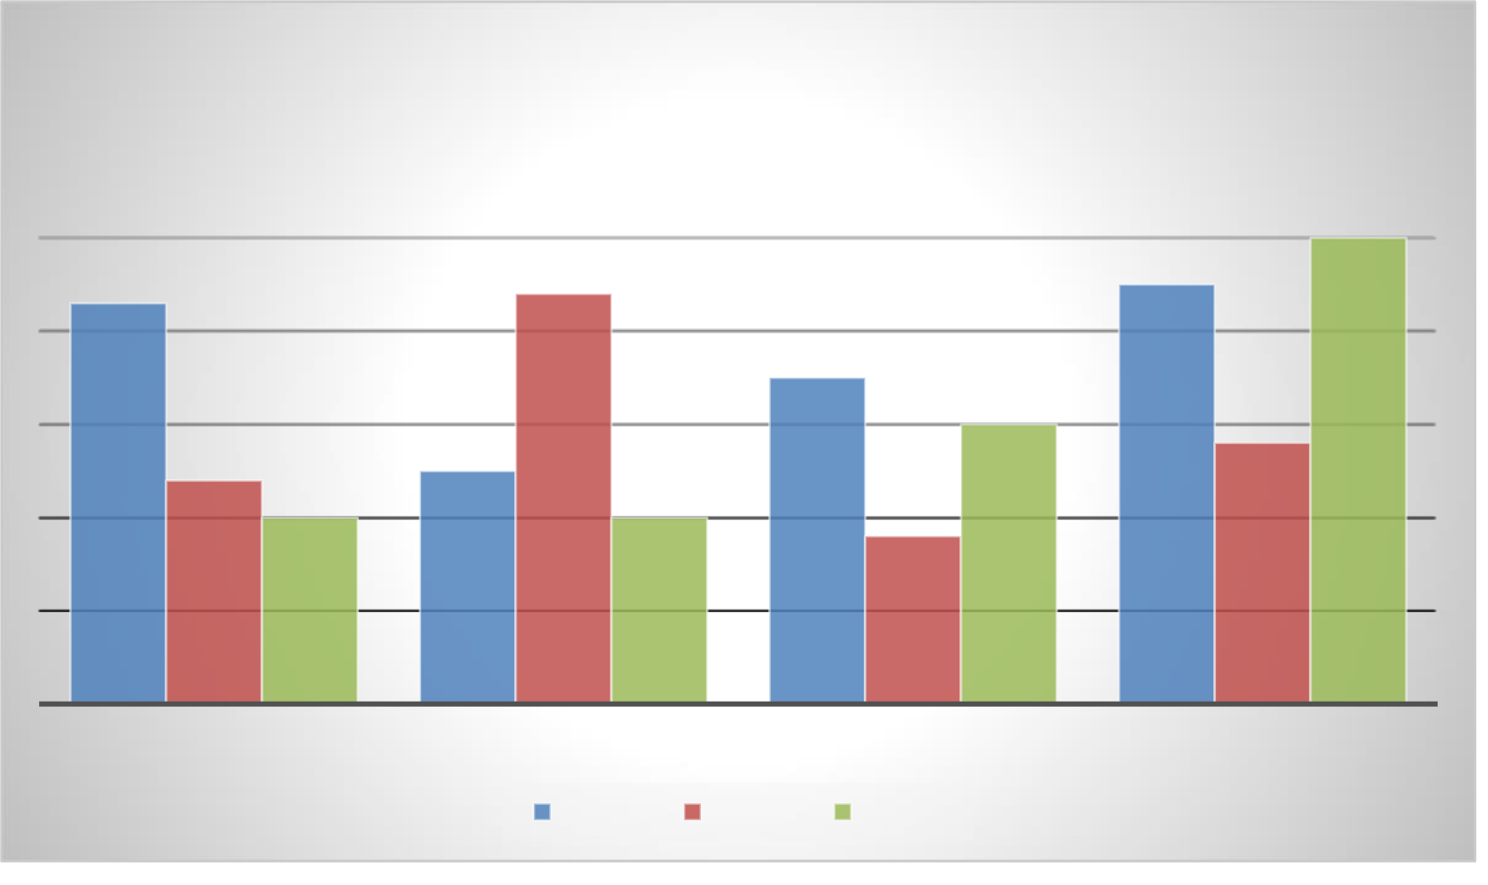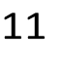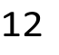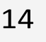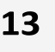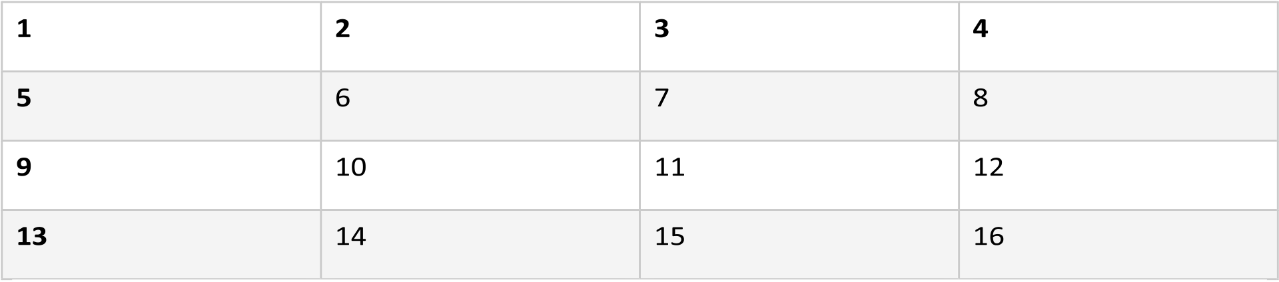

|  |  |  |  |  |  |  |  |  |  |  |  |  |  |  |  |  |  |  |  |  |  |  |  |  |  |  |  |  |  |  |  |  |  |  |  |  |  |  |  |  |  |  |  |  |  |  |  |  |  |  |  |  |  |  |  |  |  |  |  |  |  |  |  |  |  |  |  |  |  |  |  |  |  |  |  |  |  |  |  |  |  |  |  |  |  |  |  |  |  |  |  |  |  |  |  |  |  |  |  |  |  |  |  |  |  |  |  |  |  |  |  |  |  |  |  |  |  |  |  |  |  |  |  |  |  |  |  |  |  |  |  |  |  |  |  |  |  |  |  |  |  |  |  |  |  |  |  |  |  |  |  |  |  |  |  |  |  |  |  |  |  |  |  |  |  |  |  |  |  |  |  |  |  |  |  |  |  |  |  |  |  |  |  |  |  |  |  |  |  |
| --- | --- | --- | --- | --- | --- | --- | --- | --- | --- | --- | --- | --- | --- | --- | --- | --- | --- | --- | --- | --- | --- | --- | --- | --- | --- | --- | --- | --- | --- | --- | --- | --- | --- | --- | --- | --- | --- | --- | --- | --- | --- | --- | --- | --- | --- | --- | --- | --- | --- | --- | --- | --- | --- | --- | --- | --- | --- | --- | --- | --- | --- | --- | --- | --- | --- | --- | --- | --- | --- | --- | --- | --- | --- | --- | --- | --- | --- | --- | --- | --- | --- | --- | --- | --- | --- | --- | --- | --- | --- | --- | --- | --- | --- | --- | --- | --- | --- | --- | --- | --- | --- | --- | --- | --- | --- | --- | --- | --- | --- | --- | --- | --- | --- | --- | --- | --- | --- | --- | --- | --- | --- | --- | --- | --- | --- | --- | --- | --- | --- | --- | --- | --- | --- | --- | --- | --- | --- | --- | --- | --- | --- | --- | --- | --- | --- | --- | --- | --- | --- | --- | --- | --- | --- | --- | --- | --- | --- | --- | --- | --- | --- | --- | --- | --- | --- | --- | --- | --- | --- | --- | --- | --- | --- | --- | --- | --- | --- | --- | --- | --- | --- | --- | --- | --- | --- | --- | --- | --- | --- |
| **Chart Title**   |  |  |  |  |  |  |  |  |  |  |  |  |  |  |  |  |  | | --- | --- | --- | --- | --- | --- | --- | --- | --- | --- | --- | --- | --- | --- | --- | --- | --- | |  |  |  |  |  |  |  |  |  |  |  |  |  |  |  | **5** |  | |  |  |  |  |  |  |  |  |  |  |  |  |  |  |  | |  |  |  |  |  |  |  |  |  |  |  |  |  |  |  | |  | **4.3** |  |  |  |  | **4.4** |  |  |  |  |  |  | **4.5** |  | |  |  |  |  |  |  |  |  |  | **3.5** |  |  |  |  |  | |  |  |  |  |  |  |  |  |  |  |  |  |  |  |  | |  |  |  |  |  |  |  |  |  |  |  | **3** |  |  |  | |  |  |  |  |  |  |  |  |  |  |  |  |  |  |  | |  |  |  |  |  | **2.5** |  |  |  |  |  |  |  |  | **2.8** | |  |  | **2.4** |  |  |  |  |  |  |  |  |  |  |  |  | |  |  |  | **2** |  |  |  | **2** |  |  | **1.8** |  |  |  |  |  |  |  |  |  |  |  |  |  | | --- | --- | --- | --- | --- | --- | --- | --- | | CATEGORY 1 | CATEGORY 2 | |  |  | CATEGORY 3 | | CATEGORY 4 | |  | |  | | --- | |  | |  | | Series 1 | |  | | --- | |  | |  | | Series 2 | |  | | --- | |  | |  | | Series 3 1 |  | |

Nullam vel elementum elit. Pellentesque et bibendum metus, quis tincidunt dolor. Sed nec sem sit amet risus vulputate malesuada. Duis in fringilla lectus. Quisque sed massa vitae ante porta dapibus. Mauris aliquam malesuada mattis. Aliquam at ligula vel magna tincidunt consectetur ac nec ex. Integer gravida quam eget mauris cursus bibendum. Vivamus metus leo, consectetur id interdum egestas, aliquam in orci. Ut at blandit velit. Nunc at orci odio. Etiam dapibus ac arcu in eleifend. Ut quam odio, aliquam in egestas sit amet, tincidunt in massa. Donec at aliquet arcu. Donec quis ipsum elementum enim congue posuere ac quis dolor. Nam quis justo vel mauris pulvinar vulputate vel at odio.

|  |  |  |  |  |  |  |  |
| --- | --- | --- | --- | --- | --- | --- | --- |
| 2 | 14 | 3 | 11 | 4 | 12 | 5 | 13 |
| 6 | 7 | 8 | 9 |
| 10 |
| 15 | 16 |



Maecenas eu ligula eget eros placerat vehicula ut ut odio. Aenean tincidunt velit vel neque efficitur, ut porta purus scelerisque. In dignissim cursus magna, quis iaculis sapien viverra quis. Integer vitae metus ut urna fermentum rutrum. Suspendisse nec purus hendrerit dolor tempor porttitor. Nullam volutpat, est quis convallis tristique, tellus leo dictum lorem, laoreet tristique libero odio id mi. Pellentesque viverra tempor augue, a sodales nisi convallis id. Mauris vel dolor id orci aliquam rhoncus quis vel sem. Fusce mollis non lectus eu tristique.

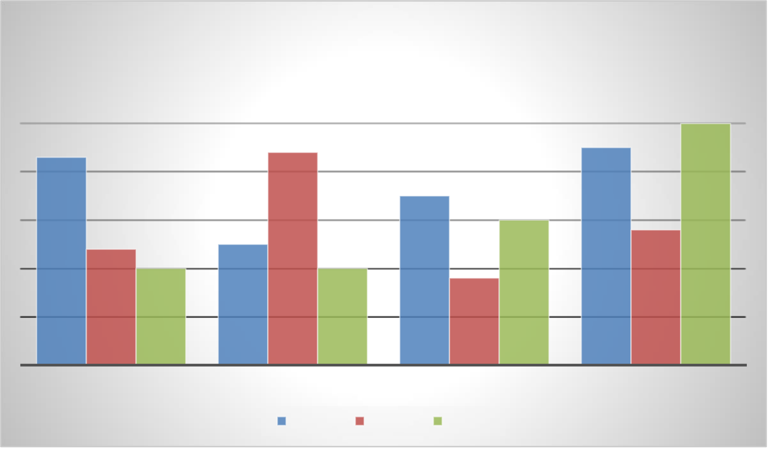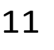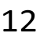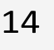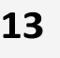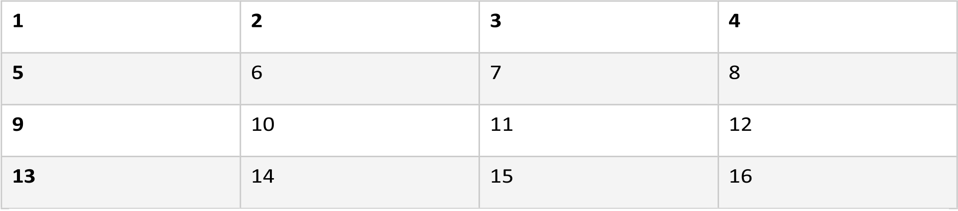

|  |  |  |  |  |  |  |  |  |  |  |  |  |  |  |  |  |  |  |  |  |  |  |  |  |  |  |  |  |  |  |  |  |  |  |  |  |  |  |  |  |  |  |  |  |  |  |  |  |  |  |  |  |  |  |  |  |  |  |  |  |  |  |  |  |  |  |  |  |  |  |  |  |  |  |  |  |  |  |  |  |  |  |  |  |  |  |  |  |  |  |  |  |  |  |  |  |  |  |  |  |  |  |  |  |  |  |  |  |  |  |  |  |  |  |  |  |  |  |  |  |  |  |  |  |  |  |  |  |  |  |  |  |  |  |  |  |  |  |  |  |  |  |  |  |  |  |  |  |  |  |  |  |  |  |  |  |  |  |  |  |  |  |  |  |  |  |  |  |  |  |  |  |  |  |  |  |  |  |  |  |  |  |  |  |  |  |  |  |  |
| --- | --- | --- | --- | --- | --- | --- | --- | --- | --- | --- | --- | --- | --- | --- | --- | --- | --- | --- | --- | --- | --- | --- | --- | --- | --- | --- | --- | --- | --- | --- | --- | --- | --- | --- | --- | --- | --- | --- | --- | --- | --- | --- | --- | --- | --- | --- | --- | --- | --- | --- | --- | --- | --- | --- | --- | --- | --- | --- | --- | --- | --- | --- | --- | --- | --- | --- | --- | --- | --- | --- | --- | --- | --- | --- | --- | --- | --- | --- | --- | --- | --- | --- | --- | --- | --- | --- | --- | --- | --- | --- | --- | --- | --- | --- | --- | --- | --- | --- | --- | --- | --- | --- | --- | --- | --- | --- | --- | --- | --- | --- | --- | --- | --- | --- | --- | --- | --- | --- | --- | --- | --- | --- | --- | --- | --- | --- | --- | --- | --- | --- | --- | --- | --- | --- | --- | --- | --- | --- | --- | --- | --- | --- | --- | --- | --- | --- | --- | --- | --- | --- | --- | --- | --- | --- | --- | --- | --- | --- | --- | --- | --- | --- | --- | --- | --- | --- | --- | --- | --- | --- | --- | --- | --- | --- | --- | --- | --- | --- | --- | --- | --- | --- | --- | --- | --- | --- | --- | --- | --- |
| **Chart Title**   |  |  |  |  |  |  |  |  |  |  |  |  |  |  |  |  |  | | --- | --- | --- | --- | --- | --- | --- | --- | --- | --- | --- | --- | --- | --- | --- | --- | --- | |  |  |  |  |  |  |  |  |  |  |  |  |  |  |  | **5** |  | |  |  |  |  |  |  |  |  |  |  |  |  |  |  |  | |  |  |  |  |  |  |  |  |  |  |  |  |  |  |  | |  | **4.3** |  |  |  |  | **4.4** |  |  |  |  |  |  | **4.5** |  | |  |  |  |  |  |  |  |  |  | **3.5** |  |  |  |  |  | |  |  |  |  |  |  |  |  |  |  |  |  |  |  |  | |  |  |  |  |  |  |  |  |  |  |  | **3** |  |  |  | |  |  |  |  |  |  |  |  |  |  |  |  |  |  |  | |  |  |  |  |  | **2.5** |  |  |  |  |  |  |  |  | **2.8** | |  |  | **2.4** |  |  |  |  |  |  |  |  |  |  |  |  | |  |  |  | **2** |  |  |  | **2** |  |  | **1.8** |  |  |  |  |  |  |  |  |  |  |  |  |  | | --- | --- | --- | --- | --- | --- | --- | --- | | CATEGORY 1 | CATEGORY 2 | |  |  | CATEGORY 3 | | CATEGORY 4 | |  | |  | | --- | |  | |  | | Series 1 | |  | | --- | |  | |  | | Series 2 | |  | | --- | |  | |  | | Series 3 1 |  | |

Proin tempor sapien quis pretium elementum. Donec mollis mauris quis nulla tincidunt rutrum. Fusce semper feugiat arcu a imperdiet. Donec eleifend finibus mi ac egestas. Maecenas placerat odio non hendrerit vulputate. In facilisis, velit vitae facilisis malesuada, nunc nisi ullamcorper nulla, vitae blandit nunc elit eu odio. Vivamus iaculis, risus et tincidunt tincidunt, leo felis condimentum risus, in semper quam mi quis felis. Vivamus pulvinar eros turpis, ac lobortis velit hendrerit convallis. Maecenas sed consequat libero, eget sagittis neque. Vestibulum ante ipsum primis in faucibus orci luctus et ultrices posuere cubilia curae;

Donec commodo odio posuere justo molestie placerat. Praesent sagittis commodo lectus et posuere. Sed dapibus justo a consequat sollicitudin. Maecenas non condimentum ligula. Vestibulum ultrices elit vel maximus porttitor. Sed elementum urna ac est tempus efficitur.

Interdum et malesuada fames ac ante ipsum primis in faucibus. Nullam pellentesque sagittis vulputate. Curabitur at dolor sapien.

|  |  |  |  |  |  |  |  |
| --- | --- | --- | --- | --- | --- | --- | --- |
| 2 | 14 | 3 | 11 | 4 | 12 | 5 | 13 |
| 6 | 7 | 8 | 9 |
| 10 |
| 15 | 16 |



Nulla eu neque hendrerit, vehicula odio non, tincidunt eros. Phasellus neque arcu, varius non arcu fermentum, vehicula feugiat nisl. Maecenas vitae accumsan dolor, et eleifend ipsum. Nunc in suscipit turpis. Quisque quis aliquam arcu, vel porta sem. Nunc sed egestas diam. Proin orci urna, pulvinar at egestas ac, vestibulum id ante. Fusce at risus eget tellus consectetur fringilla sed ut dui. Ut congue sapien non est vestibulum, in facilisis metus

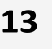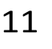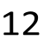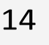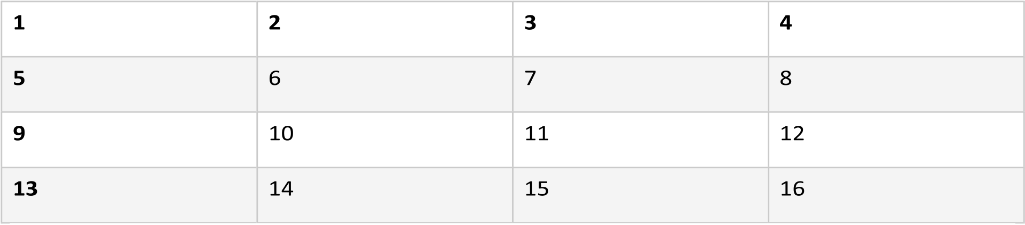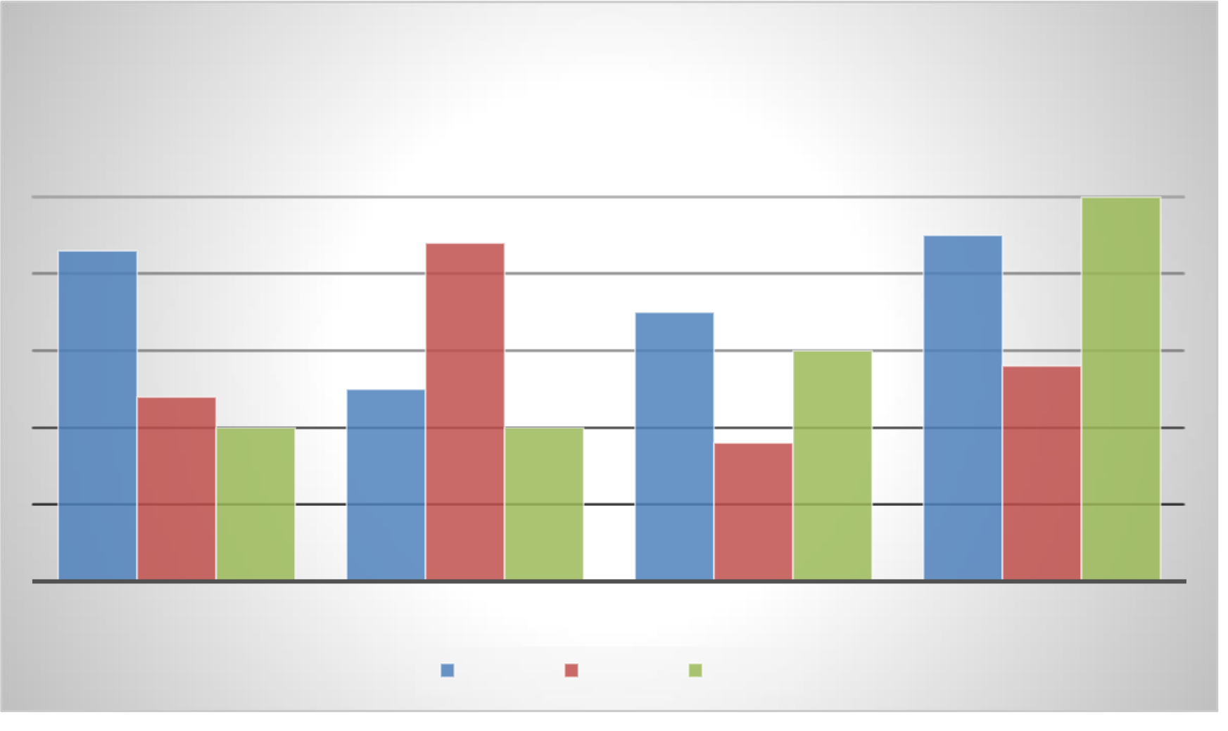

cursus. Curabitur gravida quam nec ipsum rhoncus, nec malesuada nibh tincidunt. Donec ornare ultrices quam, non luctus est mattis eu. Phasellus eget ornare ex.

|  |  |  |  |  |  |  |  |
| --- | --- | --- | --- | --- | --- | --- | --- |
| 2 | 14 | 3 | 11 | 4 | 12 | 5 | 13 |
| 6 | 7 | 8 | 9 |
| 10 |
| 15 | 16 |



|  |  |  |  |  |  |  |  |  |  |  |  |  |  |  |  |  |  |  |  |  |  |  |  |  |  |  |  |  |  |  |  |  |  |  |  |  |  |  |  |  |  |  |  |  |  |  |  |  |  |  |  |  |  |  |  |  |  |  |  |  |  |  |  |  |  |  |  |  |  |  |  |  |  |  |  |  |  |  |  |  |  |  |  |  |  |  |  |  |  |  |  |  |  |  |  |  |  |  |  |  |  |  |  |  |  |  |  |  |  |  |  |  |  |  |  |  |  |  |  |  |  |  |  |  |  |  |  |  |  |  |  |  |  |  |  |  |  |  |  |  |  |  |  |  |  |  |  |  |  |  |  |  |  |  |  |  |  |  |  |  |  |  |  |  |  |  |  |  |  |  |  |  |  |  |  |  |  |  |  |  |  |  |  |  |  |  |  |  |  |
| --- | --- | --- | --- | --- | --- | --- | --- | --- | --- | --- | --- | --- | --- | --- | --- | --- | --- | --- | --- | --- | --- | --- | --- | --- | --- | --- | --- | --- | --- | --- | --- | --- | --- | --- | --- | --- | --- | --- | --- | --- | --- | --- | --- | --- | --- | --- | --- | --- | --- | --- | --- | --- | --- | --- | --- | --- | --- | --- | --- | --- | --- | --- | --- | --- | --- | --- | --- | --- | --- | --- | --- | --- | --- | --- | --- | --- | --- | --- | --- | --- | --- | --- | --- | --- | --- | --- | --- | --- | --- | --- | --- | --- | --- | --- | --- | --- | --- | --- | --- | --- | --- | --- | --- | --- | --- | --- | --- | --- | --- | --- | --- | --- | --- | --- | --- | --- | --- | --- | --- | --- | --- | --- | --- | --- | --- | --- | --- | --- | --- | --- | --- | --- | --- | --- | --- | --- | --- | --- | --- | --- | --- | --- | --- | --- | --- | --- | --- | --- | --- | --- | --- | --- | --- | --- | --- | --- | --- | --- | --- | --- | --- | --- | --- | --- | --- | --- | --- | --- | --- | --- | --- | --- | --- | --- | --- | --- | --- | --- | --- | --- | --- | --- | --- | --- | --- | --- | --- | --- | --- |
| **Chart Title**   |  |  |  |  |  |  |  |  |  |  |  |  |  |  |  |  |  | | --- | --- | --- | --- | --- | --- | --- | --- | --- | --- | --- | --- | --- | --- | --- | --- | --- | |  |  |  |  |  |  |  |  |  |  |  |  |  |  |  | **5** |  | |  |  |  |  |  |  |  |  |  |  |  |  |  |  |  | |  |  |  |  |  |  |  |  |  |  |  |  |  |  |  | |  | **4.3** |  |  |  |  | **4.4** |  |  |  |  |  |  | **4.5** |  | |  |  |  |  |  |  |  |  |  | **3.5** |  |  |  |  |  | |  |  |  |  |  |  |  |  |  |  |  |  |  |  |  | |  |  |  |  |  |  |  |  |  |  |  | **3** |  |  |  | |  |  |  |  |  |  |  |  |  |  |  |  |  |  |  | |  |  |  |  |  | **2.5** |  |  |  |  |  |  |  |  | **2.8** | |  |  | **2.4** |  |  |  |  |  |  |  |  |  |  |  |  | |  |  |  | **2** |  |  |  | **2** |  |  | **1.8** |  |  |  |  |  |  |  |  |  |  |  |  |  | | --- | --- | --- | --- | --- | --- | --- | --- | | CATEGORY 1 | CATEGORY 2 | |  |  | CATEGORY 3 | | CATEGORY 4 | |  | |  | | --- | |  | |  | | Series 1 | |  | | --- | |  | |  | | Series 2 | |  | | --- | |  | |  | | Series 3 |  | |

In tellus sem, convallis vel dolor lacinia, ultrices cursus mauris. Ut fermentum, nisi eu bibendum pretium, mi lectus aliquam ligula, sit amet accumsan dolor velit ut nulla. Vestibulum molestie libero eu purus sagittis, ac ornare tellus consectetur. Nullam nulla magna, egestas et dolor convallis, porta ultrices lacus. Suspendisse potenti. Pellentesque aliquam rutrum ornare. Orci varius natoque penatibus et magnis dis parturient montes, nascetur ridiculus mus. Praesent imperdiet egestas lacus, elementum tristique nunc cursus sed. Vivamus dictum pharetra nunc a iaculis. Sed pellentesque nunc ante, ac viverra magna tempus tincidunt. Etiam non lacus quis lectus lobortis porta.

Fusce semper porta nulla vel consequat. Ut accumsan vulputate odio sit amet pharetra. Quisque pellentesque finibus lacus, at ullamcorper nunc. Sed sollicitudin sit amet ligula sed semper. Vivamus porta velit est, vitae luctus dolor iaculis nec. Curabitur dictum consectetur lorem, vitae vehicula tortor mollis id. Integer cursus odio risus, nec varius risus gravida vitae. Aenean lacinia erat sed aliquet gravida. Donec mattis arcu leo, ultricies vehicula tellus vehicula faucibus. 1

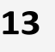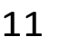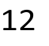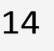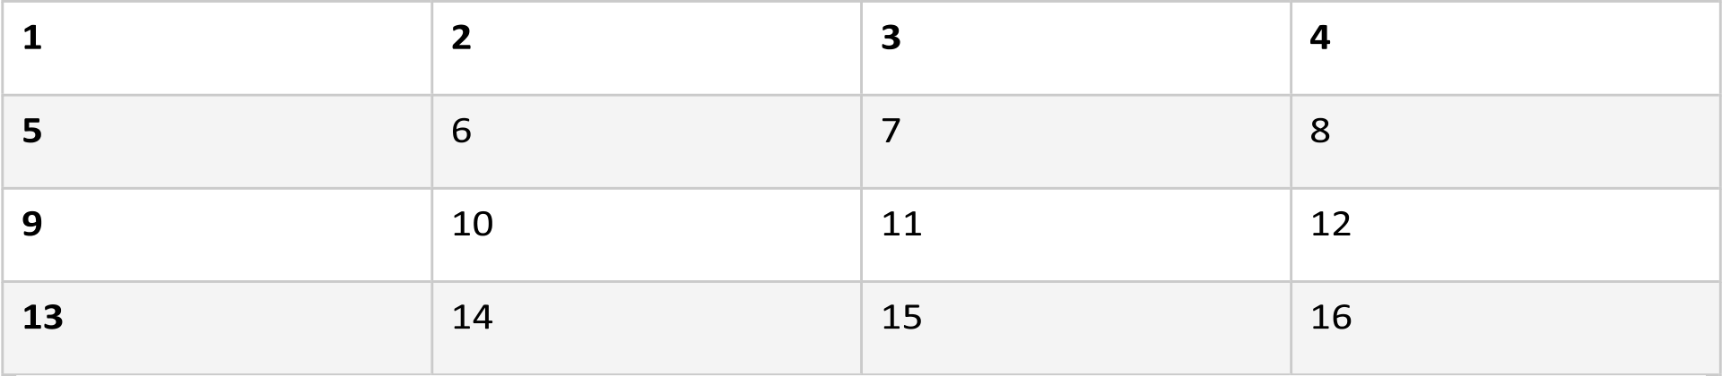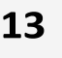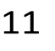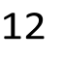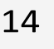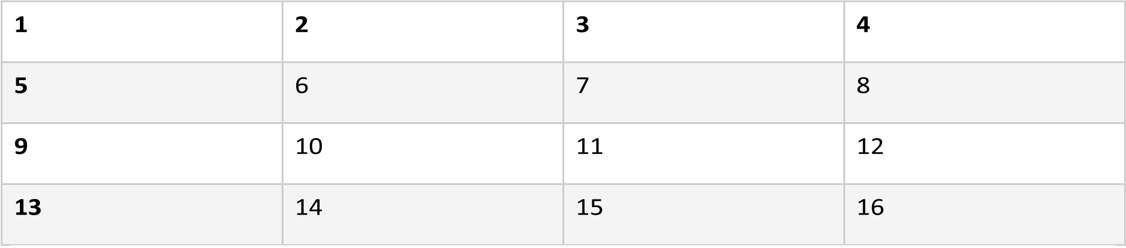

|  |  |  |  |  |  |  |  |
| --- | --- | --- | --- | --- | --- | --- | --- |
| 2 | 14 | 3 | 11 | 4 | 12 | 5 | 13 |
| 6 | 7 | 8 | 9 |
| 10 |
| 15 | 16 |

 1

Aenean in aliquet tellus. Sed eget libero posuere, euismod tellus vitae, porta tortor. Curabitur consectetur, eros ac maximus dictum, mi nisl tempus tortor, ac aliquam dui libero sed quam. Nunc eget ante vulputate, sodales orci volutpat, maximus nulla. Pellentesque sollicitudin aliquet scelerisque. Aenean facilisis volutpat fringilla. Sed finibus iaculis metus, non congue sem aliquet eu. Nam sollicitudin metus augue. Vestibulum vel nisl at sapien sollicitudin ornare eget in lectus. Donec condimentum nunc at convallis placerat. Maecenas gravida, metus at ornare aliquam, erat mi pellentesque augue, at feugiat orci risus eu felis.

|  |  |  |  |  |  |  |  |
| --- | --- | --- | --- | --- | --- | --- | --- |
| 2 | 14 | 3 | 11 | 4 | 12 | 5 | 13 |
| 6 | 7 | 8 | 9 |
| 10 |
| 15 | 16 |



Sed at suscipit nulla. Quisque orci est, congue et diam quis, pharetra posuere augue. Sed ipsum est, vehicula a enim non, venenatis vehicula leo. Suspendisse quis quam nec felis vehicula lobortis. Aliquam egestas nec leo vitae dapibus. Cras vel libero pretium, iaculis risus vitae, sollicitudin massa. Integer mi nunc, ultrices a aliquam volutpat, placerat sed mauris. Sed viverra a lacus vitae lobortis. Nam vestibulum quam at feugiat dignissim. Mauris vel augue ex. Sed turpis nisi, aliquam vitae varius vitae, sollicitudin in tortor. Phasellus ex sem, gravida eleifend neque eget, dignissim cursus justo. Suspendisse faucibus dictum orci, eget facilisis orci tincidunt sed. Nam pharetra tempor felis a iaculis. Praesent at neque nec ex auctor consectetur quis ac metus. Praesent dignissim, elit vel imperdiet lobortis, purus orci sodales nisl, ac efficitur dui neque et libero.

Curabitur fringilla quam eu rutrum consequat. Vivamus rutrum ipsum eget nisl pharetra imperdiet. Donec iaculis posuere vehicula. Proin imperdiet enim in condimentum pulvinar. Nunc in semper eros. Vivamus tempus neque id volutpat euismod. Aenean tincidunt risus est, in vestibulum dui fringilla sit amet. Duis interdum libero urna, nec vulputate urna pharetra in.

Cras ac nunc eu ex hendrerit lacinia sit amet ut ante. Quisque molestie, diam id venenatis dapibus, orci neque fringilla eros, vitae tincidunt purus purus ut massa. Morbi sed mi tincidunt nibh tincidunt vehicula ac eget justo. Duis eu cursus ipsum, quis tempor nulla. In euismod risus quis enim ultricies, accumsan feugiat massa aliquam. Duis id pellentesque mauris, quis blandit justo. Donec placerat urna et massa posuere rutrum. Integer eleifend risus sem, sed iaculis massa condimentum eget. Pellentesque pharetra, sem nec maximus fringilla, augue ipsum cursus odio, commodo molestie massa tortor et urna. Cras finibus a nulla ut mollis. 1

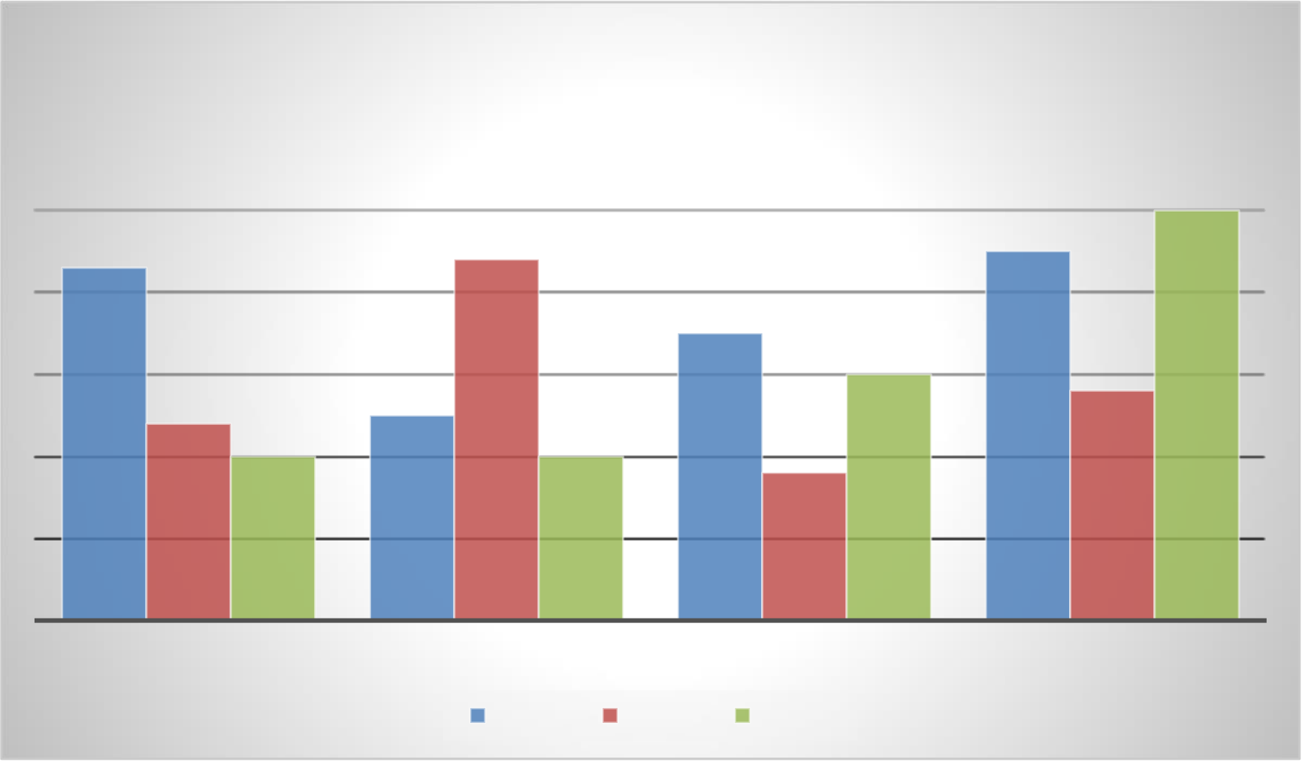

|  |  |  |  |  |  |  |  |  |  |  |  |  |  |  |  |  |  |  |  |  |  |  |  |  |  |  |  |  |  |  |  |  |  |  |  |  |  |  |  |  |  |  |  |  |  |  |  |  |  |  |  |  |  |  |  |  |  |  |  |  |  |  |  |  |  |  |  |  |  |  |  |  |  |  |  |  |  |  |  |  |  |  |  |  |  |  |  |  |  |  |  |  |  |  |  |  |  |  |  |  |  |  |  |  |  |  |  |  |  |  |  |  |  |  |  |  |  |  |  |  |  |  |  |  |  |  |  |  |  |  |  |  |  |  |  |  |  |  |  |  |  |  |  |  |  |  |  |  |  |  |  |  |  |  |  |  |  |  |  |  |  |  |  |  |  |  |  |  |  |  |  |  |  |  |  |  |  |  |  |  |  |  |  |  |  |  |  |  |  |
| --- | --- | --- | --- | --- | --- | --- | --- | --- | --- | --- | --- | --- | --- | --- | --- | --- | --- | --- | --- | --- | --- | --- | --- | --- | --- | --- | --- | --- | --- | --- | --- | --- | --- | --- | --- | --- | --- | --- | --- | --- | --- | --- | --- | --- | --- | --- | --- | --- | --- | --- | --- | --- | --- | --- | --- | --- | --- | --- | --- | --- | --- | --- | --- | --- | --- | --- | --- | --- | --- | --- | --- | --- | --- | --- | --- | --- | --- | --- | --- | --- | --- | --- | --- | --- | --- | --- | --- | --- | --- | --- | --- | --- | --- | --- | --- | --- | --- | --- | --- | --- | --- | --- | --- | --- | --- | --- | --- | --- | --- | --- | --- | --- | --- | --- | --- | --- | --- | --- | --- | --- | --- | --- | --- | --- | --- | --- | --- | --- | --- | --- | --- | --- | --- | --- | --- | --- | --- | --- | --- | --- | --- | --- | --- | --- | --- | --- | --- | --- | --- | --- | --- | --- | --- | --- | --- | --- | --- | --- | --- | --- | --- | --- | --- | --- | --- | --- | --- | --- | --- | --- | --- | --- | --- | --- | --- | --- | --- | --- | --- | --- | --- | --- | --- | --- | --- | --- | --- | --- | --- |
| **Chart Title**   |  |  |  |  |  |  |  |  |  |  |  |  |  |  |  |  |  | | --- | --- | --- | --- | --- | --- | --- | --- | --- | --- | --- | --- | --- | --- | --- | --- | --- | |  |  |  |  |  |  |  |  |  |  |  |  |  |  |  | **5** |  | |  |  |  |  |  |  |  |  |  |  |  |  |  |  |  | |  |  |  |  |  |  |  |  |  |  |  |  |  |  |  | |  | **4.3** |  |  |  |  | **4.4** |  |  |  |  |  |  | **4.5** |  | |  |  |  |  |  |  |  |  |  | **3.5** |  |  |  |  |  | |  |  |  |  |  |  |  |  |  |  |  |  |  |  |  | |  |  |  |  |  |  |  |  |  |  |  | **3** |  |  |  | |  |  |  |  |  |  |  |  |  |  |  |  |  |  |  | |  |  |  |  |  | **2.5** |  |  |  |  |  |  |  |  | **2.8** | |  |  | **2.4** |  |  |  |  |  |  |  |  |  |  |  |  | |  |  |  | **2** |  |  |  | **2** |  |  | **1.8** |  |  |  |  |  |  |  |  |  |  |  |  |  | | --- | --- | --- | --- | --- | --- | --- | --- | | CATEGORY 1 | CATEGORY 2 | |  |  | CATEGORY 3 | | CATEGORY 4 | |  | |  | | --- | |  | |  | | Series 1 | |  | | --- | |  | |  | | Series 2 | |  | | --- | |  | |  | | Series 3 |  | |

Sed semper metus hendrerit purus pharetra, a dapibus turpis egestas. Cras dictum, ipsum ac dapibus blandit, turpis libero vehicula sem, at congue massa leo nec ipsum. Maecenas hendrerit mollis dolor, et ultricies nunc sollicitudin non. Nullam ipsum ligula, dapibus at tristique at, ultricies id nulla. Proin rhoncus tincidunt porta. Maecenas ullamcorper neque id fringilla tempor. Sed vel euismod eros. Ut ullamcorper urna sed lectus commodo, sed fermentum urna lacinia. Donec quis elit ullamcorper, sodales risus non, vulputate turpis. Nunc sit amet posuere nisl, id luctus risus. In maximus turpis sem, et malesuada ligula fermentum in. Ut tristique ante eget velit auctor, ut hendrerit eros rhoncus. Curabitur et tincidunt justo. Integer congue, ligula sit amet eleifend congue, risus libero tempor tellus, eget fringilla magna quam ac nisi. Phasellus tortor felis, malesuada non turpis quis, tincidunt varius nisi. Quisque laoreet rutrum vehicula.

Vestibulum id urna quis nulla pellentesque commodo et quis quam. Curabitur imperdiet risus quis quam posuere, condimentum lobortis neque bibendum. In enim metus, consequat vel enim eget, fermentum auctor mauris. Nullam gravida iaculis sapien eget porttitor. Donec eget urna egestas, vehicula nisl et, gravida turpis. Vivamus id vestibulum metus. Pellentesque tristique ligula et sodales egestas. Nullam facilisis eget dolor sit amet volutpat. Aenean nec eros lectus. Maecenas bibendum massa magna, quis eleifend tellus posuere id.

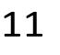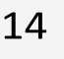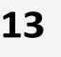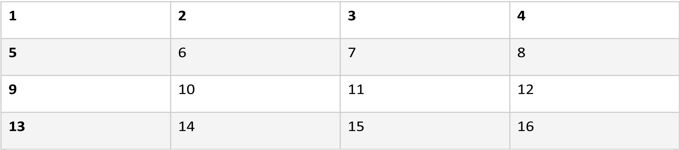

|  |  |  |  |  |  |  |  |  |  |  |  |  |  |  |  |  |  |  |  |  |  |  |  |  |  |  |  |  |  |  |  |  |  |  |  |  |  |  |  |  |  |  |  |  |  |  |  |  |  |  |  |  |  |  |  |  |  |  |  |  |  |  |  |  |  |  |  |  |  |  |  |  |  |  |  |  |  |  |  |  |  |  |  |  |  |  |  |  |  |  |  |  |  |  |  |  |  |  |  |  |  |  |  |  |  |  |  |  |  |  |  |  |  |  |  |  |  |  |  |  |  |  |  |  |  |  |  |  |  |  |  |  |  |  |  |  |  |  |  |  |  |  |  |  |  |  |  |  |  |  |  |  |  |  |  |  |  |  |  |  |  |  |  |  |  |  |  |  |  |  |  |  |  |  |  |  |  |  |  |  |  |  |  |  |  |  |  |  |  |
| --- | --- | --- | --- | --- | --- | --- | --- | --- | --- | --- | --- | --- | --- | --- | --- | --- | --- | --- | --- | --- | --- | --- | --- | --- | --- | --- | --- | --- | --- | --- | --- | --- | --- | --- | --- | --- | --- | --- | --- | --- | --- | --- | --- | --- | --- | --- | --- | --- | --- | --- | --- | --- | --- | --- | --- | --- | --- | --- | --- | --- | --- | --- | --- | --- | --- | --- | --- | --- | --- | --- | --- | --- | --- | --- | --- | --- | --- | --- | --- | --- | --- | --- | --- | --- | --- | --- | --- | --- | --- | --- | --- | --- | --- | --- | --- | --- | --- | --- | --- | --- | --- | --- | --- | --- | --- | --- | --- | --- | --- | --- | --- | --- | --- | --- | --- | --- | --- | --- | --- | --- | --- | --- | --- | --- | --- | --- | --- | --- | --- | --- | --- | --- | --- | --- | --- | --- | --- | --- | --- | --- | --- | --- | --- | --- | --- | --- | --- | --- | --- | --- | --- | --- | --- | --- | --- | --- | --- | --- | --- | --- | --- | --- | --- | --- | --- | --- | --- | --- | --- | --- | --- | --- | --- | --- | --- | --- | --- | --- | --- | --- | --- | --- | --- | --- | --- | --- | --- | --- | --- |
| **Chart Title**   |  |  |  |  |  |  |  |  |  |  |  |  |  |  |  |  |  | | --- | --- | --- | --- | --- | --- | --- | --- | --- | --- | --- | --- | --- | --- | --- | --- | --- | |  |  |  |  |  |  |  |  |  |  |  |  |  |  |  | **5** |  | |  |  |  |  |  |  |  |  |  |  |  |  |  |  |  | |  |  |  |  |  |  |  |  |  |  |  |  |  |  |  | |  | **4.3** |  |  |  |  | **4.4** |  |  |  |  |  |  | **4.5** |  | |  |  |  |  |  |  |  |  |  | **3.5** |  |  |  |  |  | |  |  |  |  |  |  |  |  |  |  |  |  |  |  |  | |  |  |  |  |  |  |  |  |  |  |  | **3** |  |  |  | |  |  |  |  |  |  |  |  |  |  |  |  |  |  |  | |  |  |  |  |  | **2.5** |  |  |  |  |  |  |  |  | **2.8** | |  |  | **2.4** |  |  |  |  |  |  |  |  |  |  |  |  | |  |  |  | **2** |  |  |  | **2** |  |  | **1.8** |  |  |  |  |  |  |  |  |  |  |  |  |  | | --- | --- | --- | --- | --- | --- | --- | --- | | CATEGORY 1 | CATEGORY 2 | |  |  | CATEGORY 3 | | CATEGORY 4 | |  | |  | | --- | |  | |  | | Series 1 | |  | | --- | |  | |  | | Series 2 | |  | | --- | |  | |  | | Series 3 1 |  | |

In viverra consequat erat ac efficitur. Morbi fringilla tortor id consequat volutpat. In nec felis tempor, suscipit velit vel, sollicitudin arcu. Donec placerat a augue a egestas. Fusce blandit in orci et viverra. Mauris in luctus odio. Pellentesque id lacus sit amet libero vestibulum pharetra vitae vel turpis. Donec dui velit, sodales at tortor nec, cursus mollis quam. Fusce aliquam efficitur mauris eu condimentum. Morbi faucibus rhoncus purus. Morbi cursus feugiat tellus, sit amet auctor purus aliquam eget. Fusce scelerisque erat sem, ut blandit risus tincidunt sed.

Nulla a tortor et nunc vehicula venenatis. Quisque sed diam massa. Cras vitae tellus et risus ultricies tempus. Donec tincidunt sapien sit amet lacus facilisis, eget porta dui tristique. Morbi euismod cursus tempus. Aliquam facilisis, elit pulvinar dapibus tristique, felis neque dictum lacus, id fermentum tellus quam eget purus. Integer non mi id dolor condimentum volutpat vel et dui. Quisque mollis, urna et eleifend molestie, dolor tortor bibendum nisi, accumsan eleifend dui magna vel lacus. Vestibulum congue dapibus sapien at egestas.

|  |  |  |  |  |  |  |  |
| --- | --- | --- | --- | --- | --- | --- | --- |
| 2 | 14 | 3 | 11 | 4 | 12 | 5 | 13 |
| 6 | 7 | 8 | 9 |
| 10 |
| 15 | 16 |



Nulla facilisi. Quisque nec mollis eros. Suspendisse pulvinar purus metus. Vivamus lectus augue, faucibus in commodo a, pellentesque quis risus. Vestibulum ante ipsum primis in faucibus orci luctus et ultrices posuere cubilia curae; Nam ultrices eros sed vehicula scelerisque. Phasellus a tortor fermentum, pretium magna nec, ultrices ipsum. Praesent sit amet ligula et lacus porttitor luctus. Maecenas sit amet commodo dolor. Praesent fermentum euismod nulla eu malesuada. Fusce porttitor sagittis mi. Fusce et pellentesque ante. Mauris

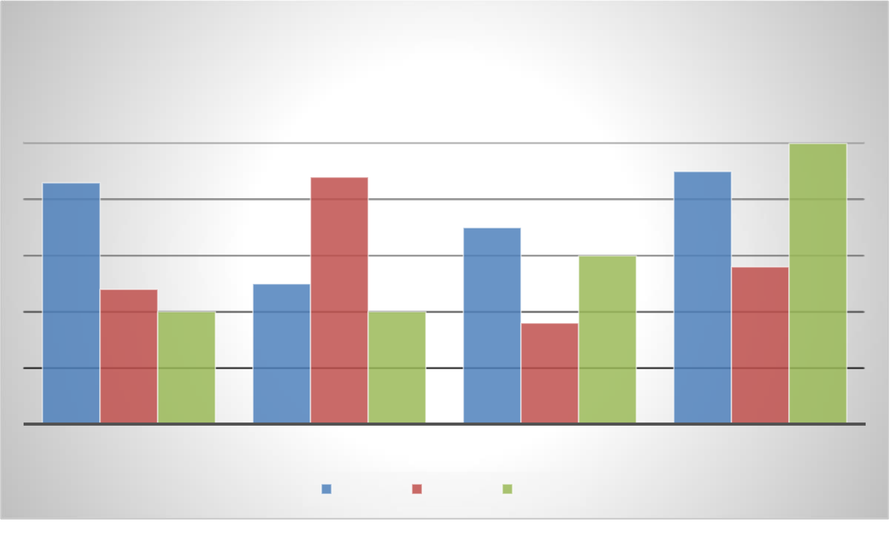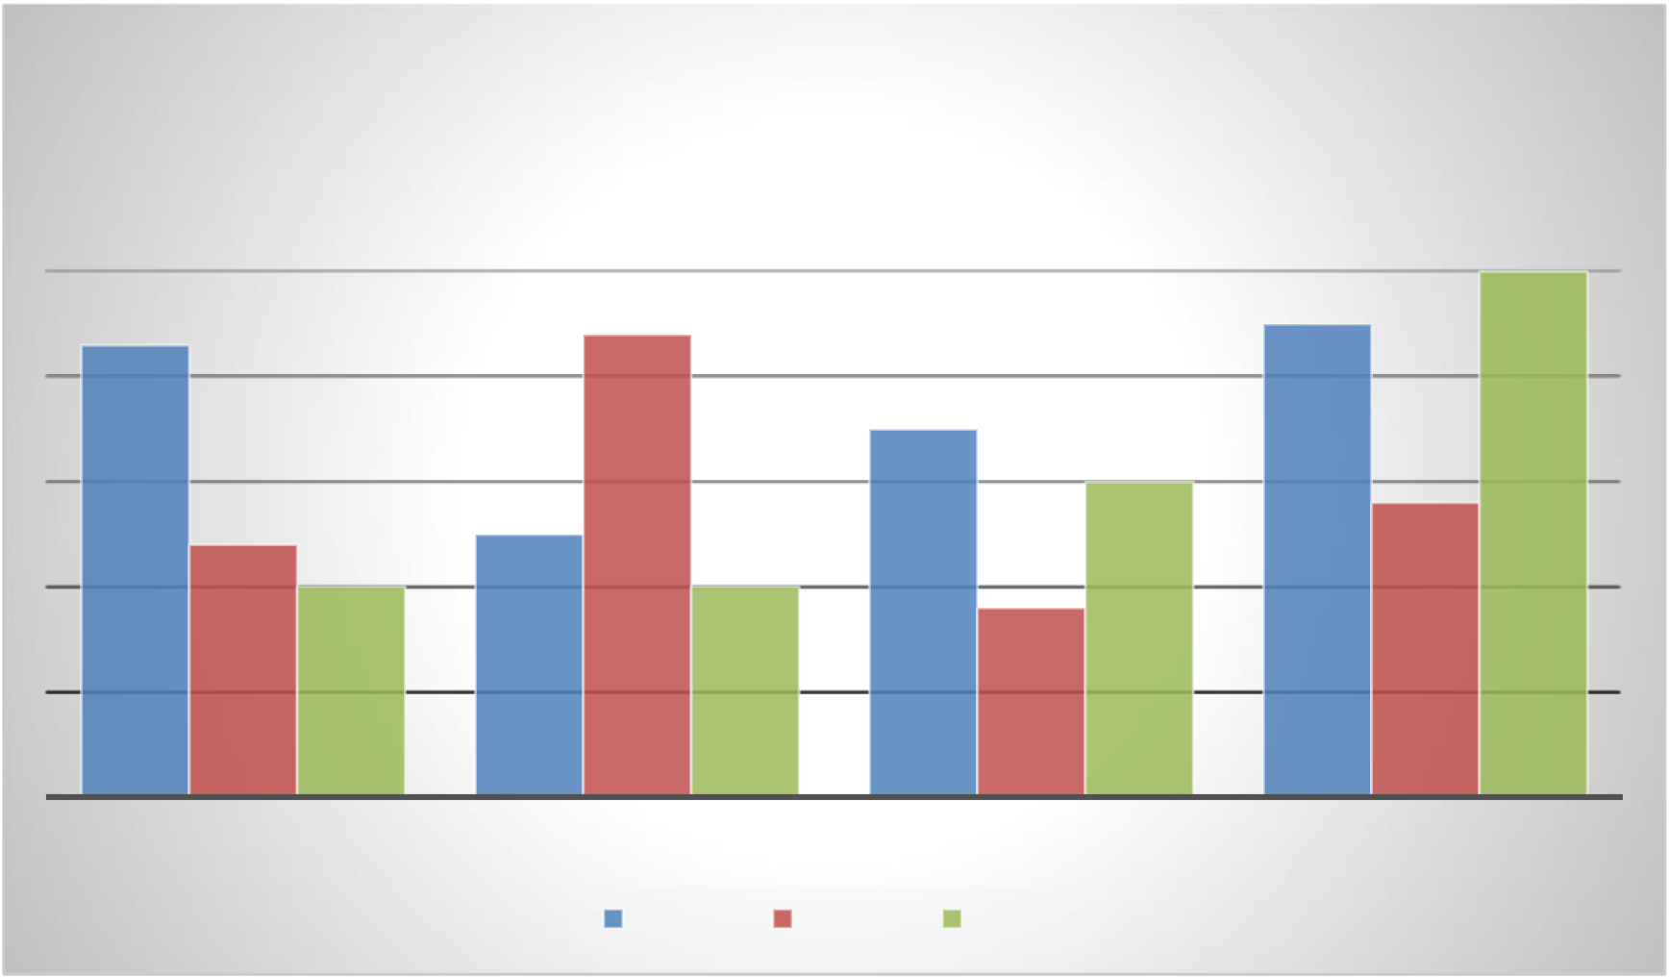

commodo eros nec neque vehicula, a aliquet lorem interdum. Sed varius ipsum eu arcu tempus hendrerit id sed tortor. Sed tristique vestibulum metus, id vehicula ipsum venenatis vel. Morbi faucibus euismod enim et suscipit.

Cras porttitor venenatis leo vitae rutrum. Proin luctus posuere sem, id lacinia nunc fermentum sit amet. Donec vel urna neque. Nunc ultrices nisl et aliquam molestie. Proin laoreet diam risus, et ultricies nulla pharetra vel. Pellentesque vel dictum erat. Suspendisse tincidunt vestibulum turpis, vel posuere tortor tempor at. Vestibulum in nisi malesuada, faucibus massa ut, aliquet dolor. Mauris tellus est, tristique quis lobortis sit amet, commodo quis leo. Pellentesque et magna ac nisl hendrerit porttitor in a dolor. Aenean euismod erat quis ipsum ultricies vehicula. Nunc maximus sagittis urna, fringilla maximus nulla aliquet ac. Pellentesque convallis libero arcu, quis laoreet massa iaculis et. Pellentesque iaculis bibendum ex eu accumsan. Suspendisse potenti.

**Chart Title**

**5**

|  |  |  |
| --- | --- | --- |
| **4.3** | **4.4** | **4.5** |

**3.5**

|  |  |  |  |  |  |  |
| --- | --- | --- | --- | --- | --- | --- |
| **2.4** | **2** | **2.5** | Series 2 | **1.8** | **3** | **2.8** |
| **2** |
| CATEGORY 1 | CATEGORY 2 | CATEGORY 3 | CATEGORY 4 |
| Series 1 | Series 3 |

Curabitur fringilla elit a quam finibus suscipit. Cras nec nibh non dolor bibendum imperdiet et ut nunc. Quisque velit mauris, dictum in ultricies non, imperdiet non enim. Interdum et malesuada fames ac ante ipsum primis in faucibus. Nulla pharetra odio sit amet dolor rutrum hendrerit. Donec nec dapibus sapien. Morbi sagittis pulvinar elit, ac malesuada justo. Morbi vitae euismod massa. Nulla nec imperdiet nisi.

Nunc malesuada nisl vel tortor accumsan, at suscipit magna pharetra. Ut tincidunt ante eget purus malesuada iaculis. Quisque id aliquam dui. Ut tempor congue egestas. Class aptent taciti sociosqu ad litora torquent per conubia nostra, per inceptos himenaeos. Nullam eget dolor interdum, placerat neque ut, faucibus risus. Cras velit velit, feugiat at eleifend non, mattis eu eros.

Praesent ullamcorper lorem in lectus porta, at porta nulla pellentesque. Maecenas semper neque nec tortor commodo aliquet. Praesent mattis odio vulputate mi dictum, nec eleifend eros ultrices. Donec lorem nisi, accumsan iaculis neque at, auctor consectetur neque. Suspendisse potenti. Integer efficitur tempus rutrum. Vivamus quis condimentum neque, ac varius orci. Pellentesque ullamcorper tortor sapien, quis aliquam tortor porttitor a. Pellentesque habitant morbi tristique senectus et netus et malesuada fames ac turpis egestas. Pellentesque vel pellentesque velit. Aliquam erat volutpat. Proin gravida finibus enim, sit amet tincidunt nisl

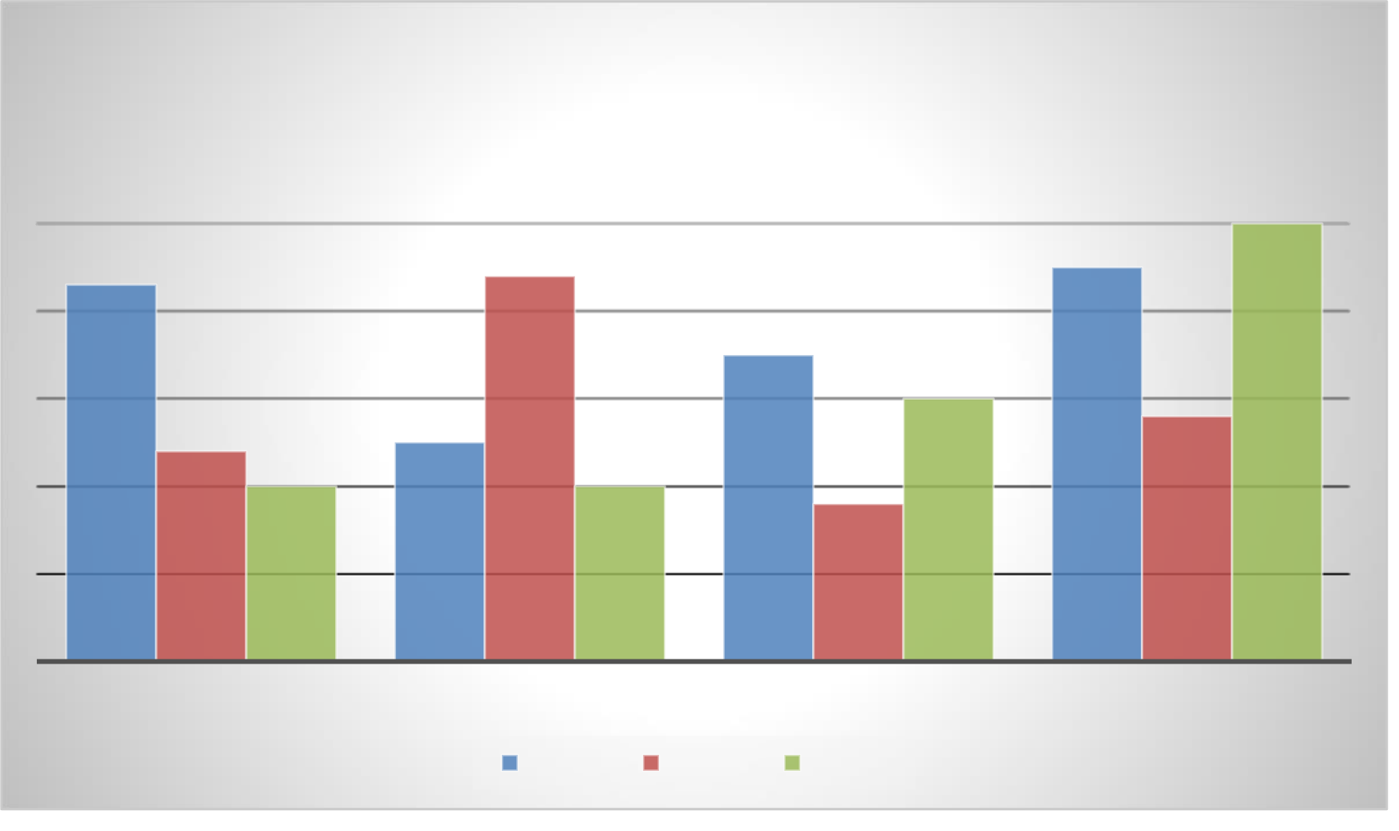

efficitur id. Praesent orci libero, rhoncus sed imperdiet quis, eleifend sed magna. Phasellus pulvinar, odio et feugiat ultrices, velit magna ornare massa, euismod imperdiet risus ante sit amet quam. Duis molestie sem mollis dolor condimentum fermentum. Duis magna risus, consequat vel congue in, volutpat et tellus.

|  |  |  |  |  |  |  |  |  |  |  |  |  |  |  |  |  |  |  |  |  |  |  |  |  |  |  |  |  |  |  |  |  |  |  |  |  |  |  |  |  |  |  |  |  |  |  |  |  |  |  |  |  |  |  |  |  |  |  |  |  |  |  |  |  |  |  |  |  |  |  |  |  |  |  |  |  |  |  |  |  |  |  |  |  |  |  |  |  |  |  |  |  |  |  |  |  |  |  |  |  |  |  |  |  |  |  |  |  |  |  |  |  |  |  |  |  |  |  |  |  |  |  |  |  |  |  |  |  |  |  |  |  |  |  |  |  |  |  |  |  |  |  |  |  |  |  |  |  |  |  |  |  |  |  |  |  |  |  |  |  |  |  |  |  |  |  |  |  |  |  |  |  |  |  |  |  |  |  |  |  |  |  |  |  |  |  |  |  |  |
| --- | --- | --- | --- | --- | --- | --- | --- | --- | --- | --- | --- | --- | --- | --- | --- | --- | --- | --- | --- | --- | --- | --- | --- | --- | --- | --- | --- | --- | --- | --- | --- | --- | --- | --- | --- | --- | --- | --- | --- | --- | --- | --- | --- | --- | --- | --- | --- | --- | --- | --- | --- | --- | --- | --- | --- | --- | --- | --- | --- | --- | --- | --- | --- | --- | --- | --- | --- | --- | --- | --- | --- | --- | --- | --- | --- | --- | --- | --- | --- | --- | --- | --- | --- | --- | --- | --- | --- | --- | --- | --- | --- | --- | --- | --- | --- | --- | --- | --- | --- | --- | --- | --- | --- | --- | --- | --- | --- | --- | --- | --- | --- | --- | --- | --- | --- | --- | --- | --- | --- | --- | --- | --- | --- | --- | --- | --- | --- | --- | --- | --- | --- | --- | --- | --- | --- | --- | --- | --- | --- | --- | --- | --- | --- | --- | --- | --- | --- | --- | --- | --- | --- | --- | --- | --- | --- | --- | --- | --- | --- | --- | --- | --- | --- | --- | --- | --- | --- | --- | --- | --- | --- | --- | --- | --- | --- | --- | --- | --- | --- | --- | --- | --- | --- | --- | --- | --- | --- | --- | --- |
| **Chart Title**   |  |  |  |  |  |  |  |  |  |  |  |  |  |  |  |  |  | | --- | --- | --- | --- | --- | --- | --- | --- | --- | --- | --- | --- | --- | --- | --- | --- | --- | |  |  |  |  |  |  |  |  |  |  |  |  |  |  |  | **5** |  | |  |  |  |  |  |  |  |  |  |  |  |  |  |  |  | |  |  |  |  |  |  |  |  |  |  |  |  |  |  |  | |  | **4.3** |  |  |  |  | **4.4** |  |  |  |  |  |  | **4.5** |  | |  |  |  |  |  |  |  |  |  | **3.5** |  |  |  |  |  | |  |  |  |  |  |  |  |  |  |  |  |  |  |  |  | |  |  |  |  |  |  |  |  |  |  |  | **3** |  |  |  | |  |  |  |  |  |  |  |  |  |  |  |  |  |  |  | |  |  |  |  |  | **2.5** |  |  |  |  |  |  |  |  | **2.8** | |  |  | **2.4** |  |  |  |  |  |  |  |  |  |  |  |  | |  |  |  | **2** |  |  |  | **2** |  |  | **1.8** |  |  |  |  |  |  |  |  |  |  |  |  |  | | --- | --- | --- | --- | --- | --- | --- | --- | | CATEGORY 1 | CATEGORY 2 | |  |  | CATEGORY 3 | | CATEGORY 4 | |  | |  |  | | --- | --- | |  |  | | Series 1 | |  |  | | --- | --- | |  |  | | Series 2 | |  |  | | --- | --- | |  |  | | Series 3 |  | |

Praesent cursus sem eget felis vehicula, ut imperdiet enim ullamcorper. Nam ullamcorper hendrerit risus sit amet venenatis. Class aptent taciti sociosqu ad litora torquent per conubia nostra, per inceptos himenaeos. Suspendisse nec faucibus libero. In at sem ornare, tempus arcu eget, commodo arcu. Morbi tortor elit, mollis vitae nisi non, semper feugiat libero. Nulla non viverra metus.

Aenean interdum arcu id leo convallis, sed congue neque laoreet. Morbi finibus aliquam cursus. Cras malesuada lacus ac velit luctus venenatis. Nulla porta ornare lacus in posuere. Aliquam erat volutpat. Suspendisse lobortis sapien in sem gravida tristique. Duis consectetur lorem vitae urna cursus, at consectetur nibh facilisis. Nunc sollicitudin sem at arcu scelerisque imperdiet. Etiam luctus sapien nec ullamcorper congue. Ut et tristique ante. Fusce nisi dolor, pulvinar a egestas ut, ornare a lacus.

Duis mattis, leo in mollis mollis, mauris quam accumsan sapien, at tempor lorem tortor quis ipsum. Proin sem risus, mollis eu arcu ut, feugiat condimentum leo. Phasellus viverra ornare mi sit amet porttitor. Vestibulum id sodales lectus, aliquet consequat ante. Aliquam id odio vestibulum ligula porttitor feugiat at in ante. Donec eu leo id enim pretium pellentesque. Vestibulum aliquet aliquam mattis. Morbi ac viverra nibh. Sed aliquet, nisl et laoreet accumsan, eros turpis mattis ante, vitae pellentesque lectus metus nec mauris. Ut nibh risus, fermentum at semper at, ultrices a turpis. Integer ex neque, mattis eu ultrices a, scelerisque eu turpis. Sed at lorem non eros cursus pellentesque. Proin sed sodales sapien.

Nullam ultrices, erat sit amet auctor vulputate, nulla eros ultricies magna, non vehicula eros purus at felis. Ut vel interdum massa. In hac habitasse platea dictumst. Sed aliquet elit quis tincidunt mattis. In imperdiet non

felis eget dictum. Nunc ut purus sem. Fusce vitae augue ac nisi mollis mollis. Sed id quam euismod, sagittis elit sed, dignissim libero.

Cras commodo, quam quis convallis ornare, nunc purus scelerisque nunc, vel tincidunt nisl eros a lectus. Sed pulvinar accumsan tristique. Phasellus in lectus felis. Aliquam a ex non lectus malesuada tincidunt. Aliquam est orci, mattis nec aliquet eu, commodo quis turpis. Praesent dui dui, accumsan ut turpis vel, iaculis maximus erat. Aliquam pharetra sollicitudin ornare. Morbi volutpat lorem eu nisl laoreet, non elementum elit scelerisque. Nam tincidunt, augue quis viverra faucibus, quam ipsum pulvinar nisl, non blandit erat leo quis arcu. Nulla ullamcorper quam vel urna pulvinar vulputate. Duis ac vestibulum neque, vitae fringilla tellus. Donec lobortis mollis felis tempus volutpat.

Etiam at est augue. Pellentesque euismod blandit nisi, sit amet consectetur erat. Sed sit amet iaculis risus. Praesent ac justo sed ipsum commodo pharetra. Vivamus nisi nisl, condimentum a sem quis, consequat fringilla augue. Maecenas sit amet bibendum quam. Phasellus luctus orci quis posuere egestas. Fusce eget lectus non odio vestibulum tempor vitae in justo. Morbi facilisis urna eu lobortis finibus.

|  |  |  |  |
| --- | --- | --- | --- |
| **1** | **2** | **3** | **4** |
| **5** | 6 | 7 | 8 |
| **9** | 10 | 11 | 12 |
| **13** | 14 | 15 | 16 |

Mauris augue velit, fermentum in mauris non, venenatis mattis orci. Curabitur congue gravida tortor, nec posuere purus. Mauris in tempus nunc. Donec volutpat nisi nec tortor pulvinar, euismod commodo enim rutrum. Praesent rhoncus arcu dui, porttitor interdum ante dictum dictum. Aenean leo ex, condimentum sit amet ornare eu, semper sed turpis. Donec consectetur tortor sed nisi consequat, molestie feugiat risus egestas. Fusce dignissim iaculis nisi, et lacinia neque malesuada ut. Nullam sollicitudin urna at massa commodo, sed accumsan massa laoreet.

Maecenas faucibus eleifend enim, a pretium magna. Vestibulum ante ipsum primis in faucibus orci luctus et ultrices posuere cubilia curae; Etiam aliquam sem mi, a sagittis mauris sodales vitae. Quisque ac ex in lorem placerat ultrices. Cras nec ex maximus, placerat arcu quis, porta quam. Donec tristique arcu nec vulputate gravida. Vestibulum pharetra libero sed magna vestibulum, quis lobortis ante facilisis. Pellentesque dui diam, egestas vel varius vitae, pharetra vel elit. Fusce eu ligula in urna dignissim posuere non et nunc.

Sed ut aliquet metus. In et nibh efficitur sapien consequat porta. Nullam venenatis nulla leo, vel varius felis vulputate nec. Pellentesque semper urna neque, nec dictum felis dignissim at. Ut vel sem quis neque pellentesque dignissim a iaculis sapien. Vestibulum ante ipsum primis in faucibus orci luctus et ultrices posuere cubilia curae; In viverra leo in nulla bibendum, elementum ultricies sapien dignissim. Donec id ornare elit.

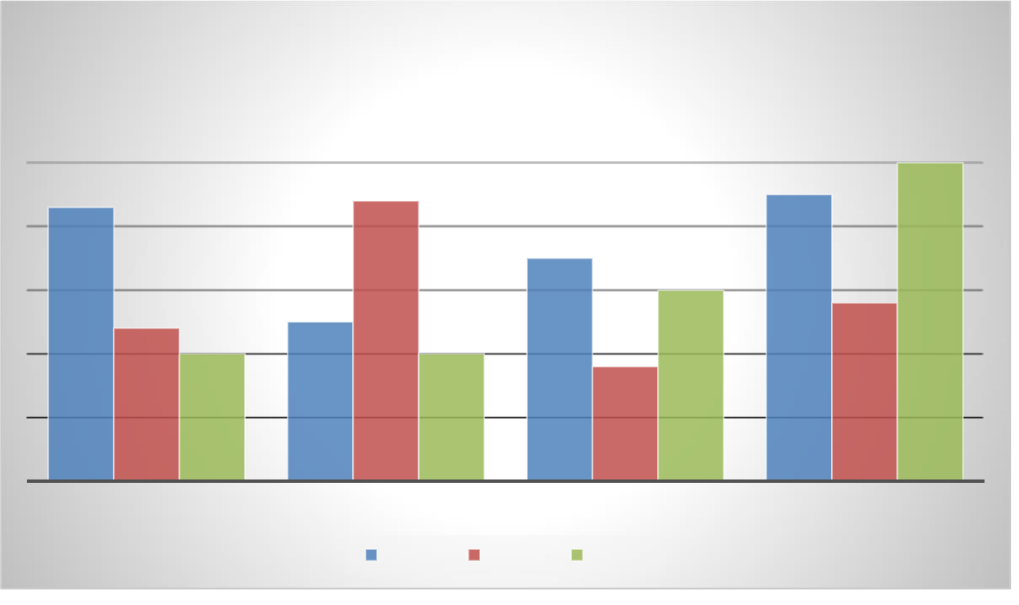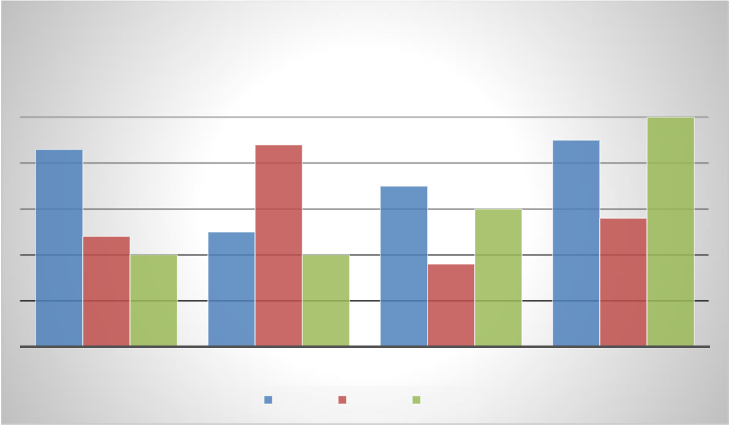

Aliquam ante ligula, pharetra ut blandit et, mollis in leo. Etiam semper libero sed auctor faucibus. Nullam a vestibulum nibh, ac facilisis felis. Nunc tincidunt tempus condimentum. Morbi et eros magna. Donec rhoncus, nibh vel rhoncus ornare, nisl magna congue est, eget lobortis orci diam sed libero. Nunc a nibh tincidunt, molestie enim at, dignissim nibh. Sed porttitor erat eget nisi finibus semper.

**Chart Title**

**5**

|  |  |  |
| --- | --- | --- |
| **4.3** | **4.4** | **4.5** |

**3.5**

|  |  |  |  |  |  |  |
| --- | --- | --- | --- | --- | --- | --- |
| **2.4** | **2** | **2.5** | Series 2 | **1.8** | **3** | **2.8** |
| **2** |
| CATEGORY 1 | CATEGORY 2 | CATEGORY 3 | CATEGORY 4 |
| Series 1 | Series 3 |

Cras in malesuada arcu, eu accumsan mauris. Praesent efficitur eros lacinia porttitor fermentum. Phasellus tempor finibus odio, ut iaculis neque auctor euismod. Donec diam eros, tempor a tortor sit amet, auctor mattis risus. Pellentesque volutpat facilisis dictum. Pellentesque id turpis fermentum, vestibulum leo vitae, dictum quam. Maecenas a justo lacus. Donec vestibulum quis ante vitae placerat. Aenean pellentesque libero eu nunc vulputate, eu vestibulum erat maximus. Suspendisse ac eros efficitur, tristique erat vel, lacinia turpis. Class aptent taciti sociosqu ad litora torquent per conubia nostra, per inceptos himenaeos. Vestibulum semper sem vel velit condimentum, et tristique nibh aliquet. Phasellus bibendum tempor pellentesque. Etiam finibus libero lectus, sed convallis nisi maximus a.

Donec finibus justo lacinia dictum hendrerit. Curabitur volutpat urna arcu, vitae pharetra augue laoreet sit amet. Aenean mattis risus velit, quis fringilla nulla ornare quis. Duis mollis non tellus nec interdum. Nam ut finibus eros, quis pretium ligula. Praesent suscipit urna sed nisi facilisis, nec vehicula sapien imperdiet. Nulla facilisi. Maecenas suscipit nibh bibendum sollicitudin facilisis. Praesent nec cursus odio. Mauris ac erat orci. Sed hendrerit vestibulum rhoncus. Phasellus porttitor neque vel elit semper, vitae euismod ipsum venenatis. Aliquam finibus erat in orci mattis imperdiet. Pellentesque ullamcorper turpis ante.

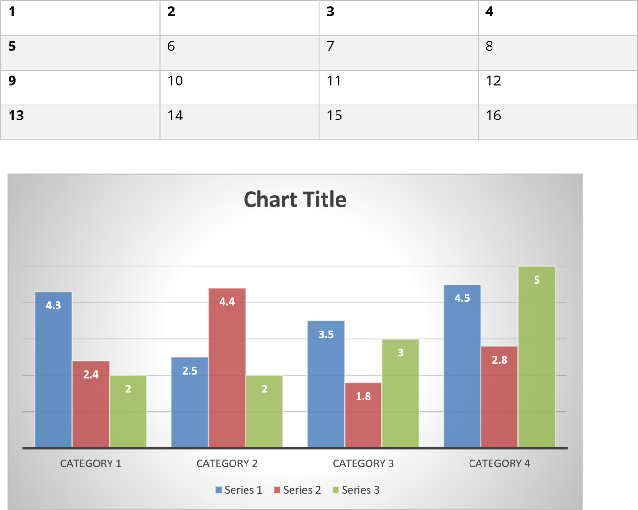

Quisque id felis gravida, ornare ex id, facilisis est. Nullam suscipit mauris ligula, sit amet facilisis metus mattis id. Vestibulum ac libero sapien. Donec tristique eu velit nec ullamcorper. Vestibulum interdum volutpat luctus. Aliquam dictum ultrices urna eu ornare. Vivamus fermentum bibendum congue. Fusce dapibus vitae urna nec tincidunt.

Phasellus sed lacinia nulla, at lobortis ante. Cras vel nulla non tellus sodales placerat. Maecenas iaculis, ipsum at aliquam faucibus, tortor magna pellentesque est, quis efficitur orci risus ac nulla. Nam ultrices odio vitae suscipit condimentum. Donec quis enim malesuada, consectetur diam id, luctus ligula. Nulla bibendum pharetra venenatis. Suspendisse tincidunt tristique iaculis. Cras ornare, elit id dignissim ultrices, nisl neque eleifend quam, non malesuada ante augue a metus. Vivamus pulvinar orci et magna porta congue. Etiam in ex hendrerit tortor ornare tristique ut et sapien. In hac habitasse platea dictumst. Fusce felis turpis, convallis vel ipsum id, semper elementum tortor.

|  |  |  |  |
| --- | --- | --- | --- |
| **1** | **2** | **3** | **4** |
| **5** | 6 | 7 | 8 |

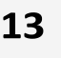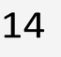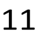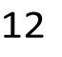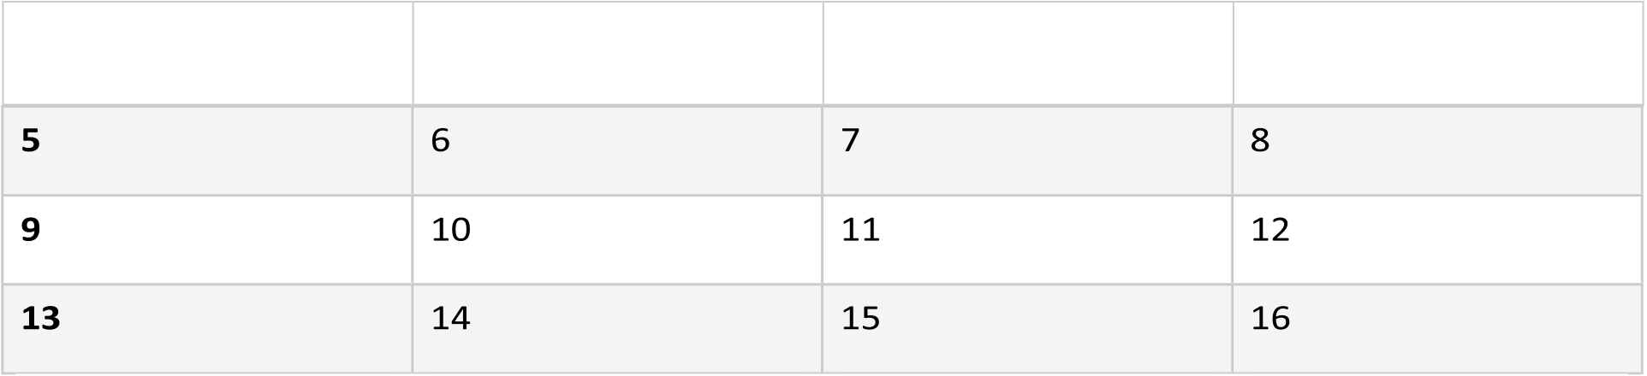

|  |  |  |  |
| --- | --- | --- | --- |
| **9** | 10 | 11 | 12 |
| **13** | 14 | 15 | 16 |

Integer nec venenatis diam, a condimentum lacus. Aliquam erat volutpat. Praesent eu justo nisl. Sed consectetur elit eget nulla sodales tincidunt. Fusce urna eros, tristique id varius in, elementum sed ex. Praesent sollicitudin tortor eget odio commodo consequat. Quisque pellentesque non ipsum nec semper. Nulla volutpat, odio nec mollis sodales, elit mi mattis lectus, non auctor nulla odio eu dolor. Integer viverra id ante quis egestas. Fusce interdum risus libero, egestas eleifend orci pulvinar eget. Nam pulvinar erat id finibus tincidunt. Sed ut mi ut arcu euismod rutrum eget a lectus. Nullam sagittis vestibulum nulla. Ut volutpat non arcu at finibus. Morbi sed dignissim enim, sed porttitor mi.

Vestibulum laoreet varius neque sed convallis. Sed eget enim ac sem congue blandit. Integer posuere mattis nunc quis rutrum. Ut egestas suscipit dictum. Vestibulum eu volutpat lectus, id scelerisque nunc. Nam auctor orci sed elementum imperdiet. Proin ac volutpat massa. Aenean feugiat nisi vitae nibh sollicitudin, sagittis blandit magna rutrum. Suspendisse tempor dui sit amet quam suscipit, sit amet ornare sapien luctus. Curabitur porta lobortis rhoncus. Vivamus vitae vestibulum elit. Cras gravida vel orci eget lacinia. Curabitur sodales leo consequat massa consequat, at lacinia mi venenatis. Vestibulum at turpis est.

Sed eu massa purus. Morbi neque dui, sodales ornare enim eu, interdum egestas tellus. Integer suscipit sem congue, euismod quam vitae, vulputate libero. Nullam accumsan commodo lorem, in rutrum nisl facilisis id. Phasellus finibus dictum felis, non fermentum erat aliquet ac. Vivamus sit amet orci urna. Aenean blandit erat sit amet quam blandit, eget vehicula felis iaculis. Cras faucibus eleifend lacinia.

|  |  |  |  |  |  |  |  |  |  |  |  |
| --- | --- | --- | --- | --- | --- | --- | --- | --- | --- | --- | --- |
| **1** | 6 | 14 | **2** | 7 | 11 | **3** | 8 | 12 | **4** | 9 | 13 |
| 10 |
| 15 | 16 |



Suspendisse id pellentesque nisl, quis commodo nunc. Sed neque ex, hendrerit eu quam eget, vulputate pellentesque dui. Fusce a nisl scelerisque, eleifend risus sed, pretium dui. Donec quis augue facilisis, rhoncus magna at, mattis massa. Nam tincidunt tincidunt elit, nec dictum metus molestie ac. Aliquam sed consequat purus, a dapibus ante. Nulla massa elit, dignissim ac justo sed, tempus blandit felis. Integer ut molestie quam. Etiam condimentum tempus nisl, et lacinia sapien feugiat sed. In scelerisque, tortor sed gravida rhoncus, risus magna volutpat dolor, eget dictum metus elit sit amet urna. Proin suscipit nulla in ligula sollicitudin, vel cursus ante aliquam. Nam venenatis velit posuere neque lacinia fermentum. 5

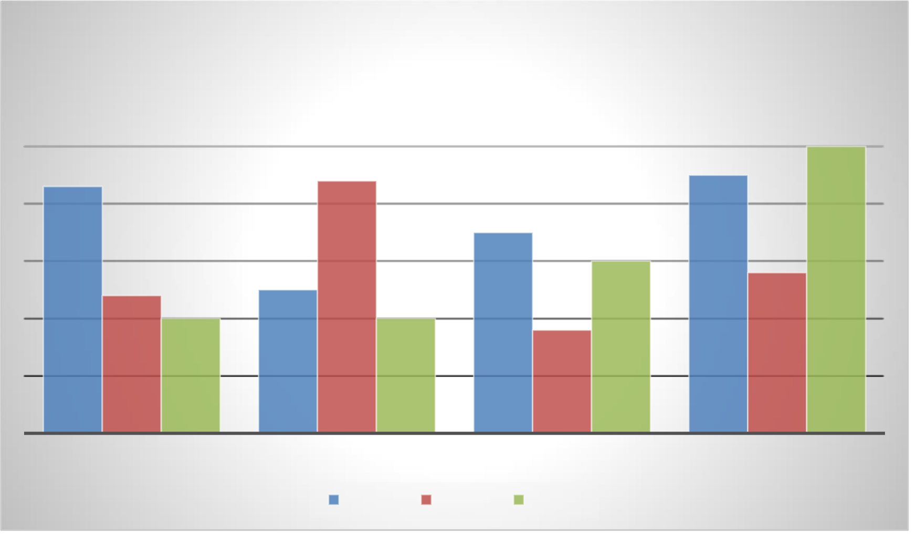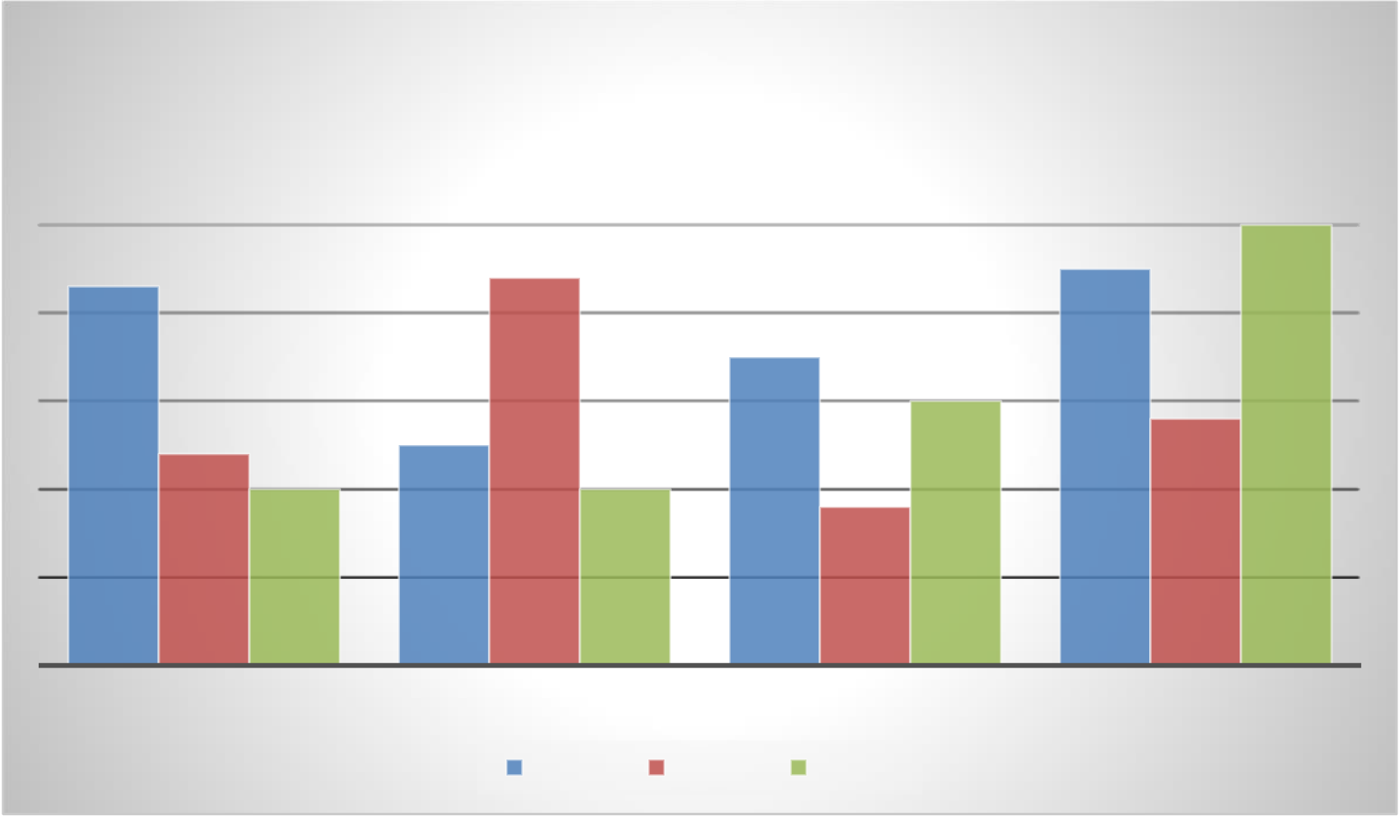

Vivamus commodo ex eu ultricies posuere. Suspendisse tempor vestibulum leo. Suspendisse potenti. Vivamus rutrum rhoncus feugiat. Quisque efficitur cursus augue, quis pretium diam varius in. Aenean eu convallis turpis. Mauris porttitor leo eget ligula accumsan condimentum.

**Chart Title**

**5**

|  |  |  |
| --- | --- | --- |
| **4.3** | **4.4** | **4.5** |

**3.5**

|  |  |  |  |  |  |  |
| --- | --- | --- | --- | --- | --- | --- |
| **2.4** | **2** | **2.5** | Series 2 | **1.8** | **3** | **2.8** |
| **2** |
| CATEGORY 1 | CATEGORY 2 | CATEGORY 3 | CATEGORY 4 |
| Series 1 | Series 3 |

Suspendisse potenti. Integer maximus neque et metus euismod volutpat. Cras gravida nisi at tortor egestas cursus. Quisque placerat pellentesque magna, sed ultrices nisi imperdiet et. Maecenas commodo eros eu nisl tristique, vitae finibus urna vehicula. Pellentesque habitant morbi tristique senectus et netus et malesuada fames ac turpis egestas. Mauris vel mattis urna. Integer id vulputate nulla. Duis pulvinar ipsum sit amet risus dapibus ullamcorper. In semper porta dignissim. Duis sed ipsum viverra, sollicitudin justo vitae, suscipit risus. Pellentesque dignissim ante eget neque blandit auctor eu sit amet libero. Vivamus maximus quis lectus nec sodales. Etiam tincidunt tellus odio, eu sollicitudin mauris convallis id. Etiam nunc quam, tempus vitae imperdiet eget, mattis et ligula. Etiam vel enim at erat dapibus tempus.

Sed eu augue vitae velit malesuada mattis in at velit. Phasellus erat dui, facilisis vitae nunc eget, consequat commodo dolor. Maecenas et risus ac risus tincidunt volutpat a vel leo. Praesent vitae pulvinar arcu. Lorem ipsum dolor sit amet, consectetur adipiscing elit. Fusce laoreet condimentum imperdiet. Morbi finibus nunc ac vestibulum pretium. Nunc at porttitor nisl. Duis at auctor est. Etiam nisl enim, sollicitudin vel luctus vel, pulvinar quis erat. Sed id orci elit.

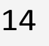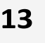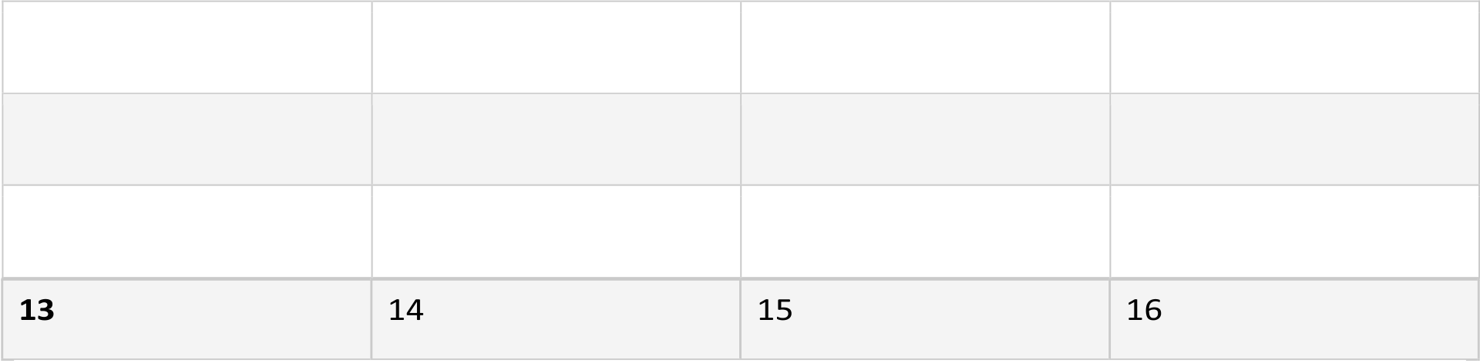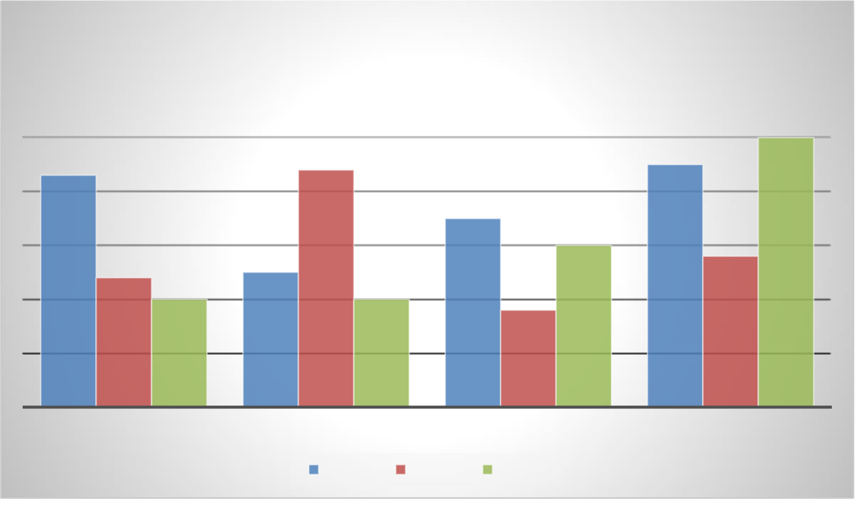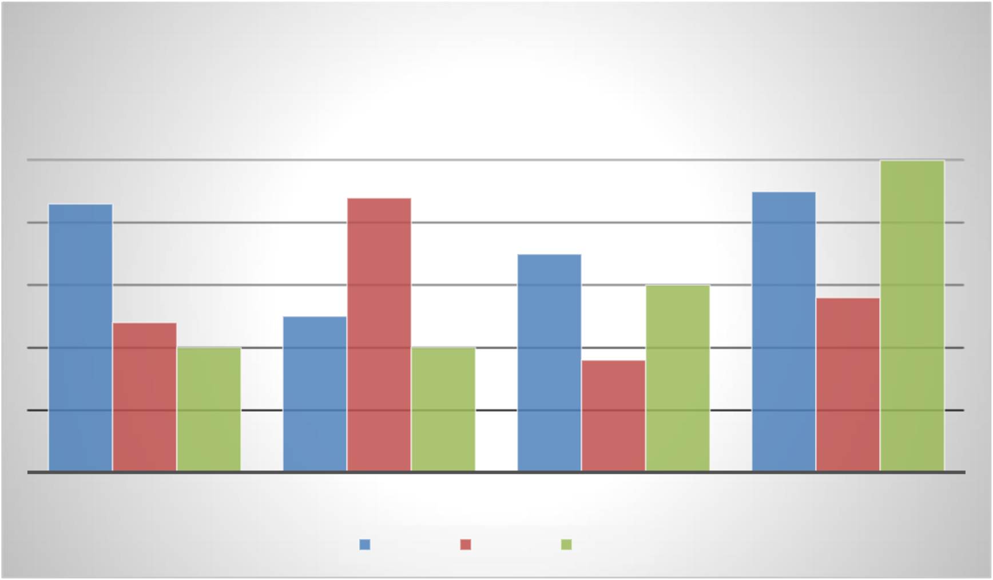

**Chart Title**

**5**

|  |  |  |
| --- | --- | --- |
| **4.3** | **4.4** | **4.5** |

**3.5**

|  |  |  |  |  |  |  |
| --- | --- | --- | --- | --- | --- | --- |
| **2.4** | **2** | **2.5** | Series 2 | **1.8** | **3** | **2.8** |
| **2** |
| CATEGORY 1 | CATEGORY 2 | CATEGORY 3 | CATEGORY 4 |
| Series 1 | Series 3 13 |

Cras ut ornare lectus. Orci varius natoque penatibus et magnis dis parturient montes, nascetur ridiculus mus. Suspendisse mi nisl, congue non orci eget, sodales vulputate metus. Vestibulum rutrum feugiat urna, eget pellentesque nunc egestas a. Phasellus congue vitae leo ut suscipit. Nulla sit amet neque at metus fringilla mattis. Nulla justo lorem, congue sagittis massa at, placerat congue eros. In sit amet turpis odio. Maecenas convallis, turpis non fringilla maximus, massa nulla luctus nibh, id tincidunt eros orci hendrerit neque. Etiam pulvinar lobortis suscipit. Vestibulum leo arcu, pretium a nisl nec, fermentum egestas libero. Mauris fermentum dui eu est laoreet, eu viverra velit volutpat. Sed pharetra justo leo.

|  |  |  |  |  |  |  |
| --- | --- | --- | --- | --- | --- | --- |
| **1** | 14 | **2** | 15 | **3** | 16 | **4** |
| **5** | 6 | 7 | 8 |
| **9** | 10 | 11 | 12 |



Nulla facilisi. Aenean mollis ligula in lacus facilisis maximus. Integer cursus eget lorem eget laoreet. Fusce bibendum eget enim a bibendum. Phasellus semper ex a justo cursus ornare. Integer bibendum blandit varius. Vivamus magna metus, sollicitudin sed augue a, vestibulum dignissim nibh. Integer a leo enim.

Nunc nisl ante, porta vitae rhoncus eu, hendrerit vestibulum urna. Pellentesque eget ultricies quam. Quisque tristique commodo congue. Quisque vulputate euismod dui, nec dignissim libero hendrerit a. Morbi lacus leo, facilisis non urna vel, aliquet euismod tellus. Nam a metus a urna viverra sodales ut vitae metus. In hac habitasse platea dictumst. Etiam fringilla sapien luctus turpis dapibus auctor. Maecenas sed arcu at velit auctor aliquet.

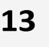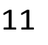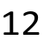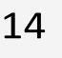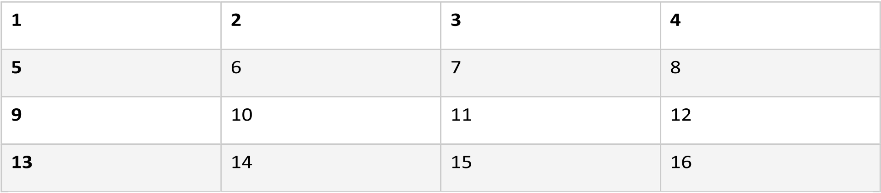

Aliquam maximus sed lorem ut pharetra. Duis ut semper nisl. Mauris molestie sapien sed eros sodales, sed eleifend mauris facilisis. Suspendisse finibus ligula sit amet odio dictum aliquam. Ut tincidunt, libero nec pellentesque tristique, sem felis ultrices arcu, at faucibus lacus justo quis leo. Sed eget nunc a   
lectus lacinia porttitor.

|  |  |  |  |  |  |  |  |
| --- | --- | --- | --- | --- | --- | --- | --- |
| 2 | 14 | 3 | 11 | 4 | 12 | 5 | 13 |
| 6 | 7 | 8 | 9 |
| 10 |
| 15 | 16 |



Donec lacinia urna eget lobortis iaculis. Interdum et malesuada fames ac ante ipsum primis in faucibus. Nulla nec sagittis lectus. Praesent tristique posuere nisi, a auctor sapien venenatis in. Donec diam velit, placerat et diam vitae, imperdiet dignissim dui. Nam vitae interdum risus. Proin et volutpat tortor, in sodales lectus.

Suspendisse at rhoncus leo. Nulla vitae bibendum tellus. Fusce quis erat dui. Vivamus eu pharetra nunc. Suspendisse finibus felis sed lobortis egestas. Sed tellus tortor, tempor sit amet aliquam vehicula, vestibulum in tortor. Fusce vel auctor neque.

Nullam sollicitudin pretium ex sit amet molestie. Duis augue urna, sollicitudin at mattis nec, maximus vitae felis. Sed quis gravida felis. Cras at libero id nibh venenatis condimentum quis vel arcu. Etiam id sapien sed quam bibendum ornare. Phasellus porttitor, quam quis facilisis imperdiet, nisi neque euismod erat, sed efficitur nibh velit in nibh. Aliquam venenatis lorem id metus porta placerat. Sed eu neque cursus, scelerisque urna eu, facilisis eros. Vestibulum lacinia risus purus, eu bibendum felis tristique id. Ut interdum aliquam tellus, et porttitor magna mollis non. Sed fermentum ligula eu sem rhoncus, et mollis felis sodales.

Fusce sollicitudin arcu arcu, ut suscipit diam accumsan id. In hac habitasse platea dictumst. Vestibulum luctus consequat dolor ac aliquam. Cras molestie fringilla magna a facilisis. Quisque tincidunt dictum consequat. Etiam nec efficitur nisl. Maecenas mattis ligula in libero dictum cursus.

Etiam id mi lacus. Curabitur iaculis nunc vitae diam auctor faucibus. Sed efficitur nunc sit amet aliquet scelerisque. Suspendisse non luctus metus. Maecenas enim elit, varius id mauris ut, commodo mollis lorem. Vivamus non enim massa. Nam non lectus condimentum, feugiat urna in, rhoncus tellus. Aliquam vel ex nec turpis dapibus venenatis. Vestibulum lacinia sit amet erat nec pharetra. Phasellus odio sapien, pulvinar non fermentum quis, sagittis nec nulla.

1

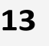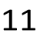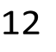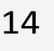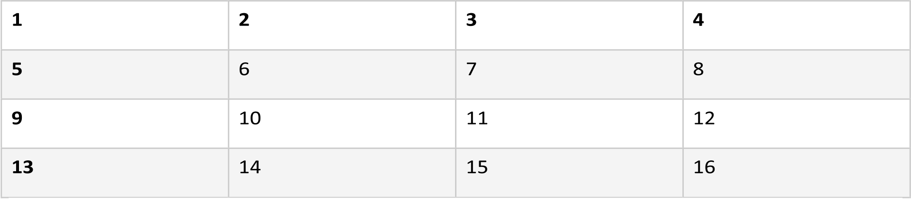

Curabitur arcu nulla, porta ac nulla ultrices, pellentesque aliquam turpis. Nulla ligula ex, malesuada ac turpis in, sagittis euismod ligula. Maecenas sodales magna sit amet sapien bibendum, vel accumsan diam congue. Nullam tempor diam in urna facilisis ultrices. Mauris lacinia varius neque, vitae eleifend neque feugiat in. Vestibulum ante ipsum primis in faucibus orci luctus et ultrices posuere cubilia curae; Orci varius natoque penatibus et magnis dis parturient montes, nascetur ridiculus mus. Pellentesque nec venenatis lectus. Vivamus et ligula in sapien commodo tristique ac in ipsum. Vivamus tortor metus, consectetur non libero non, auctor ultrices mauris. Phasellus pharetra dapibus tellus, ac tincidunt risus tristique malesuada. Quisque lorem justo, vulputate a augue ac, vulputate pharetra nunc. Maecenas convallis rhoncus enim, sed bibendum arcu tempor at.

|  |  |  |  |  |  |  |  |  |  |
| --- | --- | --- | --- | --- | --- | --- | --- | --- | --- |
|  | 2 | 14 | 3 | 11 | 4 | 12 | 5 | 13 | 1 |
| 6 | 7 | 8 | 9 |
| 10 |
| 15 | 16 |

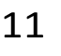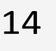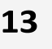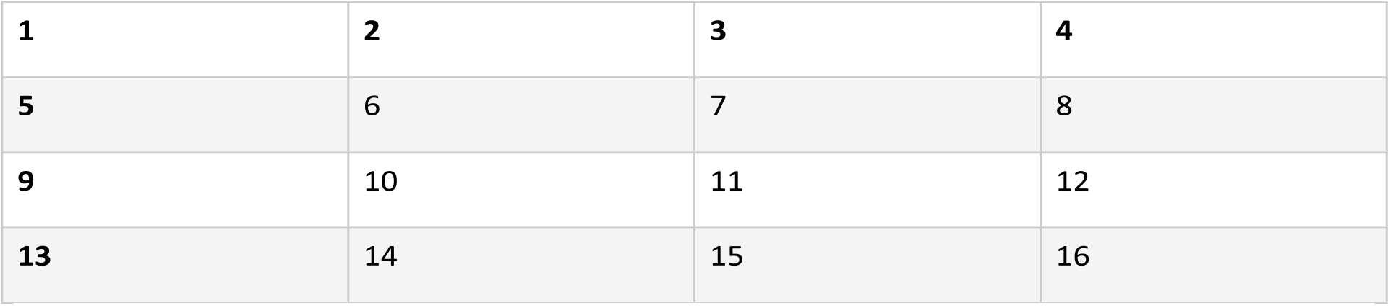

|  |  |  |  |  |  |  |  |  |  |  |  |  |  |  |  |  |  |  |  |  |  |  |  |  |  |  |  |  |  |  |  |  |  |  |  |  |  |  |  |  |  |  |  |  |  |  |  |  |  |  |  |  |  |  |  |  |  |  |  |  |  |  |  |  |  |  |  |  |  |  |  |  |  |  |  |  |  |  |  |  |  |  |  |  |  |  |  |  |  |  |  |  |  |  |  |  |  |  |  |  |  |  |  |  |  |  |  |  |  |  |  |  |  |  |  |  |  |  |  |  |  |  |  |  |  |  |  |  |  |  |  |  |  |  |  |  |  |  |  |  |  |  |  |  |  |  |  |  |  |  |  |  |  |  |  |  |  |  |  |  |  |  |  |  |  |  |  |  |  |  |  |  |  |  |  |  |  |  |  |  |  |  |  |  |  |  |  |  |  |
| --- | --- | --- | --- | --- | --- | --- | --- | --- | --- | --- | --- | --- | --- | --- | --- | --- | --- | --- | --- | --- | --- | --- | --- | --- | --- | --- | --- | --- | --- | --- | --- | --- | --- | --- | --- | --- | --- | --- | --- | --- | --- | --- | --- | --- | --- | --- | --- | --- | --- | --- | --- | --- | --- | --- | --- | --- | --- | --- | --- | --- | --- | --- | --- | --- | --- | --- | --- | --- | --- | --- | --- | --- | --- | --- | --- | --- | --- | --- | --- | --- | --- | --- | --- | --- | --- | --- | --- | --- | --- | --- | --- | --- | --- | --- | --- | --- | --- | --- | --- | --- | --- | --- | --- | --- | --- | --- | --- | --- | --- | --- | --- | --- | --- | --- | --- | --- | --- | --- | --- | --- | --- | --- | --- | --- | --- | --- | --- | --- | --- | --- | --- | --- | --- | --- | --- | --- | --- | --- | --- | --- | --- | --- | --- | --- | --- | --- | --- | --- | --- | --- | --- | --- | --- | --- | --- | --- | --- | --- | --- | --- | --- | --- | --- | --- | --- | --- | --- | --- | --- | --- | --- | --- | --- | --- | --- | --- | --- | --- | --- | --- | --- | --- | --- | --- | --- | --- | --- | --- | --- |
| **Chart Title**   |  |  |  |  |  |  |  |  |  |  |  |  |  |  |  |  |  | | --- | --- | --- | --- | --- | --- | --- | --- | --- | --- | --- | --- | --- | --- | --- | --- | --- | |  |  |  |  |  |  |  |  |  |  |  |  |  |  |  | **5** |  | |  |  |  |  |  |  |  |  |  |  |  |  |  |  |  | |  |  |  |  |  |  |  |  |  |  |  |  |  |  |  | |  | **4.3** |  |  |  |  | **4.4** |  |  |  |  |  |  | **4.5** |  | |  |  |  |  |  |  |  |  |  | **3.5** |  |  |  |  |  | |  |  |  |  |  |  |  |  |  |  |  |  |  |  |  | |  |  |  |  |  |  |  |  |  |  |  | **3** |  |  |  | |  |  |  |  |  |  |  |  |  |  |  |  |  |  |  | |  |  |  |  |  | **2.5** |  |  |  |  |  |  |  |  | **2.8** | |  |  | **2.4** |  |  |  |  |  |  |  |  |  |  |  |  | |  |  |  | **2** |  |  |  | **2** |  |  | **1.8** |  |  |  |  |  |  |  |  |  |  |  |  |  | | --- | --- | --- | --- | --- | --- | --- | --- | | CATEGORY 1 | CATEGORY 2 | |  |  | CATEGORY 3 | | CATEGORY 4 | |  | |  | | --- | |  | |  | | Series 1 | |  | | --- | |  | |  | | Series 2 | |  | | --- | |  | |  | | Series 3 1 |  | |

Pellentesque posuere fermentum enim sit amet interdum. Aliquam dignissim condimentum enim ac suscipit. Proin in justo vitae felis aliquet viverra. Nulla mattis risus eu enim lacinia, in fringilla nisl dictum. Curabitur sagittis odio a diam lacinia finibus. Fusce in nunc et nunc sollicitudin auctor ac eu mi. Cras ac augue lorem.

In hac habitasse platea dictumst. Nullam pharetra sem non augue posuere, ac condimentum orci molestie. Morbi est arcu, molestie ac ultricies ut, dignissim bibendum leo. Sed in rhoncus velit. Vivamus fermentum mauris urna, eget vulputate ipsum ultrices eget. Quisque at pharetra ligula. In rutrum ultricies massa eu euismod. Interdum et malesuada fames ac ante ipsum primis in faucibus. Aenean venenatis urna in felis lobortis rhoncus. Quisque arcu quam, molestie eu tincidunt sed, accumsan vitae erat. Curabitur ultrices in enim porttitor semper.

Mauris vehicula erat et mollis eleifend. In hac habitasse platea dictumst. Morbi id mattis nunc, sit amet placerat metus. Etiam dictum vehicula turpis. Vivamus sed augue placerat, vestibulum ex ut, auctor neque. Proin in posuere libero. Quisque sodales velit massa, et luctus nibh euismod eu. Nullam accumsan aliquet justo eget sagittis.

|  |  |  |  |  |  |  |  |
| --- | --- | --- | --- | --- | --- | --- | --- |
| 2 | 14 | 3 | 11 | 4 | 12 | 5 | 13 |
| 6 | 7 | 8 | 9 |
| 10 |
| 15 | 16 |



Quisque orci metus, aliquet et purus quis, luctus feugiat ipsum. Aenean egestas pharetra consectetur. Orci varius natoque penatibus et magnis dis parturient montes, nascetur ridiculus mus. Fusce hendrerit vestibulum sodales. Suspendisse potenti. Sed libero dui, sagittis vitae iaculis sit amet, molestie in lorem. Vestibulum quis

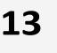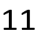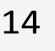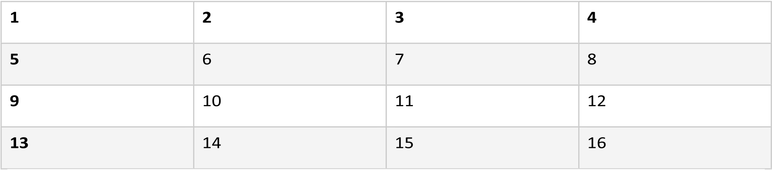

convallis nisl. Quisque pretium dolor mauris, quis vestibulum elit eleifend sit amet. Praesent blandit, libero gravida lacinia mattis, enim sapien pharetra orci, eget vehicula augue dui vel dui. Fusce rhoncus nulla at tortor facilisis imperdiet. Mauris porta nulla eget arcu varius, ac faucibus leo malesuada. Vivamus eu lorem rutrum, semper sapien in, posuere risus. Sed ac bibendum massa. Fusce mattis metus tellus, sed gravida libero varius eu.

|  |  |  |  |  |  |  |  |
| --- | --- | --- | --- | --- | --- | --- | --- |
| 2 | 14 | 3 | 11 | 4 | 12 | 5 | 13 |
| 6 | 7 | 8 | 9 |
| 10 |
| 15 | 16 |



Maecenas egestas vitae tellus vel euismod. Aenean egestas ipsum non sodales aliquet. Vestibulum feugiat tellus vitae suscipit dictum. Nullam ut efficitur velit. Morbi vitae iaculis ipsum. Aliquam nec leo leo. Praesent nec diam nec velit cursus ultricies. Etiam mauris arcu, consequat sit amet pretium ac, rutrum vitae mauris. Maecenas a magna faucibus, finibus ligula in, luctus lectus. Nullam pulvinar eros tortor. Proin at porttitor purus, feugiat ornare ligula. Maecenas rhoncus felis quis purus mattis maximus. Mauris nulla ligula, convallis vel neque vitae, eleifend malesuada tortor. Sed et ipsum faucibus, suscipit tellus eget, tristique enim. Cras efficitur orci eget tortor porttitor, id pellentesque nisi tempus. Nunc cursus, massa ut porttitor viverra, mauris risus porttitor lacus, dignissim blandit tellus libero id felis.

Phasellus et eros velit. In pharetra velit nulla, vitae efficitur ligula condimentum sed. Donec vel aliquam nisi. Ut varius turpis lorem, eu tempor turpis imperdiet vel. Mauris accumsan iaculis diam. Lorem ipsum dolor sit amet, consectetur adipiscing elit. Suspendisse vestibulum, mi commodo tempor consequat, augue urna accumsan nibh, vel dictum massa eros et diam. Proin in est tempus, posuere augue sed, consequat velit. Morbi venenatis leo vitae purus scelerisque imperdiet. Donec lobortis odio eget convallis convallis. Duis varius dolor eu consectetur tincidunt. Vestibulum malesuada dui diam, ac tristique dui maximus a.

Curabitur consectetur neque vel elementum consectetur. In ut eleifend quam. Sed ornare eros eget venenatis euismod. Suspendisse vitae orci sodales, egestas neque ut, auctor leo. Praesent et lacus tellus. Quisque mollis lobortis neque vel sollicitudin. Suspendisse sagittis in metus eget dignissim. Proin lectus tortor, finibus et auctor non, luctus id sem. Duis cursus, diam et aliquet volutpat, augue dolor hendrerit sem, et condimentum purus leo ut lectus. Nunc ut lacinia massa. Donec pellentesque metus sed scelerisque laoreet. Mauris vitae facilisis diam.

Vestibulum hendrerit metus est, non iaculis sem egestas et. Integer sodales vehicula commodo. Maecenas viverra, nibh dignissim tempor finibus, nisi sapien tincidunt libero, et luctus dui orci eu ex. Suspendisse varius vel neque sit amet vulputate. Praesent vulputate bibendum sem, vitae suscipit mauris condimentum in. Maecenas neque felis, condimentum quis enim at, commodo facilisis odio. Duis ut porta odio. Sed euismod nibh vel ligula vestibulum rhoncus. 1

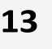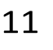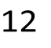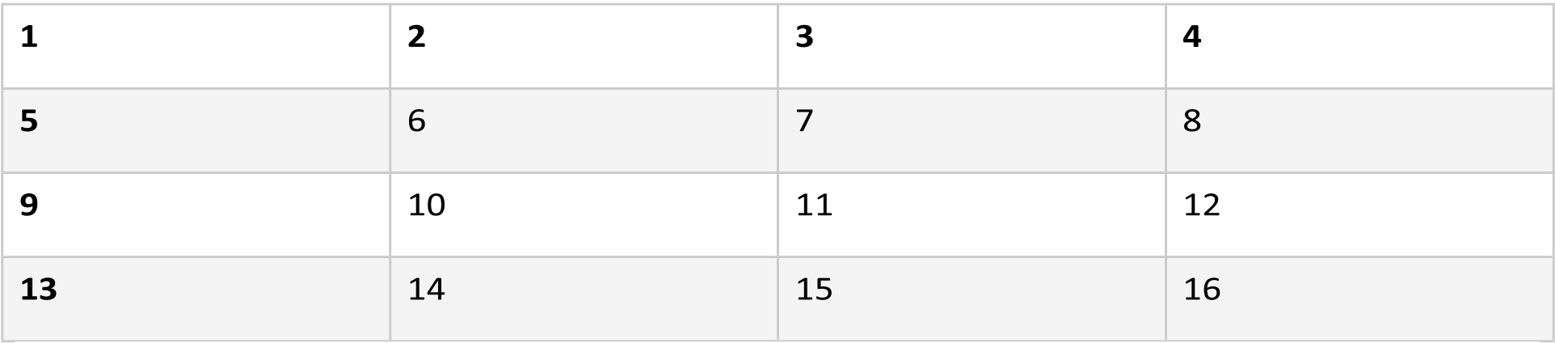

Integer auctor molestie tincidunt. Duis quis eleifend mi. Nullam ac est nec purus imperdiet rutrum nec sed massa. In maximus vulputate metus, in convallis augue scelerisque lobortis. Sed egestas dui ligula, eu euismod ante pharetra ut. Etiam condimentum dui a vestibulum elementum. Donec turpis ipsum, suscipit eu auctor ac, molestie sit amet odio. Suspendisse lectus tortor, ornare nec venenatis placerat, molestie non sem. Nunc tincidunt vel nisl luctus auctor. Praesent a eros porttitor, consequat lorem at, tempus ex. Vestibulum risus dui, tempor eu ante non, vestibulum condimentum elit.

Morbi faucibus dictum varius. Cras massa ligula, pharetra eget fermentum id, ultrices vulputate urna. Donec varius diam dolor, vitae cursus augue ornare eget. Nulla sit amet felis condimentum, fringilla sapien ac, mattis urna. Aliquam in nulla dolor. Nam ultricies vel ante eget congue. Suspendisse in placerat magna. Nulla condimentum elit non commodo volutpat. Curabitur leo felis, eleifend sed ornare sed, scelerisque quis est.

Vestibulum eget pharetra magna, sit amet gravida justo. Maecenas vehicula augue sed tempor pulvinar.

Ut nec nunc tortor. Maecenas nec venenatis dolor. Ut ultrices efficitur imperdiet. Aenean ut nunc bibendum nisi venenatis condimentum in ut felis. Maecenas rutrum eleifend massa in tristique. Nam ultricies consequat dui, eu fermentum libero. Mauris pretium est neque, eget dignissim tellus dignissim at. In quis tortor nec dui vulputate ullamcorper ac nec augue. Etiam maximus quam molestie mauris faucibus dictum. Pellentesque habitant morbi tristique senectus et netus et malesuada fames ac turpis egestas. Aliquam tortor elit, tincidunt vel nisi rhoncus, tristique convallis nisi. Etiam at nisl eget eros mollis venenatis non at quam. Vestibulum ac urna ut elit accumsan vestibulum. Nam elementum ac lectus at efficitur.

Phasellus vel lectus iaculis, tristique ligula non, rutrum tellus. Cras ornare nunc at elit ultricies malesuada. Nunc sodales id risus non luctus. Cras malesuada arcu purus. Ut eu cursus sem. In sagittis ullamcorper lectus, non ornare ante. Sed vel tortor suscipit, eleifend libero mollis, congue leo. Donec eget leo nec mi consectetur congue quis at eros.

|  |  |  |  |  |  |  |  |
| --- | --- | --- | --- | --- | --- | --- | --- |
| 2 | 14 | 3 | 11 | 4 | 12 | 5 | 13 |
| 6 | 7 | 8 | 9 |
| 10 |
| 15 | 16 |



Morbi ac lacus sit amet ipsum placerat consectetur. Lorem ipsum dolor sit amet, consectetur adipiscing elit. Quisque scelerisque quis tellus in euismod. Proin pellentesque dignissim tempor. Fusce odio est, maximus quis ipsum sed, condimentum imperdiet orci. Donec et tellus non mi mattis molestie. Integer nec sem scelerisque, posuere nulla ultrices, tristique urna. Vivamus scelerisque nunc a nisl suscipit vulputate. Nulla consectetur ullamcorper velit sit amet convallis. Curabitur facilisis dapibus velit. Integer semper pulvinar iaculis. Ut blandit, lorem ut tempus bibendum, mi massa commodo lectus, sit amet porta nunc diam sit amet nisi. Suspendisse potenti. Donec sit amet luctus magna, ac tempus turpis. Curabitur hendrerit, orci in iaculis sodales, nulla augue ornare purus, eu sollicitudin augue sapien at arcu.

Phasellus elementum elit dapibus augue eleifend, faucibus elementum ex bibendum. Pellentesque molestie, ligula vel tincidunt pulvinar, nibh dolor ullamcorper tortor, eu dignissim nisl lacus eget leo. Nulla bibendum nisi a odio dictum, in sollicitudin sem malesuada. Praesent tincidunt pharetra consectetur. Donec risus ante, iaculis 1

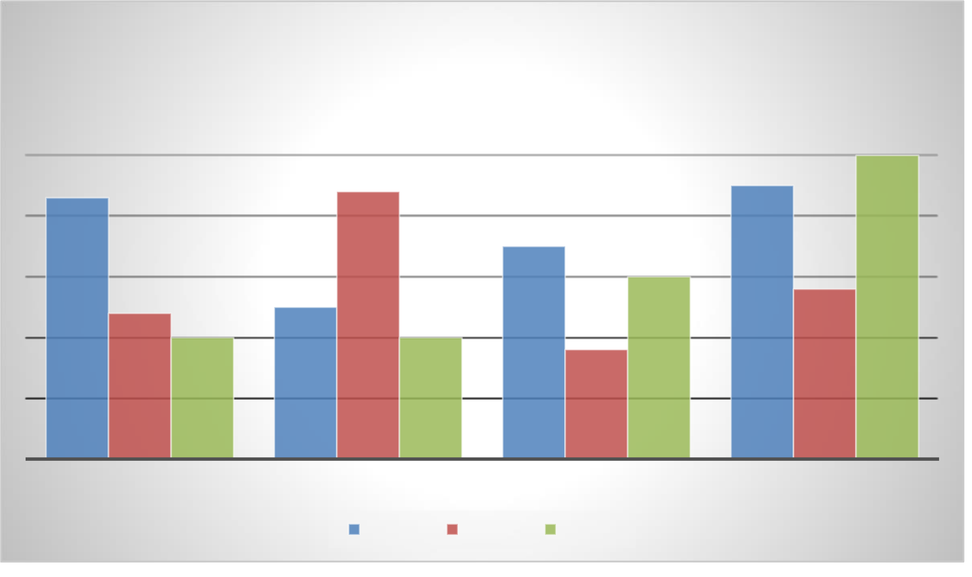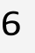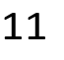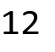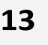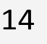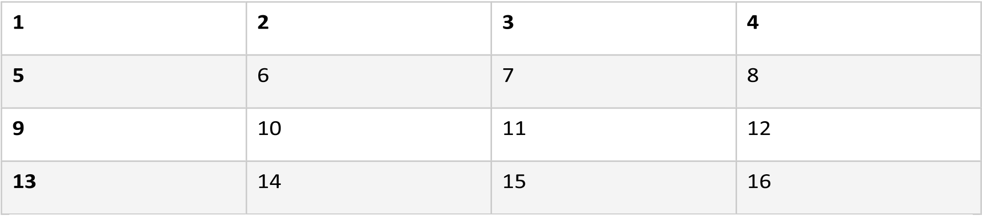

ut feugiat quis, tristique vehicula ante. Donec in erat nisl. Ut non leo sit amet nulla laoreet convallis id ac odio. Nunc vitae mi sem. Cras ut dolor viverra dolor iaculis tincidunt quis et erat. Quisque commodo vestibulum risus. Praesent ornare gravida enim, vel blandit lacus varius ut. Nulla commodo convallis mi id vestibulum. Sed at tristique elit. Nulla facilisi. Suspendisse vel metus eget lorem imperdiet viverra.

|  |  |  |  |  |  |  |  |  |  |  |  |  |  |  |  |  |  |  |  |  |  |  |  |  |  |  |  |  |  |  |  |  |  |  |  |  |  |  |  |  |  |  |  |  |  |  |  |  |  |  |  |  |  |  |  |  |  |  |  |  |  |  |  |  |  |  |  |  |  |  |  |  |  |  |  |  |  |  |  |  |  |  |  |  |  |  |  |  |  |  |  |  |  |  |  |  |  |  |  |  |  |  |  |  |  |  |  |  |  |  |  |  |  |  |  |  |  |  |  |  |  |  |  |  |  |  |  |  |  |  |  |  |  |  |  |  |  |  |  |  |  |  |  |  |  |  |  |  |  |  |  |  |  |  |  |  |  |  |  |  |  |  |  |  |  |  |  |  |  |  |  |  |  |  |  |  |  |  |  |  |  |  |  |  |  |  |  |  |  |
| --- | --- | --- | --- | --- | --- | --- | --- | --- | --- | --- | --- | --- | --- | --- | --- | --- | --- | --- | --- | --- | --- | --- | --- | --- | --- | --- | --- | --- | --- | --- | --- | --- | --- | --- | --- | --- | --- | --- | --- | --- | --- | --- | --- | --- | --- | --- | --- | --- | --- | --- | --- | --- | --- | --- | --- | --- | --- | --- | --- | --- | --- | --- | --- | --- | --- | --- | --- | --- | --- | --- | --- | --- | --- | --- | --- | --- | --- | --- | --- | --- | --- | --- | --- | --- | --- | --- | --- | --- | --- | --- | --- | --- | --- | --- | --- | --- | --- | --- | --- | --- | --- | --- | --- | --- | --- | --- | --- | --- | --- | --- | --- | --- | --- | --- | --- | --- | --- | --- | --- | --- | --- | --- | --- | --- | --- | --- | --- | --- | --- | --- | --- | --- | --- | --- | --- | --- | --- | --- | --- | --- | --- | --- | --- | --- | --- | --- | --- | --- | --- | --- | --- | --- | --- | --- | --- | --- | --- | --- | --- | --- | --- | --- | --- | --- | --- | --- | --- | --- | --- | --- | --- | --- | --- | --- | --- | --- | --- | --- | --- | --- | --- | --- | --- | --- | --- | --- | --- | --- | --- |
| **Chart Title**   |  |  |  |  |  |  |  |  |  |  |  |  |  |  |  |  |  | | --- | --- | --- | --- | --- | --- | --- | --- | --- | --- | --- | --- | --- | --- | --- | --- | --- | |  |  |  |  |  |  |  |  |  |  |  |  |  |  |  | **5** |  | |  |  |  |  |  |  |  |  |  |  |  |  |  |  |  | |  |  |  |  |  |  |  |  |  |  |  |  |  |  |  | |  | **4.3** |  |  |  |  | **4.4** |  |  |  |  |  |  | **4.5** |  | |  |  |  |  |  |  |  |  |  | **3.5** |  |  |  |  |  | |  |  |  |  |  |  |  |  |  |  |  |  |  |  |  | |  |  |  |  |  |  |  |  |  |  |  | **3** |  |  |  | |  |  |  |  |  |  |  |  |  |  |  |  |  |  |  | |  |  |  |  |  | **2.5** |  |  |  |  |  |  |  |  | **2.8** | |  |  | **2.4** |  |  |  |  |  |  |  |  |  |  |  |  | |  |  |  | **2** |  |  |  | **2** |  |  | **1.8** |  |  |  |  |  |  |  |  |  |  |  |  |  | | --- | --- | --- | --- | --- | --- | --- | --- | | CATEGORY 1 | CATEGORY 2 | |  |  | CATEGORY 3 | | CATEGORY 4 | |  | |  |  | | --- | --- | |  |  | | Series 1 | |  |  | | --- | --- | |  |  | | Series 2 | |  |  | | --- | --- | |  |  | | Series 3 1 |  | |

In lobortis elit nulla, non consequat magna faucibus sit amet. Proin vel dui rutrum, porta turpis quis, interdum nunc. Phasellus blandit fermentum nisl faucibus hendrerit. Nullam scelerisque lorem mollis nibh fermentum, et eleifend libero ultrices. Cras scelerisque sapien nec elit ultrices euismod. Phasellus scelerisque ligula justo, sit amet lacinia turpis tincidunt a. Vivamus viverra pharetra urna, et tempus enim fermentum eu. In pharetra vel nulla eu blandit. Curabitur in metus eget massa accumsan rutrum elementum et velit. Praesent et nunc nec augue lobortis tempus.

Integer ut ullamcorper augue. Sed ullamcorper viverra turpis sed tempus. Donec sit amet hendrerit turpis, efficitur euismod nisi. Praesent in augue sit amet arcu dapibus pellentesque. Sed sem augue, pellentesque ut odio in, volutpat pellentesque metus. Lorem ipsum dolor sit amet, consectetur adipiscing elit. Maecenas et mauris at dui feugiat tincidunt non nec diam. Integer laoreet urna nec risus mollis ultrices. Cras at aliquam tellus. Aenean egestas dictum sem, id pellentesque felis rhoncus sodales. Proin scelerisque felis et lectus sollicitudin, et rutrum erat sagittis. Vivamus vehicula ex nisl, sit amet pharetra nibh aliquet vel.

|  |  |  |  |  |  |  |  |
| --- | --- | --- | --- | --- | --- | --- | --- |
| 2 | 14 | 3 | 11 | 4 | 12 | 5 | 13 |
| 6 | 7 | 8 | 9 |
| 10 |
| 15 | 16 |



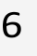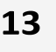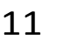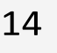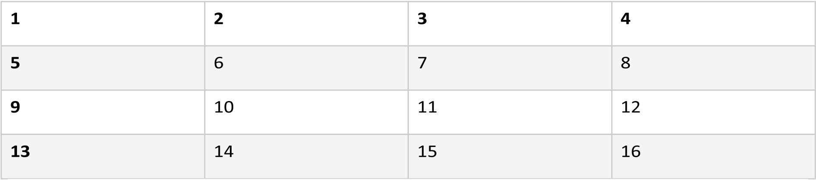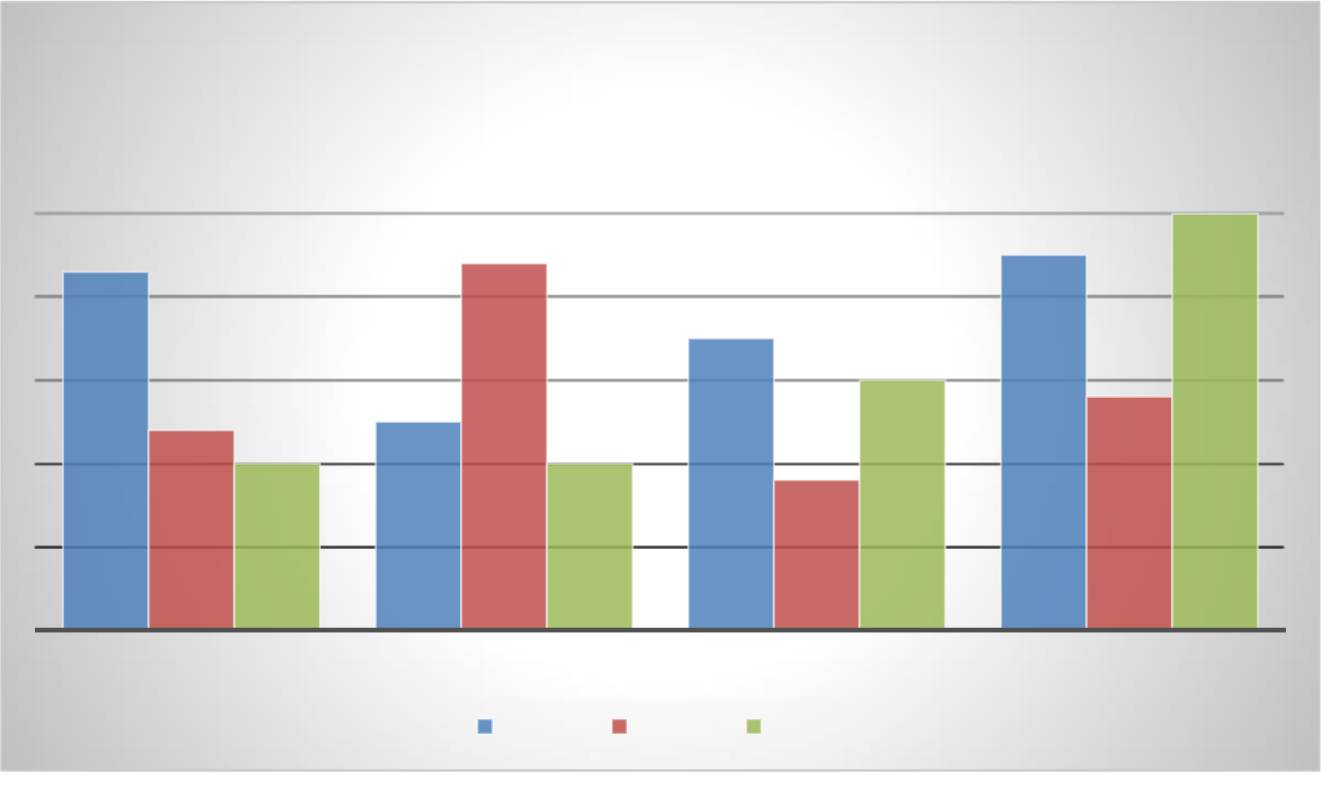

Vivamus risus nulla, mattis at ante eget, aliquet imperdiet diam. Curabitur ante massa, ornare finibus tempor quis, volutpat quis orci. Vestibulum posuere pharetra dolor in vulputate. Vestibulum id ultricies dolor, pretium hendrerit dolor. Pellentesque ut ipsum at tellus ornare laoreet eu eu diam. Morbi bibendum enim sed semper vestibulum. Duis id mollis erat, ac elementum augue. Proin id mollis enim. Maecenas aliquam ante enim, et convallis ante volutpat sit amet. Aenean pretium tincidunt neque, eu varius nisl faucibus vel. Aenean tempus, tellus quis cursus facilisis, neque purus tristique quam, ac scelerisque ipsum mauris mollis magna. Donec vel imperdiet dolor. Sed elit dolor, pharetra a eros at, pretium hendrerit diam. Ut malesuada sem tempus laoreet tincidunt. Morbi ultrices tortor maximus, interdum purus quis, imperdiet lorem. Quisque at erat eu mauris dapibus convallis sit amet accumsan dolor.

In pellentesque gravida ex, at venenatis massa. Curabitur eget imperdiet ipsum, vitae molestie velit. Quisque enim elit, lobortis non pretium nec, posuere ultricies ante. Aliquam semper, nunc vel consectetur sagittis, eros nunc semper justo, sit amet facilisis diam velit eu orci. Integer arcu nisi, maximus eget elit ac, congue convallis turpis. Nulla facilisi. Fusce rhoncus pretium ligula, sed pulvinar lorem posuere eu. Duis egestas luctus cursus.

|  |  |  |  |  |  |  |  |
| --- | --- | --- | --- | --- | --- | --- | --- |
| 2 | 14 | 3 | 11 | 4 | 12 | 5 | 13 |
| 6 | 7 | 8 | 9 |
| 10 |
| 15 | 16 |



|  |  |  |  |  |  |  |  |  |  |  |  |  |  |  |  |  |  |  |  |  |  |  |  |  |  |  |  |  |  |  |  |  |  |  |  |  |  |  |  |  |  |  |  |  |  |  |  |  |  |  |  |  |  |  |  |  |  |  |  |  |  |  |  |  |  |  |  |  |  |  |  |  |  |  |  |  |  |  |  |  |  |  |  |  |  |  |  |  |  |  |  |  |  |  |  |  |  |  |  |  |  |  |  |  |  |  |  |  |  |  |  |  |  |  |  |  |  |  |  |  |  |  |  |  |  |  |  |  |  |  |  |  |  |  |  |  |  |  |  |  |  |  |  |  |  |  |  |  |  |  |  |  |  |  |  |  |  |  |  |  |  |  |  |  |  |  |  |  |  |  |  |  |  |  |  |  |  |  |  |  |  |  |  |  |  |  |  |  |  |
| --- | --- | --- | --- | --- | --- | --- | --- | --- | --- | --- | --- | --- | --- | --- | --- | --- | --- | --- | --- | --- | --- | --- | --- | --- | --- | --- | --- | --- | --- | --- | --- | --- | --- | --- | --- | --- | --- | --- | --- | --- | --- | --- | --- | --- | --- | --- | --- | --- | --- | --- | --- | --- | --- | --- | --- | --- | --- | --- | --- | --- | --- | --- | --- | --- | --- | --- | --- | --- | --- | --- | --- | --- | --- | --- | --- | --- | --- | --- | --- | --- | --- | --- | --- | --- | --- | --- | --- | --- | --- | --- | --- | --- | --- | --- | --- | --- | --- | --- | --- | --- | --- | --- | --- | --- | --- | --- | --- | --- | --- | --- | --- | --- | --- | --- | --- | --- | --- | --- | --- | --- | --- | --- | --- | --- | --- | --- | --- | --- | --- | --- | --- | --- | --- | --- | --- | --- | --- | --- | --- | --- | --- | --- | --- | --- | --- | --- | --- | --- | --- | --- | --- | --- | --- | --- | --- | --- | --- | --- | --- | --- | --- | --- | --- | --- | --- | --- | --- | --- | --- | --- | --- | --- | --- | --- | --- | --- | --- | --- | --- | --- | --- | --- | --- | --- | --- | --- | --- | --- | --- |
| **Chart Title**   |  |  |  |  |  |  |  |  |  |  |  |  |  |  |  |  |  | | --- | --- | --- | --- | --- | --- | --- | --- | --- | --- | --- | --- | --- | --- | --- | --- | --- | |  |  |  |  |  |  |  |  |  |  |  |  |  |  |  | **5** |  | |  |  |  |  |  |  |  |  |  |  |  |  |  |  |  | |  |  |  |  |  |  |  |  |  |  |  |  |  |  |  | |  | **4.3** |  |  |  |  | **4.4** |  |  |  |  |  |  | **4.5** |  | |  |  |  |  |  |  |  |  |  | **3.5** |  |  |  |  |  | |  |  |  |  |  |  |  |  |  |  |  |  |  |  |  | |  |  |  |  |  |  |  |  |  |  |  | **3** |  |  |  | |  |  |  |  |  |  |  |  |  |  |  |  |  |  |  | |  |  |  |  |  | **2.5** |  |  |  |  |  |  |  |  | **2.8** | |  |  | **2.4** |  |  |  |  |  |  |  |  |  |  |  |  | |  |  |  | **2** |  |  |  | **2** |  |  | **1.8** |  |  |  |  |  |  |  |  |  |  |  |  |  | | --- | --- | --- | --- | --- | --- | --- | --- | | CATEGORY 1 | CATEGORY 2 | |  |  | CATEGORY 3 | | CATEGORY 4 | |  | |  |  | | --- | --- | |  |  | | Series 1 | |  |  | | --- | --- | |  |  | | Series 2 | |  |  | | --- | --- | |  |  | | Series 3 |  | |

Nunc ornare risus sit amet tincidunt imperdiet. Nulla ut magna tempor tellus faucibus lacinia sed at ante. Sed scelerisque, urna mollis vulputate fermentum, risus orci gravida leo, in commodo odio neque vel lectus. In at quam nec quam luctus sollicitudin et sed orci. Nunc diam lacus, rutrum vel cursus ut, rutrum sit amet felis. In 1

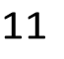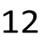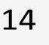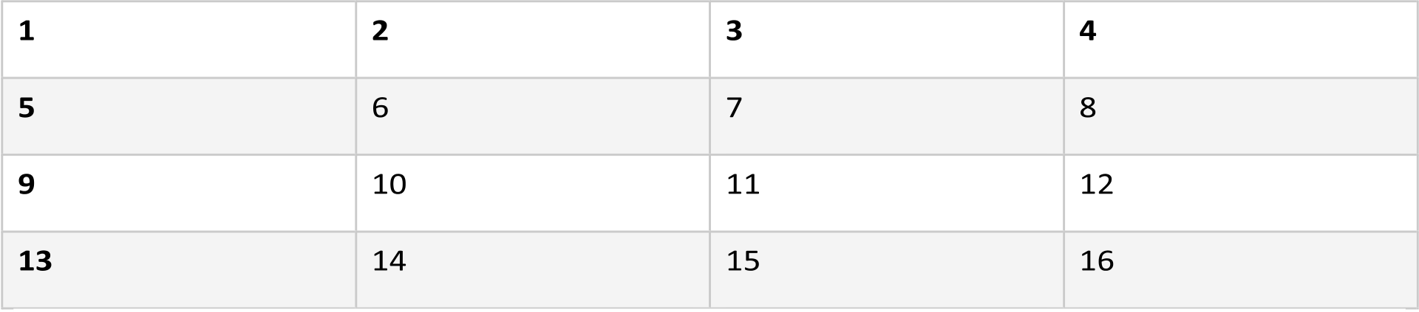

sed blandit ipsum. Nunc fermentum magna vel est luctus venenatis. Nulla sollicitudin vel leo sed finibus. Nulla eget leo sit amet tortor fringilla dapibus. Maecenas aliquet imperdiet lacus, eget accumsan risus fermentum non. Praesent metus erat, fermentum id sollicitudin vel, volutpat ac sem. Praesent ut leo vel ligula elementum iaculis porttitor a leo. Pellentesque placerat mollis tellus a vehicula.

Vestibulum ante ipsum primis in faucibus orci luctus et ultrices posuere cubilia curae; Nulla nec diam sed nibh convallis eleifend eu in dui. Aliquam at magna auctor nisi suscipit luctus id a odio. Etiam ipsum nulla, pretium non vestibulum quis, tincidunt at massa. Vivamus turpis turpis, pulvinar a nulla a, efficitur bibendum ipsum. Nunc laoreet finibus commodo. Nam pretium neque urna, at sollicitudin arcu commodo in.

|  |  |  |  |  |  |  |
| --- | --- | --- | --- | --- | --- | --- |
| 2 | 3 | 11 | 4 | 12 | 5 | 13 |
| 6 | 7 | 8 | 9 |
| 10 |
| 14 | 15 | 16 |



Quisque vulputate nisi nec magna blandit, vitae accumsan mi tincidunt. Pellentesque vel semper nibh, ut semper lacus. Pellentesque egestas libero at ex vehicula, eu luctus risus tristique. Nulla a mauris in turpis vestibulum bibendum sit amet sit amet nulla. Fusce tempor finibus ex at facilisis. Fusce a fringilla mauris, et mollis elit. Quisque finibus, purus a laoreet commodo, enim ipsum tempor velit, id facilisis enim sapien sed elit. Suspendisse hendrerit sollicitudin leo, ut finibus nulla tincidunt in. Suspendisse tempus bibendum eros, nec varius ante. Etiam sed consequat dui. Donec at magna arcu. Mauris euismod nisi nec turpis rutrum consectetur.

Mauris vel felis eu enim ornare imperdiet. Praesent et dolor at neque vehicula rhoncus. Phasellus risus neque, facilisis nec vehicula in, sollicitudin sed magna. Proin purus erat, finibus non metus vel, volutpat tincidunt libero. Sed enim lacus, placerat nec porttitor nec, luctus sit amet nibh. Sed bibendum ultricies arcu, at facilisis nisi varius at. Curabitur porta at erat nec euismod. Nullam ut ultrices tellus. Morbi in nunc ac lacus volutpat laoreet. 1

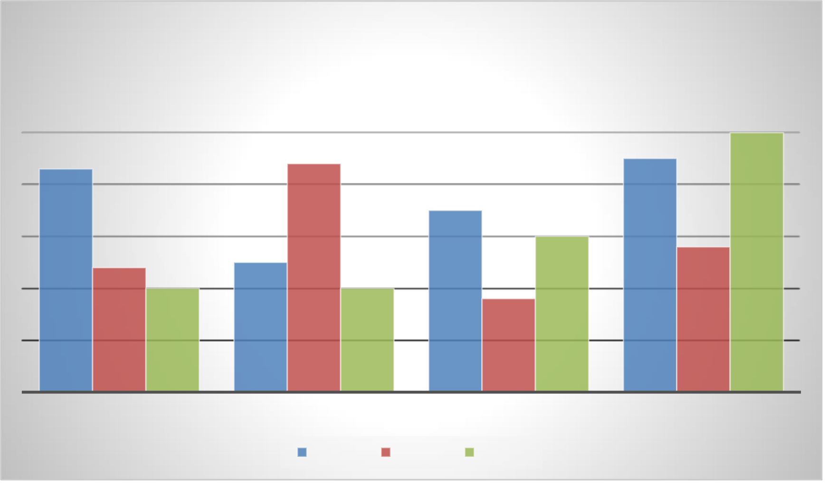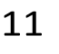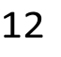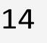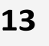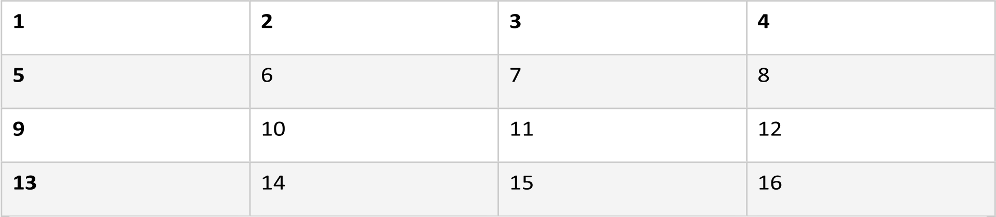

|  |  |  |  |  |  |  |  |  |  |  |  |  |  |  |  |  |  |  |  |  |  |  |  |  |  |  |  |  |  |  |  |  |  |  |  |  |  |  |  |  |  |  |  |  |  |  |  |  |  |  |  |  |  |  |  |  |  |  |  |  |  |  |  |  |  |  |  |  |  |  |  |  |  |  |  |  |  |  |  |  |  |  |  |  |  |  |  |  |  |  |  |  |  |  |  |  |  |  |  |  |  |  |  |  |  |  |  |  |  |  |  |  |  |  |  |  |  |  |  |  |  |  |  |  |  |  |  |  |  |  |  |  |  |  |  |  |  |  |  |  |  |  |  |  |  |  |  |  |  |  |  |  |  |  |  |  |  |  |  |  |  |  |  |  |  |  |  |  |  |  |  |  |  |  |  |  |  |  |  |  |  |  |  |  |  |  |  |  |  |
| --- | --- | --- | --- | --- | --- | --- | --- | --- | --- | --- | --- | --- | --- | --- | --- | --- | --- | --- | --- | --- | --- | --- | --- | --- | --- | --- | --- | --- | --- | --- | --- | --- | --- | --- | --- | --- | --- | --- | --- | --- | --- | --- | --- | --- | --- | --- | --- | --- | --- | --- | --- | --- | --- | --- | --- | --- | --- | --- | --- | --- | --- | --- | --- | --- | --- | --- | --- | --- | --- | --- | --- | --- | --- | --- | --- | --- | --- | --- | --- | --- | --- | --- | --- | --- | --- | --- | --- | --- | --- | --- | --- | --- | --- | --- | --- | --- | --- | --- | --- | --- | --- | --- | --- | --- | --- | --- | --- | --- | --- | --- | --- | --- | --- | --- | --- | --- | --- | --- | --- | --- | --- | --- | --- | --- | --- | --- | --- | --- | --- | --- | --- | --- | --- | --- | --- | --- | --- | --- | --- | --- | --- | --- | --- | --- | --- | --- | --- | --- | --- | --- | --- | --- | --- | --- | --- | --- | --- | --- | --- | --- | --- | --- | --- | --- | --- | --- | --- | --- | --- | --- | --- | --- | --- | --- | --- | --- | --- | --- | --- | --- | --- | --- | --- | --- | --- | --- | --- | --- | --- |
| **Chart Title**   |  |  |  |  |  |  |  |  |  |  |  |  |  |  |  |  |  | | --- | --- | --- | --- | --- | --- | --- | --- | --- | --- | --- | --- | --- | --- | --- | --- | --- | |  |  |  |  |  |  |  |  |  |  |  |  |  |  |  | **5** |  | |  |  |  |  |  |  |  |  |  |  |  |  |  |  |  | |  |  |  |  |  |  |  |  |  |  |  |  |  |  |  | |  | **4.3** |  |  |  |  | **4.4** |  |  |  |  |  |  | **4.5** |  | |  |  |  |  |  |  |  |  |  | **3.5** |  |  |  |  |  | |  |  |  |  |  |  |  |  |  |  |  |  |  |  |  | |  |  |  |  |  |  |  |  |  |  |  | **3** |  |  |  | |  |  |  |  |  |  |  |  |  |  |  |  |  |  |  | |  |  |  |  |  | **2.5** |  |  |  |  |  |  |  |  | **2.8** | |  |  | **2.4** |  |  |  |  |  |  |  |  |  |  |  |  | |  |  |  | **2** |  |  |  | **2** |  |  | **1.8** |  |  |  |  |  |  |  |  |  |  |  |  |  | | --- | --- | --- | --- | --- | --- | --- | --- | | CATEGORY 1 | CATEGORY 2 | |  |  | CATEGORY 3 | | CATEGORY 4 | |  | |  | | --- | |  | |  | | Series 1 | |  | | --- | |  | |  | | Series 2 | |  | | --- | |  | |  | | Series 3 1 |  | |

Pellentesque habitant morbi tristique senectus et netus et malesuada fames ac turpis egestas. Mauris nec erat sapien. Phasellus metus neque, rhoncus vulputate quam et, ultrices facilisis nisl. Suspendisse potenti. Suspendisse laoreet sagittis dignissim. Integer lectus turpis, porta placerat magna sed, pharetra imperdiet tellus. Quisque dignissim sodales hendrerit. Etiam eget nunc maximus, cursus lorem vel, finibus dui. Vestibulum dictum risus vel mauris euismod imperdiet. Quisque et pulvinar sem, non pellentesque nisl. Vivamus pretium tempus ex blandit laoreet. Nullam aliquam ultrices mauris, ac euismod quam tincidunt ut. Pellentesque eu massa id metus vulputate elementum non a urna. Integer dignissim aliquet risus nec viverra.

In hac habitasse platea dictumst. Pellentesque aliquam turpis accumsan metus condimentum laoreet. Sed metus nisi, sodales vitae hendrerit non, posuere nec turpis. Donec sed arcu non magna auctor auctor et nec ex. Sed ligula sapien, sollicitudin quis iaculis non, maximus id risus. Sed posuere diam laoreet lorem imperdiet venenatis. Fusce eu lorem ut mi mattis tempor a id neque. Suspendisse dapibus laoreet auctor. Aliquam ultricies mi at aliquet malesuada. Etiam porta fringilla euismod. Quisque lectus ipsum, porttitor sit amet augue nec, tempor facilisis lectus.

|  |  |  |  |  |  |  |  |
| --- | --- | --- | --- | --- | --- | --- | --- |
| 2 | 14 | 3 | 11 | 4 | 12 | 5 | 13 |
| 6 | 7 | 8 | 9 |
| 10 |
| 15 | 16 |



In interdum lacinia maximus. Nam eget mauris et ligula lobortis cursus quis eu neque. Suspendisse faucibus tristique odio quis tempor. Proin vel augue eros. Cras sodales justo odio, sed varius felis interdum at. Sed eu dignissim diam. Donec faucibus lectus eu euismod faucibus. In dolor neque, ultrices ut sagittis vel, interdum ut

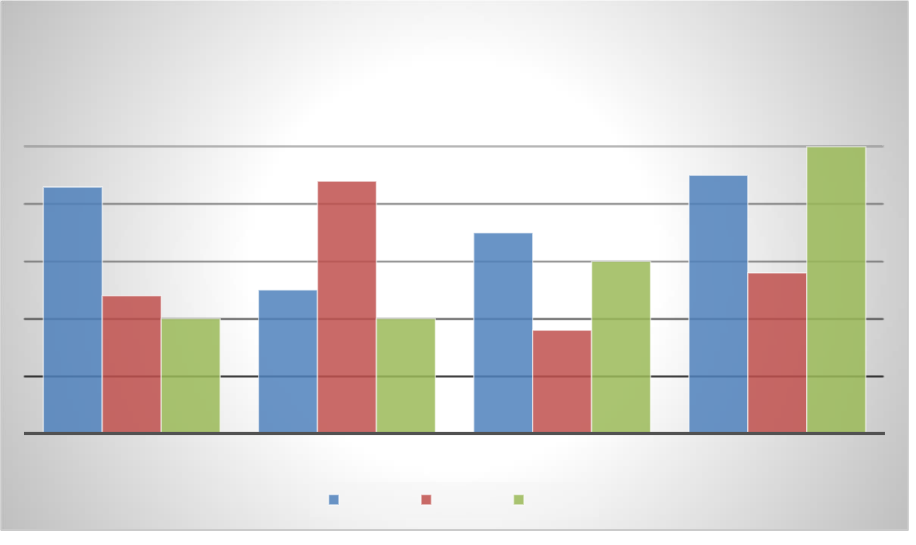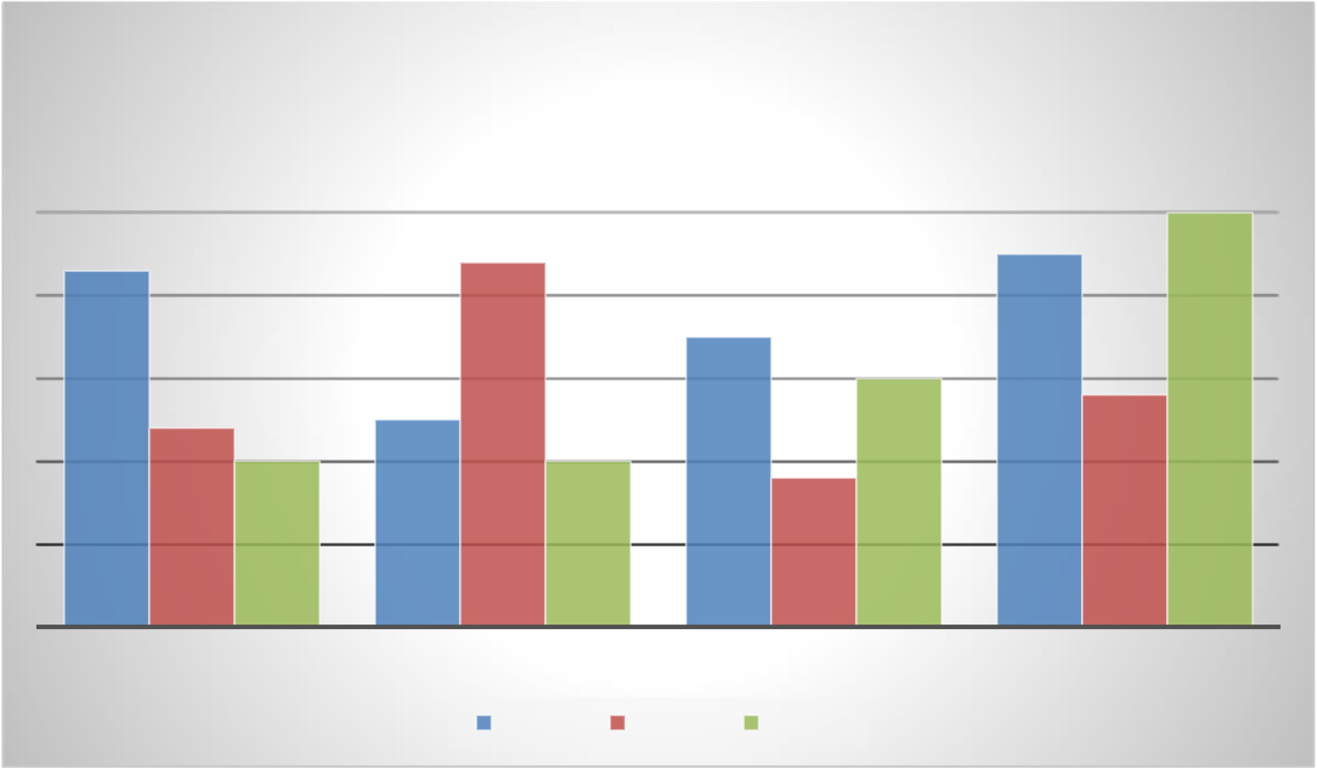

tortor. Pellentesque quam sapien, varius et ultricies et, mollis quis neque. Nam eget massa molestie, fermentum arcu vitae, euismod lacus. Etiam molestie risus pulvinar, ornare lorem lacinia, auctor mauris.

Pellentesque et est est. Donec suscipit neque non vehicula mattis. Proin convallis mauris tortor, eu scelerisque ante dapibus at. Aliquam sit amet convallis purus, at volutpat sem. Mauris varius ipsum ultrices scelerisque tempus. Donec ante nunc, bibendum eget interdum in, ultrices quis nulla. Fusce quis venenatis tellus, sit amet dictum orci. Fusce finibus sem in ligula sollicitudin varius.

**Chart Title**

**5**

|  |  |  |
| --- | --- | --- |
| **4.3** | **4.4** | **4.5** |

**3.5**

|  |  |  |  |  |  |  |
| --- | --- | --- | --- | --- | --- | --- |
| **2.4** | **2** | **2.5** | Series 2 | **1.8** | **3** | **2.8** |
| **2** |
| CATEGORY 1 | CATEGORY 2 | CATEGORY 3 | CATEGORY 4 |
| Series 1 | Series 3 |

Duis eget ante imperdiet, aliquam ex sed, lobortis augue. Donec fermentum sollicitudin odio, a suscipit tellus fermentum vel. Donec blandit malesuada libero, ut semper velit tincidunt quis.

Suspendisse pharetra mauris ac tortor efficitur dictum. Fusce maximus neque in velit tempus lacinia. Fusce eu velit quam. Proin fermentum elit a accumsan lobortis. Donec scelerisque luctus sem, at tristique tortor imperdiet sed. Lorem ipsum dolor sit amet, consectetur adipiscing elit.

Mauris tincidunt orci vel tincidunt scelerisque. Maecenas pretium risus magna, fermentum volutpat massa posuere et. Phasellus nec nisl id orci venenatis faucibus eu sit amet felis. Suspendisse sit amet ante ac nisl condimentum porttitor eu at mi. Sed vitae mauris eu nunc consectetur ultricies. Praesent non purus ut risus consectetur volutpat sed sed augue. Vivamus at maximus nisl. Donec ut posuere erat, eu iaculis nisi. Nulla in metus tincidunt nunc efficitur consectetur a vitae erat. Aenean laoreet, sapien ut suscipit posuere, metus lorem vulputate dui, in ultricies magna arcu ut odio. Nulla in leo vitae ante sollicitudin rhoncus eu et arcu. Nulla facilisi.

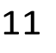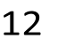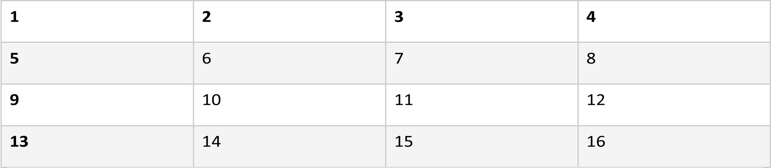

|  |  |  |  |  |  |  |  |
| --- | --- | --- | --- | --- | --- | --- | --- |
| 2 | 14 | 3 | 11 | 4 | 12 | 5 | 13 |
| 6 | 7 | 8 | 9 |
| 10 |
| 15 | 16 |



Duis porttitor augue est, sit amet ullamcorper est convallis sit amet. In vel volutpat enim. Nunc sed sapien sit amet mi vehicula vestibulum. Nullam sagittis, massa vitae fermentum elementum, ligula ipsum hendrerit tortor, eget ornare mauris turpis a leo. Sed massa nisi, varius quis facilisis ac, commodo ac metus. Duis dignissim, eros sed pellentesque mattis, felis diam consectetur orci, ac lacinia nisl mauris in justo. Nullam euismod aliquam semper. Ut pharetra tempor iaculis. Phasellus aliquam ligula risus, in tincidunt ex malesuada nec. Nam convallis placerat elit, id luctus eros volutpat non. Pellentesque ipsum nibh, sollicitudin non suscipit in, rhoncus sed ipsum. Sed consequat ligula congue congue dapibus.

Pellentesque maximus viverra posuere. Sed facilisis, erat eu luctus interdum, nibh lacus volutpat tellus, vel sodales dolor purus tincidunt mi. In auctor mollis nisi. Donec sodales ex at fermentum hendrerit. Sed sodales, elit et fermentum viverra, elit velit aliquet dolor, sed cursus elit purus vel ante. Etiam rhoncus vulputate erat, eu pulvinar justo scelerisque non. Morbi risus ligula, tristique non ex sit amet, cursus lacinia sapien. Phasellus eu augue consequat, molestie est ut, dignissim lorem. Cras varius sit amet ex ut faucibus.

Duis porttitor augue est, sit amet ullamcorper est convallis sit amet. In vel volutpat enim. Nunc sed sapien sit amet mi vehicula vestibulum. Nullam sagittis, massa vitae fermentum elementum, ligula ipsum hendrerit tortor, eget ornare mauris turpis a leo. Sed massa nisi, varius quis facilisis ac, commodo ac metus. Duis dignissim, eros sed pellentesque mattis, felis diam consectetur orci, ac lacinia nisl mauris in justo. Nullam euismod aliquam semper. Ut pharetra tempor iaculis. Phasellus aliquam ligula risus, in tincidunt ex malesuada nec. Nam convallis placerat elit, id luctus eros volutpat non. Pellentesque ipsum nibh, sollicitudin non suscipit in, rhoncus sed ipsum. Sed consequat ligula congue congue dapibus.

Pellentesque maximus viverra posuere. Sed facilisis, erat eu luctus interdum, nibh lacus volutpat tellus, vel sodales dolor purus tincidunt mi. In auctor mollis nisi. Donec sodales ex at fermentum hendrerit. Sed sodales, elit et fermentum viverra, elit velit aliquet dolor, sed cursus elit purus vel ante. Etiam rhoncus vulputate erat, eu pulvinar justo scelerisque non. Morbi risus ligula, tristique non ex sit amet, cursus lacinia sapien. Phasellus eu augue consequat, molestie est ut, dignissim lorem. Cras varius sit amet ex ut faucibus.

Duis porttitor augue est, sit amet ullamcorper est convallis sit amet. In vel volutpat enim. Nunc sed sapien sit amet mi vehicula vestibulum. Nullam sagittis, massa vitae fermentum elementum, ligula ipsum hendrerit tortor, eget ornare mauris turpis a leo. Sed massa nisi, varius quis facilisis ac, commodo ac metus. Duis dignissim, eros sed pellentesque mattis, felis diam consectetur orci, ac lacinia nisl mauris in justo. Nullam euismod aliquam semper. Ut pharetra tempor iaculis. Phasellus aliquam ligula risus, in tincidunt ex malesuada nec. Nam convallis placerat elit, id luctus eros volutpat non. Pellentesque ipsum nibh, sollicitudin non suscipit in, rhoncus sed ipsum. Sed consequat ligula congue congue dapibus. 1

Pellentesque maximus viverra posuere. Sed facilisis, erat eu luctus interdum, nibh lacus volutpat tellus, vel sodales dolor purus tincidunt mi. In auctor mollis nisi. Donec sodales ex at fermentum hendrerit. Sed sodales, elit et fermentum viverra, elit velit aliquet dolor, sed cursus elit purus vel ante. Etiam rhoncus vulputate erat, eu pulvinar justo scelerisque non. Morbi risus ligula, tristique non ex sit amet, cursus lacinia sapien. Phasellus eu augue consequat, molestie est ut, dignissim lorem. Cras varius sit amet ex ut faucibus.

Duis porttitor augue est, sit amet ullamcorper est convallis sit amet. In vel volutpat enim. Nunc sed sapien sit amet mi vehicula vestibulum. Nullam sagittis, massa vitae fermentum elementum, ligula ipsum hendrerit tortor, eget ornare mauris turpis a leo. Sed massa nisi, varius quis facilisis ac, commodo ac metus. Duis dignissim, eros sed pellentesque mattis, felis diam consectetur orci, ac lacinia nisl mauris in justo. Nullam euismod aliquam semper. Ut pharetra tempor iaculis. Phasellus aliquam ligula risus, in tincidunt ex malesuada nec. Nam convallis placerat elit, id luctus eros volutpat non. Pellentesque ipsum nibh, sollicitudin non suscipit in, rhoncus sed ipsum. Sed consequat ligula congue congue dapibus.

Pellentesque maximus viverra posuere. Sed facilisis, erat eu luctus interdum, nibh lacus volutpat tellus, vel sodales dolor purus tincidunt mi. In auctor mollis nisi. Donec sodales ex at fermentum hendrerit. Sed sodales, elit et fermentum viverra, elit velit aliquet dolor, sed cursus elit purus vel ante. Etiam rhoncus vulputate erat, eu pulvinar justo scelerisque non. Morbi risus ligula, tristique non ex sit amet, cursus lacinia sapien. Phasellus eu augue consequat, molestie est ut, dignissim lorem. Cras varius sit amet ex ut faucibus.

Duis porttitor augue est, sit amet ullamcorper est convallis sit amet. In vel volutpat enim. Nunc sed sapien sit amet mi vehicula vestibulum. Nullam sagittis, massa vitae fermentum elementum, ligula ipsum hendrerit tortor, eget ornare mauris turpis a leo. Sed massa nisi, varius quis facilisis ac, commodo ac metus. Duis dignissim, eros sed pellentesque mattis, felis diam consectetur orci, ac lacinia nisl mauris in justo. Nullam euismod aliquam semper. Ut pharetra tempor iaculis. Phasellus aliquam ligula risus, in tincidunt ex malesuada nec. Nam convallis placerat elit, id luctus eros volutpat non. Pellentesque ipsum nibh, sollicitudin non suscipit in, rhoncus sed ipsum. Sed consequat ligula congue congue dapibus.

Pellentesque maximus viverra posuere. Sed facilisis, erat eu luctus interdum, nibh lacus volutpat tellus, vel sodales dolor purus tincidunt mi. In auctor mollis nisi. Donec sodales ex at fermentum hendrerit. Sed sodales, elit et fermentum viverra, elit velit aliquet dolor, sed cursus elit purus vel ante. Etiam rhoncus vulputate erat, eu pulvinar justo scelerisque non. Morbi risus ligula, tristique non ex sit amet, cursus lacinia sapien. Phasellus eu augue consequat, molestie est ut, dignissim lorem. Cras varius sit amet ex ut faucibus.

Duis porttitor augue est, sit amet ullamcorper est convallis sit amet. In vel volutpat enim. Nunc sed sapien sit amet mi vehicula vestibulum. Nullam sagittis, massa vitae fermentum elementum, ligula ipsum hendrerit tortor, eget ornare mauris turpis a leo. Sed massa nisi, varius quis facilisis ac, commodo ac metus. Duis dignissim, eros sed pellentesque mattis, felis diam consectetur orci, ac lacinia nisl mauris in justo. Nullam euismod aliquam semper. Ut pharetra tempor iaculis. Phasellus aliquam ligula risus, in tincidunt ex malesuada nec. Nam convallis placerat elit, id luctus eros volutpat non. Pellentesque ipsum nibh, sollicitudin non suscipit in, rhoncus sed ipsum. Sed consequat ligula congue congue dapibus.

Pellentesque maximus viverra posuere. Sed facilisis, erat eu luctus interdum, nibh lacus volutpat tellus, vel sodales dolor purus tincidunt mi. In auctor mollis nisi. Donec sodales ex at fermentum hendrerit. Sed sodales, elit et fermentum viverra, elit velit aliquet dolor, sed cursus elit purus vel ante. Etiam rhoncus vulputate erat,

eu pulvinar justo scelerisque non. Morbi risus ligula, tristique non ex sit amet, cursus lacinia sapien. Phasellus eu augue consequat, molestie est ut, dignissim lorem. Cras varius sit amet ex ut faucibus.

Duis porttitor augue est, sit amet ullamcorper est convallis sit amet. In vel volutpat enim. Nunc sed sapien sit amet mi vehicula vestibulum. Nullam sagittis, massa vitae fermentum elementum, ligula ipsum hendrerit tortor, eget ornare mauris turpis a leo. Sed massa nisi, varius quis facilisis ac, commodo ac metus. Duis dignissim, eros sed pellentesque mattis, felis diam consectetur orci, ac lacinia nisl mauris in justo. Nullam euismod aliquam semper. Ut pharetra tempor iaculis. Phasellus aliquam ligula risus, in tincidunt ex malesuada nec. Nam convallis placerat elit, id luctus eros volutpat non. Pellentesque ipsum nibh, sollicitudin non suscipit in, rhoncus sed ipsum. Sed consequat ligula congue congue dapibus.

Pellentesque maximus viverra posuere. Sed facilisis, erat eu luctus interdum, nibh lacus volutpat tellus, vel sodales dolor purus tincidunt mi. In auctor mollis nisi. Donec sodales ex at fermentum hendrerit. Sed sodales, elit et fermentum viverra, elit velit aliquet dolor, sed cursus elit purus vel ante. Etiam rhoncus vulputate erat, eu pulvinar justo scelerisque non. Morbi risus ligula, tristique non ex sit amet, cursus lacinia sapien. Phasellus eu augue consequat, molestie est ut, dignissim lorem. Cras varius sit amet ex ut faucibus.

Duis porttitor augue est, sit amet ullamcorper est convallis sit amet. In vel volutpat enim. Nunc sed sapien sit amet mi vehicula vestibulum. Nullam sagittis, massa vitae fermentum elementum, ligula ipsum hendrerit tortor, eget ornare mauris turpis a leo. Sed massa nisi, varius quis facilisis ac, commodo ac metus. Duis dignissim, eros sed pellentesque mattis, felis diam consectetur orci, ac lacinia nisl mauris in justo. Nullam euismod aliquam semper. Ut pharetra tempor iaculis. Phasellus aliquam ligula risus, in tincidunt ex malesuada nec. Nam convallis placerat elit, id luctus eros volutpat non. Pellentesque ipsum nibh, sollicitudin non suscipit in, rhoncus sed ipsum. Sed consequat ligula congue congue dapibus.

Pellentesque maximus viverra posuere. Sed facilisis, erat eu luctus interdum, nibh lacus volutpat tellus, vel sodales dolor purus tincidunt mi. In auctor mollis nisi. Donec sodales ex at fermentum hendrerit. Sed sodales, elit et fermentum viverra, elit velit aliquet dolor, sed cursus elit purus vel ante. Etiam rhoncus vulputate erat, eu pulvinar justo scelerisque non. Morbi risus ligula, tristique non ex sit amet, cursus lacinia sapien. Phasellus eu augue consequat, molestie est ut, dignissim lorem. Cras varius sit amet ex ut faucibus.

Duis porttitor augue est, sit amet ullamcorper est convallis sit amet. In vel volutpat enim. Nunc sed sapien sit amet mi vehicula vestibulum. Nullam sagittis, massa vitae fermentum elementum, ligula ipsum hendrerit tortor, eget ornare mauris turpis a leo. Sed massa nisi, varius quis facilisis ac, commodo ac metus. Duis dignissim, eros sed pellentesque mattis, felis diam consectetur orci, ac lacinia nisl mauris in justo. Nullam euismod aliquam semper. Ut pharetra tempor iaculis. Phasellus aliquam ligula risus, in tincidunt ex malesuada nec. Nam convallis placerat elit, id luctus eros volutpat non. Pellentesque ipsum nibh, sollicitudin non suscipit in, rhoncus sed ipsum. Sed consequat ligula congue congue dapibus.

Pellentesque maximus viverra posuere. Sed facilisis, erat eu luctus interdum, nibh lacus volutpat tellus, vel sodales dolor purus tincidunt mi. In auctor mollis nisi. Donec sodales ex at fermentum hendrerit. Sed sodales, elit et fermentum viverra, elit velit aliquet dolor, sed cursus elit purus vel ante. Etiam rhoncus vulputate erat, eu pulvinar justo scelerisque non. Morbi risus ligula, tristique non ex sit amet, cursus lacinia sapien. Phasellus eu augue consequat, molestie est ut, dignissim lorem. Cras varius sit amet ex ut faucibus.

Duis porttitor augue est, sit amet ullamcorper est convallis sit amet. In vel volutpat enim. Nunc sed sapien sit amet mi vehicula vestibulum. Nullam sagittis, massa vitae fermentum elementum, ligula ipsum hendrerit

tortor, eget ornare mauris turpis a leo. Sed massa nisi, varius quis facilisis ac, commodo ac metus. Duis dignissim, eros sed pellentesque mattis, felis diam consectetur orci, ac lacinia nisl mauris in justo. Nullam euismod aliquam semper. Ut pharetra tempor iaculis. Phasellus aliquam ligula risus, in tincidunt ex malesuada nec. Nam convallis placerat elit, id luctus eros volutpat non. Pellentesque ipsum nibh, sollicitudin non suscipit in, rhoncus sed ipsum. Sed consequat ligula congue congue dapibus.

Pellentesque maximus viverra posuere. Sed facilisis, erat eu luctus interdum, nibh lacus volutpat tellus, vel sodales dolor purus tincidunt mi. In auctor mollis nisi. Donec sodales ex at fermentum hendrerit. Sed sodales, elit et fermentum viverra, elit velit aliquet dolor, sed cursus elit purus vel ante. Etiam rhoncus vulputate erat, eu pulvinar justo scelerisque non. Morbi risus ligula, tristique non ex sit amet, cursus lacinia sapien. Phasellus eu augue consequat, molestie est ut, dignissim lorem. Cras varius sit amet ex ut faucibus.

Duis porttitor augue est, sit amet ullamcorper est convallis sit amet. In vel volutpat enim. Nunc sed sapien sit amet mi vehicula vestibulum. Nullam sagittis, massa vitae fermentum elementum, ligula ipsum hendrerit tortor, eget ornare mauris turpis a leo. Sed massa nisi, varius quis facilisis ac, commodo ac metus. Duis dignissim, eros sed pellentesque mattis, felis diam consectetur orci, ac lacinia nisl mauris in justo. Nullam euismod aliquam semper. Ut pharetra tempor iaculis. Phasellus aliquam ligula risus, in tincidunt ex malesuada nec. Nam convallis placerat elit, id luctus eros volutpat non. Pellentesque ipsum nibh, sollicitudin non suscipit in, rhoncus sed ipsum. Sed consequat ligula congue congue dapibus.

Pellentesque maximus viverra posuere. Sed facilisis, erat eu luctus interdum, nibh lacus volutpat tellus, vel sodales dolor purus tincidunt mi. In auctor mollis nisi. Donec sodales ex at fermentum hendrerit. Sed sodales, elit et fermentum viverra, elit velit aliquet dolor, sed cursus elit purus vel ante. Etiam rhoncus vulputate erat, eu pulvinar justo scelerisque non. Morbi risus ligula, tristique non ex sit amet, cursus lacinia sapien. Phasellus eu augue consequat, molestie est ut, dignissim lorem. Cras varius sit amet ex ut faucibus.

Duis porttitor augue est, sit amet ullamcorper est convallis sit amet. In vel volutpat enim. Nunc sed sapien sit amet mi vehicula vestibulum. Nullam sagittis, massa vitae fermentum elementum, ligula ipsum hendrerit tortor, eget ornare mauris turpis a leo. Sed massa nisi, varius quis facilisis ac, commodo ac metus. Duis dignissim, eros sed pellentesque mattis, felis diam consectetur orci, ac lacinia nisl mauris in justo. Nullam euismod aliquam semper. Ut pharetra tempor iaculis. Phasellus aliquam ligula risus, in tincidunt ex malesuada nec. Nam convallis placerat elit, id luctus eros volutpat non. Pellentesque ipsum nibh, sollicitudin non suscipit in, rhoncus sed ipsum. Sed consequat ligula congue congue dapibus.

Pellentesque maximus viverra posuere. Sed facilisis, erat eu luctus interdum, nibh lacus volutpat tellus, vel sodales dolor purus tincidunt mi. In auctor mollis nisi. Donec sodales ex at fermentum hendrerit. Sed sodales, elit et fermentum viverra, elit velit aliquet dolor, sed cursus elit purus vel ante. Etiam rhoncus vulputate erat, eu pulvinar justo scelerisque non. Morbi risus ligula, tristique non ex sit amet, cursus lacinia sapien. Phasellus eu augue consequat, molestie est ut, dignissim lorem. Cras varius sit amet ex ut faucibus.

Duis porttitor augue est, sit amet ullamcorper est convallis sit amet. In vel volutpat enim. Nunc sed sapien sit amet mi vehicula vestibulum. Nullam sagittis, massa vitae fermentum elementum, ligula ipsum hendrerit tortor, eget ornare mauris turpis a leo. Sed massa nisi, varius quis facilisis ac, commodo ac metus. Duis dignissim, eros sed pellentesque mattis, felis diam consectetur orci, ac lacinia nisl mauris in justo. Nullam euismod aliquam semper. Ut pharetra tempor iaculis. Phasellus aliquam ligula risus, in tincidunt ex malesuada nec. Nam convallis placerat elit, id luctus eros volutpat non. Pellentesque ipsum nibh, sollicitudin non suscipit in, rhoncus sed ipsum. Sed consequat ligula congue congue dapibus.

Pellentesque maximus viverra posuere. Sed facilisis, erat eu luctus interdum, nibh lacus volutpat tellus, vel sodales dolor purus tincidunt mi. In auctor mollis nisi. Donec sodales ex at fermentum hendrerit. Sed sodales, elit et fermentum viverra, elit velit aliquet dolor, sed cursus elit purus vel ante. Etiam rhoncus vulputate erat, eu pulvinar justo scelerisque non. Morbi risus ligula, tristique non ex sit amet, cursus lacinia sapien. Phasellus eu augue consequat, molestie est ut, dignissim lorem. Cras varius sit amet ex ut faucibus.

Duis porttitor augue est, sit amet ullamcorper est convallis sit amet. In vel volutpat enim. Nunc sed sapien sit amet mi vehicula vestibulum. Nullam sagittis, massa vitae fermentum elementum, ligula ipsum hendrerit tortor, eget ornare mauris turpis a leo. Sed massa nisi, varius quis facilisis ac, commodo ac metus. Duis dignissim, eros sed pellentesque mattis, felis diam consectetur orci, ac lacinia nisl mauris in justo. Nullam euismod aliquam semper. Ut pharetra tempor iaculis. Phasellus aliquam ligula risus, in tincidunt ex malesuada nec. Nam convallis placerat elit, id luctus eros volutpat non. Pellentesque ipsum nibh, sollicitudin non suscipit in, rhoncus sed ipsum. Sed consequat ligula congue congue dapibus.

Pellentesque maximus viverra posuere. Sed facilisis, erat eu luctus interdum, nibh lacus volutpat tellus, vel sodales dolor purus tincidunt mi. In auctor mollis nisi. Donec sodales ex at fermentum hendrerit. Sed sodales, elit et fermentum viverra, elit velit aliquet dolor, sed cursus elit purus vel ante. Etiam rhoncus vulputate erat, eu pulvinar justo scelerisque non. Morbi risus ligula, tristique non ex sit amet, cursus lacinia sapien. Phasellus eu augue consequat, molestie est ut, dignissim lorem. Cras varius sit amet ex ut faucibus.

Duis porttitor augue est, sit amet ullamcorper est convallis sit amet. In vel volutpat enim. Nunc sed sapien sit amet mi vehicula vestibulum. Nullam sagittis, massa vitae fermentum elementum, ligula ipsum hendrerit tortor, eget ornare mauris turpis a leo. Sed massa nisi, varius quis facilisis ac, commodo ac metus. Duis dignissim, eros sed pellentesque mattis, felis diam consectetur orci, ac lacinia nisl mauris in justo. Nullam euismod aliquam semper. Ut pharetra tempor iaculis. Phasellus aliquam ligula risus, in tincidunt ex malesuada nec. Nam convallis placerat elit, id luctus eros volutpat non. Pellentesque ipsum nibh, sollicitudin non suscipit in, rhoncus sed ipsum. Sed consequat ligula congue congue dapibus.

Pellentesque maximus viverra posuere. Sed facilisis, erat eu luctus interdum, nibh lacus volutpat tellus, vel sodales dolor purus tincidunt mi. In auctor mollis nisi. Donec sodales ex at fermentum hendrerit. Sed sodales, elit et fermentum viverra, elit velit aliquet dolor, sed cursus elit purus vel ante. Etiam rhoncus vulputate erat, eu pulvinar justo scelerisque non. Morbi risus ligula, tristique non ex sit amet, cursus lacinia sapien. Phasellus eu augue consequat, molestie est ut, dignissim lorem. Cras varius sit amet ex ut faucibus.

Duis porttitor augue est, sit amet ullamcorper est convallis sit amet. In vel volutpat enim. Nunc sed sapien sit amet mi vehicula vestibulum. Nullam sagittis, massa vitae fermentum elementum, ligula ipsum hendrerit tortor, eget ornare mauris turpis a leo. Sed massa nisi, varius quis facilisis ac, commodo ac metus. Duis dignissim, eros sed pellentesque mattis, felis diam consectetur orci, ac lacinia nisl mauris in justo. Nullam euismod aliquam semper. Ut pharetra tempor iaculis. Phasellus aliquam ligula risus, in tincidunt ex malesuada nec. Nam convallis placerat elit, id luctus eros volutpat non. Pellentesque ipsum nibh, sollicitudin non suscipit in, rhoncus sed ipsum. Sed consequat ligula congue congue dapibus.

Pellentesque maximus viverra posuere. Sed facilisis, erat eu luctus interdum, nibh lacus volutpat tellus, vel sodales dolor purus tincidunt mi. In auctor mollis nisi. Donec sodales ex at fermentum hendrerit. Sed sodales, elit et fermentum viverra, elit velit aliquet dolor, sed cursus elit purus vel ante. Etiam rhoncus vulputate erat, eu pulvinar justo scelerisque non. Morbi risus ligula, tristique non ex sit amet, cursus lacinia sapien. Phasellus eu augue consequat, molestie est ut, dignissim lorem. Cras varius sit amet ex ut faucibus.

Duis porttitor augue est, sit amet ullamcorper est convallis sit amet. In vel volutpat enim. Nunc sed sapien sit amet mi vehicula vestibulum. Nullam sagittis, massa vitae fermentum elementum, ligula ipsum hendrerit tortor, eget ornare mauris turpis a leo. Sed massa nisi, varius quis facilisis ac, commodo ac metus. Duis dignissim, eros sed pellentesque mattis, felis diam consectetur orci, ac lacinia nisl mauris in justo. Nullam euismod aliquam semper. Ut pharetra tempor iaculis. Phasellus aliquam ligula risus, in tincidunt ex malesuada nec. Nam convallis placerat elit, id luctus eros volutpat non. Pellentesque ipsum nibh, sollicitudin non suscipit in, rhoncus sed ipsum. Sed consequat ligula congue congue dapibus.

Pellentesque maximus viverra posuere. Sed facilisis, erat eu luctus interdum, nibh lacus volutpat tellus, vel sodales dolor purus tincidunt mi. In auctor mollis nisi. Donec sodales ex at fermentum hendrerit. Sed sodales, elit et fermentum viverra, elit velit aliquet dolor, sed cursus elit purus vel ante. Etiam rhoncus vulputate erat, eu pulvinar justo scelerisque non. Morbi risus ligula, tristique non ex sit amet, cursus lacinia sapien. Phasellus eu augue consequat, molestie est ut, dignissim lorem. Cras varius sit amet ex ut faucibus.

Duis porttitor augue est, sit amet ullamcorper est convallis sit amet. In vel volutpat enim. Nunc sed sapien sit amet mi vehicula vestibulum. Nullam sagittis, massa vitae fermentum elementum, ligula ipsum hendrerit tortor, eget ornare mauris turpis a leo. Sed massa nisi, varius quis facilisis ac, commodo ac metus. Duis dignissim, eros sed pellentesque mattis, felis diam consectetur orci, ac lacinia nisl mauris in justo. Nullam euismod aliquam semper. Ut pharetra tempor iaculis. Phasellus aliquam ligula risus, in tincidunt ex malesuada nec. Nam convallis placerat elit, id luctus eros volutpat non. Pellentesque ipsum nibh, sollicitudin non suscipit in, rhoncus sed ipsum. Sed consequat ligula congue congue dapibus.

Pellentesque maximus viverra posuere. Sed facilisis, erat eu luctus interdum, nibh lacus volutpat tellus, vel sodales dolor purus tincidunt mi. In auctor mollis nisi. Donec sodales ex at fermentum hendrerit. Sed sodales, elit et fermentum viverra, elit velit aliquet dolor, sed cursus elit purus vel ante. Etiam rhoncus vulputate erat, eu pulvinar justo scelerisque non. Morbi risus ligula, tristique non ex sit amet, cursus lacinia sapien. Phasellus eu augue consequat, molestie est ut, dignissim lorem. Cras varius sit amet ex ut faucibus.

Duis porttitor augue est, sit amet ullamcorper est convallis sit amet. In vel volutpat enim. Nunc sed sapien sit amet mi vehicula vestibulum. Nullam sagittis, massa vitae fermentum elementum, ligula ipsum hendrerit tortor, eget ornare mauris turpis a leo. Sed massa nisi, varius quis facilisis ac, commodo ac metus. Duis dignissim, eros sed pellentesque mattis, felis diam consectetur orci, ac lacinia nisl mauris in justo. Nullam euismod aliquam semper. Ut pharetra tempor iaculis. Phasellus aliquam ligula risus, in tincidunt ex malesuada nec. Nam convallis placerat elit, id luctus eros volutpat non. Pellentesque ipsum nibh, sollicitudin non suscipit in, rhoncus sed ipsum. Sed consequat ligula congue congue dapibus.

Pellentesque maximus viverra posuere. Sed facilisis, erat eu luctus interdum, nibh lacus volutpat tellus, vel sodales dolor purus tincidunt mi. In auctor mollis nisi. Donec sodales ex at fermentum hendrerit. Sed sodales, elit et fermentum viverra, elit velit aliquet dolor, sed cursus elit purus vel ante. Etiam rhoncus vulputate erat, eu pulvinar justo scelerisque non. Morbi risus ligula, tristique non ex sit amet, cursus lacinia sapien. Phasellus eu augue consequat, molestie est ut, dignissim lorem. Cras varius sit amet ex ut faucibus.

Duis porttitor augue est, sit amet ullamcorper est convallis sit amet. In vel volutpat enim. Nunc sed sapien sit amet mi vehicula vestibulum. Nullam sagittis, massa vitae fermentum elementum, ligula ipsum hendrerit tortor, eget ornare mauris turpis a leo. Sed massa nisi, varius quis facilisis ac, commodo ac metus. Duis dignissim, eros sed pellentesque mattis, felis diam consectetur orci, ac lacinia nisl mauris in justo. Nullam euismod aliquam semper. Ut pharetra tempor iaculis. Phasellus aliquam ligula risus, in tincidunt ex malesuada

nec. Nam convallis placerat elit, id luctus eros volutpat non. Pellentesque ipsum nibh, sollicitudin non suscipit in, rhoncus sed ipsum. Sed consequat ligula congue congue dapibus.

Pellentesque maximus viverra posuere. Sed facilisis, erat eu luctus interdum, nibh lacus volutpat tellus, vel sodales dolor purus tincidunt mi. In auctor mollis nisi. Donec sodales ex at fermentum hendrerit. Sed sodales, elit et fermentum viverra, elit velit aliquet dolor, sed cursus elit purus vel ante. Etiam rhoncus vulputate erat, eu pulvinar justo scelerisque non. Morbi risus ligula, tristique non ex sit amet, cursus lacinia sapien. Phasellus eu augue consequat, molestie est ut, dignissim lorem. Cras varius sit amet ex ut faucibus.

Duis porttitor augue est, sit amet ullamcorper est convallis sit amet. In vel volutpat enim. Nunc sed sapien sit amet mi vehicula vestibulum. Nullam sagittis, massa vitae fermentum elementum, ligula ipsum hendrerit tortor, eget ornare mauris turpis a leo. Sed massa nisi, varius quis facilisis ac, commodo ac metus. Duis dignissim, eros sed pellentesque mattis, felis diam consectetur orci, ac lacinia nisl mauris in justo. Nullam euismod aliquam semper. Ut pharetra tempor iaculis. Phasellus aliquam ligula risus, in tincidunt ex malesuada nec. Nam convallis placerat elit, id luctus eros volutpat non. Pellentesque ipsum nibh, sollicitudin non suscipit in, rhoncus sed ipsum. Sed consequat ligula congue congue dapibus.

Pellentesque maximus viverra posuere. Sed facilisis, erat eu luctus interdum, nibh lacus volutpat tellus, vel sodales dolor purus tincidunt mi. In auctor mollis nisi. Donec sodales ex at fermentum hendrerit. Sed sodales, elit et fermentum viverra, elit velit aliquet dolor, sed cursus elit purus vel ante. Etiam rhoncus vulputate erat, eu pulvinar justo scelerisque non. Morbi risus ligula, tristique non ex sit amet, cursus lacinia sapien. Phasellus eu augue consequat, molestie est ut, dignissim lorem. Cras varius sit amet ex ut faucibus.

Duis porttitor augue est, sit amet ullamcorper est convallis sit amet. In vel volutpat enim. Nunc sed sapien sit amet mi vehicula vestibulum. Nullam sagittis, massa vitae fermentum elementum, ligula ipsum hendrerit tortor, eget ornare mauris turpis a leo. Sed massa nisi, varius quis facilisis ac, commodo ac metus. Duis dignissim, eros sed pellentesque mattis, felis diam consectetur orci, ac lacinia nisl mauris in justo. Nullam euismod aliquam semper. Ut pharetra tempor iaculis. Phasellus aliquam ligula risus, in tincidunt ex malesuada nec. Nam convallis placerat elit, id luctus eros volutpat non. Pellentesque ipsum nibh, sollicitudin non suscipit in, rhoncus sed ipsum. Sed consequat ligula congue congue dapibus.

Pellentesque maximus viverra posuere. Sed facilisis, erat eu luctus interdum, nibh lacus volutpat tellus, vel sodales dolor purus tincidunt mi. In auctor mollis nisi. Donec sodales ex at fermentum hendrerit. Sed sodales, elit et fermentum viverra, elit velit aliquet dolor, sed cursus elit purus vel ante. Etiam rhoncus vulputate erat, eu pulvinar justo scelerisque non. Morbi risus ligula, tristique non ex sit amet, cursus lacinia sapien. Phasellus eu augue consequat, molestie est ut, dignissim lorem. Cras varius sit amet ex ut faucibus.

Duis porttitor augue est, sit amet ullamcorper est convallis sit amet. In vel volutpat enim. Nunc sed sapien sit amet mi vehicula vestibulum. Nullam sagittis, massa vitae fermentum elementum, ligula ipsum hendrerit tortor, eget ornare mauris turpis a leo. Sed massa nisi, varius quis facilisis ac, commodo ac metus. Duis dignissim, eros sed pellentesque mattis, felis diam consectetur orci, ac lacinia nisl mauris in justo. Nullam euismod aliquam semper. Ut pharetra tempor iaculis. Phasellus aliquam ligula risus, in tincidunt ex malesuada

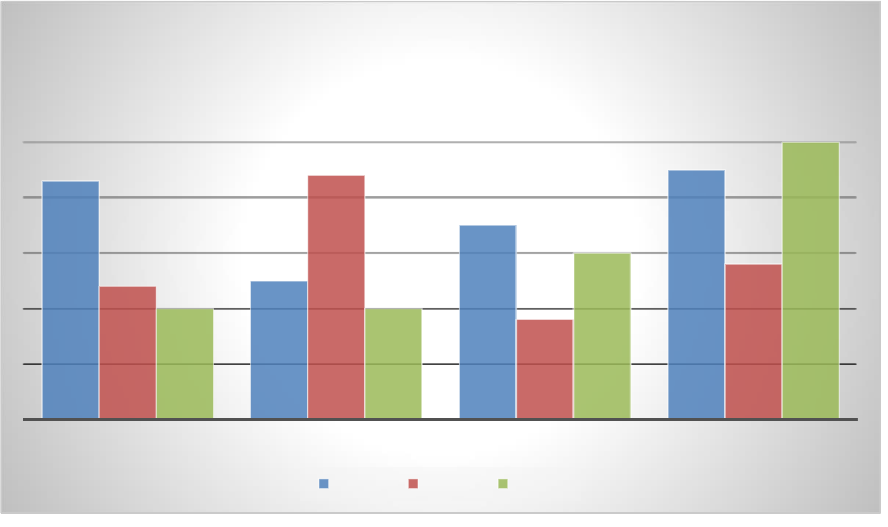

nec. Nam convallis placerat elit, id luctus eros volutpat non. Pellentesque ipsum nibh, sollicitudin non suscipit in, rhoncus sed ipsum. Sed consequat ligula congue congue dapibus.

Pellentesque maximus viverra posuere. Sed facilisis, erat eu luctus interdum, nibh lacus volutpat tellus, vel sodales dolor purus tincidunt mi. In auctor mollis nisi. Donec sodales ex at fermentum hendrerit. Sed sodales, elit et fermentum viverra, elit velit aliquet dolor, sed cursus elit purus vel ante. Etiam rhoncus vulputate erat, eu pulvinar justo scelerisque non. Morbi risus ligula, tristique non ex sit amet, cursus lacinia sapien. Phasellus eu augue consequat, molestie est ut, dignissim lorem. Cras varius sit amet ex ut faucibus.

|  |  |  |  |  |  |  |  |  |  |  |  |  |  |  |  |  |  |  |  |  |  |  |  |  |  |  |  |  |  |  |  |  |  |  |  |  |  |  |  |  |  |  |  |  |  |  |  |  |  |  |  |  |  |  |  |  |  |  |  |  |  |  |  |  |  |  |  |  |  |  |  |  |  |  |  |  |  |  |  |  |  |  |  |  |  |  |  |  |  |  |  |  |  |  |  |  |  |  |  |  |  |  |  |  |  |  |  |  |  |  |  |  |  |  |  |  |  |  |  |  |  |  |  |  |  |  |  |  |  |  |  |  |  |  |  |  |  |  |  |  |  |  |  |  |  |  |  |  |  |  |  |  |  |  |  |  |  |  |  |  |  |  |  |  |  |  |  |  |  |  |  |  |  |  |  |  |  |  |  |  |  |  |  |  |  |  |  |  |  |
| --- | --- | --- | --- | --- | --- | --- | --- | --- | --- | --- | --- | --- | --- | --- | --- | --- | --- | --- | --- | --- | --- | --- | --- | --- | --- | --- | --- | --- | --- | --- | --- | --- | --- | --- | --- | --- | --- | --- | --- | --- | --- | --- | --- | --- | --- | --- | --- | --- | --- | --- | --- | --- | --- | --- | --- | --- | --- | --- | --- | --- | --- | --- | --- | --- | --- | --- | --- | --- | --- | --- | --- | --- | --- | --- | --- | --- | --- | --- | --- | --- | --- | --- | --- | --- | --- | --- | --- | --- | --- | --- | --- | --- | --- | --- | --- | --- | --- | --- | --- | --- | --- | --- | --- | --- | --- | --- | --- | --- | --- | --- | --- | --- | --- | --- | --- | --- | --- | --- | --- | --- | --- | --- | --- | --- | --- | --- | --- | --- | --- | --- | --- | --- | --- | --- | --- | --- | --- | --- | --- | --- | --- | --- | --- | --- | --- | --- | --- | --- | --- | --- | --- | --- | --- | --- | --- | --- | --- | --- | --- | --- | --- | --- | --- | --- | --- | --- | --- | --- | --- | --- | --- | --- | --- | --- | --- | --- | --- | --- | --- | --- | --- | --- | --- | --- | --- | --- | --- | --- | --- |
| **Chart Title**   |  |  |  |  |  |  |  |  |  |  |  |  |  |  |  |  |  | | --- | --- | --- | --- | --- | --- | --- | --- | --- | --- | --- | --- | --- | --- | --- | --- | --- | |  |  |  |  |  |  |  |  |  |  |  |  |  |  |  | **5** |  | |  |  |  |  |  |  |  |  |  |  |  |  |  |  |  | |  |  |  |  |  |  |  |  |  |  |  |  |  |  |  | |  | **4.3** |  |  |  |  | **4.4** |  |  |  |  |  |  | **4.5** |  | |  |  |  |  |  |  |  |  |  | **3.5** |  |  |  |  |  | |  |  |  |  |  |  |  |  |  |  |  |  |  |  |  | |  |  |  |  |  |  |  |  |  |  |  | **3** |  |  |  | |  |  |  |  |  |  |  |  |  |  |  |  |  |  |  | |  |  |  |  |  | **2.5** |  |  |  |  |  |  |  |  | **2.8** | |  |  | **2.4** |  |  |  |  |  |  |  |  |  |  |  |  | |  |  |  | **2** |  |  |  | **2** |  |  | **1.8** |  |  |  |  |  |  |  |  |  |  |  |  |  | | --- | --- | --- | --- | --- | --- | --- | --- | | CATEGORY 1 | CATEGORY 2 | |  |  | CATEGORY 3 | | CATEGORY 4 | |  | |  | | --- | |  | |  | | Series 1 | |  | | --- | |  | |  | | Series 2 | |  | | --- | |  | |  | | Series 3 |  | |

Quisque et magna quis sapien aliquam consectetur. Praesent viverra feugiat tincidunt. Quisque pulvinar porta velit sed malesuada. Proin porttitor consectetur purus, vel cursus nunc congue non. Praesent velit leo, placerat dapibus dignissim id, pretium id libero. Maecenas eu dolor neque. Ut sed lectus aliquam, facilisis lorem a, malesuada nisl. Sed scelerisque a felis at fringilla. Suspendisse id convallis nisi.

Curabitur sed sagittis diam. Fusce rhoncus nisi vel velit posuere, et feugiat justo auctor. Nunc pretium, nisl a molestie consequat, tortor odio volutpat diam, nec eleifend felis neque sit amet enim. Aenean porttitor sit amet tellus rhoncus varius. Nam ac mauris sit amet lacus tempor luctus. Phasellus quis dictum ipsum. Sed tincidunt viverra sodales. Pellentesque imperdiet eros sed nibh tempus sagittis. Sed malesuada molestie arcu, nec elementum dui consequat vitae. Donec convallis eget nisl non lobortis. Vivamus iaculis auctor blandit. Maecenas ornare nulla a sodales varius. Nulla malesuada, elit vitae eleifend varius, lorem ipsum ultrices nibh, id lobortis nibh sapien ut mauris. Donec mollis turpis a orci tincidunt faucibus. Donec libero justo, lobortis sit amet metus ultrices, viverra accumsan elit.

Mauris vel urna dui. Quisque non tellus vehicula sapien fringilla luctus sed a turpis. Pellentesque consequat arcu at orci sollicitudin faucibus. Phasellus vel enim interdum, gravida arcu at, pulvinar neque. Sed non nisi id odio dictum commodo at ac lectus. Nullam interdum odio diam. Donec eu feugiat eros, ac placerat quam. Morbi

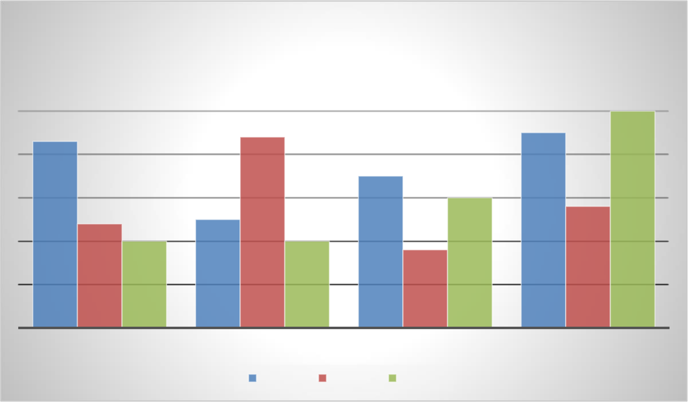

dapibus metus at faucibus interdum. Nam vulputate rhoncus augue, in faucibus tortor feugiat quis. Nullam eget turpis mattis, pulvinar massa ut, sodales odio.

|  |  |  |  |  |  |  |  |  |  |  |  |  |  |  |  |  |  |  |  |  |  |  |  |  |  |  |  |  |  |  |  |  |  |  |  |  |  |  |  |  |  |  |  |  |  |  |  |  |  |  |  |  |  |  |  |  |  |  |  |  |  |  |  |  |  |  |  |  |  |  |  |  |  |  |  |  |  |  |  |  |  |  |  |  |  |  |  |  |  |  |  |  |  |  |  |  |  |  |  |  |  |  |  |  |  |  |  |  |  |  |  |  |  |  |  |  |  |  |  |  |  |  |  |  |  |  |  |  |  |  |  |  |  |  |  |  |  |  |  |  |  |  |  |  |  |  |  |  |  |  |  |  |  |  |  |  |  |  |  |  |  |  |  |  |  |  |  |  |  |  |  |  |  |  |  |  |  |  |  |  |  |  |  |  |  |  |  |  |  |
| --- | --- | --- | --- | --- | --- | --- | --- | --- | --- | --- | --- | --- | --- | --- | --- | --- | --- | --- | --- | --- | --- | --- | --- | --- | --- | --- | --- | --- | --- | --- | --- | --- | --- | --- | --- | --- | --- | --- | --- | --- | --- | --- | --- | --- | --- | --- | --- | --- | --- | --- | --- | --- | --- | --- | --- | --- | --- | --- | --- | --- | --- | --- | --- | --- | --- | --- | --- | --- | --- | --- | --- | --- | --- | --- | --- | --- | --- | --- | --- | --- | --- | --- | --- | --- | --- | --- | --- | --- | --- | --- | --- | --- | --- | --- | --- | --- | --- | --- | --- | --- | --- | --- | --- | --- | --- | --- | --- | --- | --- | --- | --- | --- | --- | --- | --- | --- | --- | --- | --- | --- | --- | --- | --- | --- | --- | --- | --- | --- | --- | --- | --- | --- | --- | --- | --- | --- | --- | --- | --- | --- | --- | --- | --- | --- | --- | --- | --- | --- | --- | --- | --- | --- | --- | --- | --- | --- | --- | --- | --- | --- | --- | --- | --- | --- | --- | --- | --- | --- | --- | --- | --- | --- | --- | --- | --- | --- | --- | --- | --- | --- | --- | --- | --- | --- | --- | --- | --- | --- | --- |
| **Chart Title**   |  |  |  |  |  |  |  |  |  |  |  |  |  |  |  |  |  | | --- | --- | --- | --- | --- | --- | --- | --- | --- | --- | --- | --- | --- | --- | --- | --- | --- | |  |  |  |  |  |  |  |  |  |  |  |  |  |  |  | **5** |  | |  |  |  |  |  |  |  |  |  |  |  |  |  |  |  | |  |  |  |  |  |  |  |  |  |  |  |  |  |  |  | |  | **4.3** |  |  |  |  | **4.4** |  |  |  |  |  |  | **4.5** |  | |  |  |  |  |  |  |  |  |  | **3.5** |  |  |  |  |  | |  |  |  |  |  |  |  |  |  |  |  |  |  |  |  | |  |  |  |  |  |  |  |  |  |  |  | **3** |  |  |  | |  |  |  |  |  |  |  |  |  |  |  |  |  |  |  | |  |  |  |  |  | **2.5** |  |  |  |  |  |  |  |  | **2.8** | |  |  | **2.4** |  |  |  |  |  |  |  |  |  |  |  |  | |  |  |  | **2** |  |  |  | **2** |  |  | **1.8** |  |  |  |  |  |  |  |  |  |  |  |  |  | | --- | --- | --- | --- | --- | --- | --- | --- | | CATEGORY 1 | CATEGORY 2 | |  |  | CATEGORY 3 | | CATEGORY 4 | |  | |  |  | | --- | --- | |  |  | | Series 1 | |  |  | | --- | --- | |  |  | | Series 2 | |  |  | | --- | --- | |  |  | | Series 3 |  | |

Quisque vestibulum dui non pretium semper. Class aptent taciti sociosqu ad litora torquent per conubia nostra, per inceptos himenaeos. Ut varius velit ut erat cursus, viverra iaculis odio interdum. Pellentesque nec orci sollicitudin, rhoncus libero at, semper turpis. Aenean sit amet justo hendrerit, consectetur ex quis, egestas tellus. Nullam sodales dictum nulla eu varius. Duis dignissim lacus in orci blandit, ac pulvinar nibh fringilla. Fusce consectetur erat sit amet tortor convallis, sed ornare nibh euismod. Vivamus rhoncus quis orci eget pharetra. Nam at sem magna. Donec sit amet sodales tellus, ut dapibus diam. Quisque aliquet leo a mauris porta egestas.

Maecenas aliquet in orci commodo elementum. Aliquam nec quam eu velit tempus sagittis sed quis ex.

Maecenas bibendum metus augue, sed tempus ante posuere in. Duis ut nibh id dolor tempus bibendum. Maecenas mollis dapibus dolor, in sagittis elit fringilla ac. Mauris ultricies ipsum eget purus consectetur, eget cursus lacus varius. Ut at orci eu ligula suscipit iaculis nec sit amet magna. Suspendisse dolor quam, sollicitudin ut magna consectetur, aliquam aliquet tellus. In rhoncus ligula eget consectetur egestas. In dui mi, semper non risus vel, laoreet molestie est. Fusce volutpat arcu at cursus elementum. Cras eu leo eget mauris pellentesque blandit sed et turpis. Maecenas bibendum metus augue, sed tempus ante posuere in. Duis ut nibh id dolor tempus bibendum. Maecenas mollis dapibus dolor, in sagittis elit fringilla ac. Mauris ultricies ipsum eget purus consectetur, eget cursus lacus varius. Ut at orci eu ligula suscipit iaculis nec sit amet magna. Suspendisse dolor quam, sollicitudin ut magna consectetur, aliquam aliquet tellus. In rhoncus ligula eget consectetur egestas. In dui mi, semper non risus vel, laoreet molestie est. Fusce volutpat arcu at cursus elementum. Cras eu leo eget mauris pellentesque blandit sed et turpis.

Maecenas bibendum metus augue, sed tempus ante posuere in. Duis ut nibh id dolor tempus bibendum. Maecenas mollis dapibus dolor, in sagittis elit fringilla ac. Mauris ultricies ipsum eget purus consectetur, eget cursus lacus varius. Ut at orci eu ligula suscipit iaculis nec sit amet magna. Suspendisse dolor quam, sollicitudin ut magna consectetur, aliquam aliquet tellus. In rhoncus ligula eget consectetur egestas. In dui mi, semper non

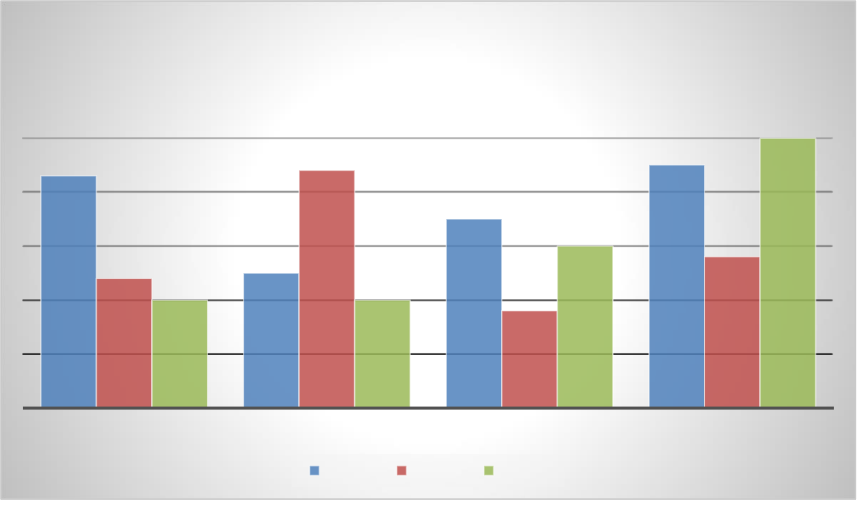

risus vel, laoreet molestie est. Fusce volutpat arcu at cursus elementum. Cras eu leo eget mauris pellentesque blandit sed et turpis.

Maecenas bibendum metus augue, sed tempus ante posuere in. Duis ut nibh id dolor tempus bibendum. Maecenas mollis dapibus dolor, in sagittis elit fringilla ac. Mauris ultricies ipsum eget purus consectetur, eget cursus lacus varius. Ut at orci eu ligula suscipit iaculis nec sit amet magna. Suspendisse dolor quam, sollicitudin ut magna consectetur, aliquam aliquet tellus. In rhoncus ligula eget consectetur egestas. In dui mi, semper non risus vel, laoreet molestie est. Fusce volutpat arcu at cursus elementum. Cras eu leo eget mauris pellentesque blandit sed et turpis.

Fusce non velit lectus. In viverra accumsan risus, at efficitur velit congue eget. Quisque facilisis pellentesque risus in imperdiet. Sed dignissim tincidunt iaculis. Pellentesque habitant morbi tristique senectus et netus et malesuada fames ac turpis egestas. Nunc id dignissim ex. Phasellus pharetra magna lacus, vel euismod nisl semper ut. Cras facilisis orci vitae auctor vestibulum. Cras vitae pretium augue. Curabitur lobortis vestibulum metus vitae ullamcorper. Donec quis faucibus tortor. Nullam posuere sapien vel purus dictum, vel ullamcorper tortor viverra.

|  |  |  |  |  |  |  |  |  |  |  |  |  |  |  |  |  |  |  |  |  |  |  |  |  |  |  |  |  |  |  |  |  |  |  |  |  |  |  |  |  |  |  |  |  |  |  |  |  |  |  |  |  |  |  |  |  |  |  |  |  |  |  |  |  |  |  |  |  |  |  |  |  |  |  |  |  |  |  |  |  |  |  |  |  |  |  |  |  |  |  |  |  |  |  |  |  |  |  |  |  |  |  |  |  |  |  |  |  |  |  |  |  |  |  |  |  |  |  |  |  |  |  |  |  |  |  |  |  |  |  |  |  |  |  |  |  |  |  |  |  |  |  |  |  |  |  |  |  |  |  |  |  |  |  |  |  |  |  |  |  |  |  |  |  |  |  |  |  |  |  |  |  |  |  |  |  |  |  |  |  |  |  |  |  |  |  |  |  |  |
| --- | --- | --- | --- | --- | --- | --- | --- | --- | --- | --- | --- | --- | --- | --- | --- | --- | --- | --- | --- | --- | --- | --- | --- | --- | --- | --- | --- | --- | --- | --- | --- | --- | --- | --- | --- | --- | --- | --- | --- | --- | --- | --- | --- | --- | --- | --- | --- | --- | --- | --- | --- | --- | --- | --- | --- | --- | --- | --- | --- | --- | --- | --- | --- | --- | --- | --- | --- | --- | --- | --- | --- | --- | --- | --- | --- | --- | --- | --- | --- | --- | --- | --- | --- | --- | --- | --- | --- | --- | --- | --- | --- | --- | --- | --- | --- | --- | --- | --- | --- | --- | --- | --- | --- | --- | --- | --- | --- | --- | --- | --- | --- | --- | --- | --- | --- | --- | --- | --- | --- | --- | --- | --- | --- | --- | --- | --- | --- | --- | --- | --- | --- | --- | --- | --- | --- | --- | --- | --- | --- | --- | --- | --- | --- | --- | --- | --- | --- | --- | --- | --- | --- | --- | --- | --- | --- | --- | --- | --- | --- | --- | --- | --- | --- | --- | --- | --- | --- | --- | --- | --- | --- | --- | --- | --- | --- | --- | --- | --- | --- | --- | --- | --- | --- | --- | --- | --- | --- | --- | --- |
| **Chart Title**   |  |  |  |  |  |  |  |  |  |  |  |  |  |  |  |  |  | | --- | --- | --- | --- | --- | --- | --- | --- | --- | --- | --- | --- | --- | --- | --- | --- | --- | |  |  |  |  |  |  |  |  |  |  |  |  |  |  |  | **5** |  | |  |  |  |  |  |  |  |  |  |  |  |  |  |  |  | |  |  |  |  |  |  |  |  |  |  |  |  |  |  |  | |  | **4.3** |  |  |  |  | **4.4** |  |  |  |  |  |  | **4.5** |  | |  |  |  |  |  |  |  |  |  | **3.5** |  |  |  |  |  | |  |  |  |  |  |  |  |  |  |  |  |  |  |  |  | |  |  |  |  |  |  |  |  |  |  |  | **3** |  |  |  | |  |  |  |  |  |  |  |  |  |  |  |  |  |  |  | |  |  |  |  |  | **2.5** |  |  |  |  |  |  |  |  | **2.8** | |  |  | **2.4** |  |  |  |  |  |  |  |  |  |  |  |  | |  |  |  | **2** |  |  |  | **2** |  |  | **1.8** |  |  |  |  |  |  |  |  |  |  |  |  |  | | --- | --- | --- | --- | --- | --- | --- | --- | | CATEGORY 1 | CATEGORY 2 | |  |  | CATEGORY 3 | | CATEGORY 4 | |  | |  |  | | --- | --- | |  |  | | Series 1 | |  |  | | --- | --- | |  |  | | Series 2 | |  |  | | --- | --- | |  |  | | Series 3 |  | |

Cras pellentesque tempor ipsum non tempor. Donec aliquam augue volutpat, volutpat nisi sit amet, mattis velit. Mauris consequat viverra pretium. Donec vitae rhoncus nisl. Quisque pharetra ligula neque, sit amet placerat felis venenatis eget. Donec condimentum aliquam dolor, nec pulvinar metus. Phasellus ac quam dictum, scelerisque felis vitae, vehicula orci. Etiam auctor, risus non consectetur porta, metus erat faucibus purus, eu posuere libero mi at augue. Nullam in aliquam nibh. Proin sollicitudin iaculis magna, ac semper risus pellentesque a. Nulla iaculis, lectus sit amet facilisis aliquet, nunc sem pulvinar libero, id porta ipsum quam nec felis. Vivamus tincidunt, diam quis efficitur iaculis, elit enim tincidunt libero, non congue quam elit ac magna. Morbi sollicitudin dolor lectus, pulvinar sagittis ligula malesuada ac. Nam vestibulum mattis arcu sit amet consequat. Morbi eu leo at risus semper laoreet. Vivamus ac bibendum metus, ac lobortis risus. Cras

pellentesque tempor ipsum non tempor. Donec aliquam augue volutpat, volutpat nisi sit amet, mattis velit. Mauris consequat viverra pretium. Donec vitae rhoncus nisl. Quisque pharetra ligula neque, sit amet placerat felis venenatis eget. Donec condimentum aliquam dolor, nec pulvinar metus. Phasellus ac quam dictum, scelerisque felis vitae, vehicula orci. Etiam auctor, risus non consectetur porta, metus erat faucibus purus, eu posuere libero mi at augue. Nullam in aliquam nibh. Proin sollicitudin iaculis magna, ac semper risus pellentesque a. Nulla iaculis, lectus sit amet facilisis aliquet, nunc sem pulvinar libero, id porta ipsum quam nec felis. Vivamus tincidunt, diam quis efficitur iaculis, elit enim tincidunt libero, non congue quam elit ac magna. Morbi sollicitudin dolor lectus, pulvinar sagittis ligula malesuada ac. Nam vestibulum mattis arcu sit amet consequat. Morbi eu leo at risus semper laoreet. Vivamus ac bibendum metus, ac lobortis risus.

Fusce id pretium tortor, vitae malesuada neque. Proin neque ligula, finibus eu tincidunt eget, sagittis ac libero. Mauris in facilisis ipsum. Fusce rutrum urna posuere, porttitor tortor a, sagittis augue. Quisque mattis porttitor tellus, vel ultrices velit consectetur quis. Fusce urna velit, fringilla sit amet tincidunt maximus, tincidunt at tellus. Nam non felis quis neque varius iaculis. Morbi nec risus libero. Cras iaculis finibus maximus. Proin dapibus metus sed tempus blandit. Nulla quam nunc, molestie non massa non, venenatis pretium nibh. Pellentesque vehicula quis quam eget malesuada. Donec pulvinar at turpis quis finibus. Nam interdum ullamcorper vestibulum.

Fusce porta efficitur lacus, vitae maximus dolor dictum nec. Aliquam eget eleifend nunc, vel tristique urna. Suspendisse quis porta elit, eu malesuada mi. Donec vitae mi nisl. Aliquam euismod, lectus et ultrices dapibus, purus nisl tempus ipsum, ut ultricies mauris odio vitae eros. Donec ornare nisi tempor, vestibulum mi id, fermentum ex. Aliquam interdum orci sit amet eros aliquet, sit amet tempor lorem dignissim. Pellentesque ut nisi condimentum, malesuada leo id, dignissim ipsum. Quisque ultrices eros eu scelerisque facilisis. Vestibulum ante ipsum primis in faucibus orci luctus et ultrices posuere cubilia curae; Donec iaculis vel mauris in vulputate. Donec varius ultricies malesuada. Nulla laoreet mauris non felis laoreet posuere et et dui.

Morbi mattis sem quis tincidunt tristique. Nulla vel posuere lectus, pharetra sagittis orci. Pellentesque tempor facilisis sem ac consequat. Donec quis semper sapien. Fusce in nulla a eros maximus blandit a eu eros. Donec ante turpis, viverra id tortor a, consequat congue purus. Vestibulum vitae lorem sit amet ex pulvinar tempor. Maecenas consequat mi vitae leo sodales, eu placerat purus congue. Pellentesque sed velit nibh. Integer iaculis magna a orci vulputate ultrices. Sed placerat porttitor velit, id rhoncus turpis commodo in. Sed maximus faucibus nulla, vitae vestibulum enim efficitur vel. Nunc porta leo ut erat fermentum molestie. Nulla facilisi.

Donec lobortis pulvinar nisl, sit amet consectetur lacus rutrum quis. Proin pretium mauris sed enim posuere ultricies.

|  |  |  |  |
| --- | --- | --- | --- |
| **1** | **2** | **3** | **4** |
| **5** | 6 | 7 | 8 |
| **9** | 10 | 11 | 12 |
| **13** | 14 | 15 | 16 |

































